Financial Risk Mitigation Senior Task Force (FRMSTF)
PJM Conference and Training Center
August 14, 2019; 9:00 a.m. – 2:30 p.m. EPT

Administration (9:00-9:30)
- Ms. Michele Greening will provide welcome, announcements and review of the Antitrust, Code of Conduct, and Public Meetings/Media Participation Guidelines. Stakeholders will be asked to approve draft minutes from the July 17, 2019 meeting.
- Ms. Susan Riley will introduce Ms. Nigeria Bloczynski, the new Chief Financial Risk Officer for PJM.
- Ms. Nigeria Bloczynski will provide her vision for the credit work stream going forward.

Work Plan (9:30-9:45)
- Ms. Anita Patel will review the Financial Risk Mitigation Senior Task Force stakeholder process work plan.

Discussion Papers and Initial Proposals (9:45 – 2:30)
- Due Diligence Criteria & Assessment Process (9:45-10:45)
Ms. Rebecca Carroll will provide an overview of the initial proposal addressing PJM’s recommended changes with respect to due diligence criteria and an assessment process.
Break 10:45-11:00
- Authorities and Discretion to Deny or Revoke Trading Rights (11:00-11:30)
Ms. Rebecca Carroll will provide an overview of the initial proposal addressing PJM’s recommended changes with respect to authorities and discretion to deny or revoke trading rights.
Lunch 11:30 – 12:30
- PJM Proposal for Enduring Governance of PJM’s Financial Markets (12:30-1:15)
Mr. Dave Anders will provide an update to PJM’s initial proposal regarding Enduring Governance populated with subcomponents into a solutions matrix.
- Recommended Changes to FTR Product Range and Auction Process (1:15-2:30)
- Mr. Brian Chmielewski provided an overview of PJM’s initial proposal on the FTR Product Range and Auction Process populated into a solutions matrix. (1:15-1:45)
Break 1:45- 2:00
- Joe Wadsworth, Vitol Inc., will provide a presentation discussing long-term auction frequency and a rolling monthly FTR auction concept. (2:00-2:30)

Future Agenda Items (2:30)
PJM Discussion Paper: Financial Criteria for Participation and Financial Surveillance Process
PJM Discussion Paper: Trade Guarantee Structure
PJM Discussion Paper: Credit Events and Discretionary Authority

Future Meeting Dates
September 5-6, 2019 | 9:00 a.m. | PJM Conference & Training Center/ WebEx
September 25, 2019 | 9:00 a.m. | PJM Conference & Training Center/ WebEx
October 18, 2019 | 9:00 a.m. | PJM Conference & Training Center/ WebEx
November 7, 2019 | 9:00 a.m. | PJM Conference & Training Center/ WebEx
Author: M. Greening

Antitrust:
You may not discuss any topics that violate, or that might appear to violate, the antitrust laws including but not limited to agreements between or among competitors regarding prices, bid and offer practices, availability of service, product design, terms of sale, division of markets, allocation of customers or any other activity that might unreasonably restrain competition. If any of these items are discussed the chair will re-direct the conversation. If the conversation still persists, parties will be asked to leave the meeting or the meeting will be adjourned.

Code of Conduct:
As a mandatory condition of attendance at today's meeting, attendees agree to adhere to the PJM Code of Conduct as detailed in PJM Manual M-34 section 4.5, including, but not limited to, participants' responsibilities and rules regarding the dissemination of meeting discussion and materials.

Public Meetings/Media Participation:
Unless otherwise noted, PJM stakeholder meetings are open to the public and to members of the media. Members of the media are asked to announce their attendance at all PJM stakeholder meetings at the beginning of the meeting or at the point they join a meeting already in progress. Members of the Media are reminded that speakers at PJM meetings cannot be quoted without explicit permission from the speaker. PJM Members are reminded that "detailed transcriptional meeting notes" and white board notes from "brainstorming sessions" shall not be disseminated. Stakeholders are also not allowed to create audio, video or online recordings of PJM meetings. PJM may create audio, video or online recordings of stakeholder meetings for internal and training purposes, and your participation at such meetings indicates your consent to the same.
Participant Identification in WebEx:
When logging into the WebEx desktop client, please enter your real first and last name as well as a valid email address. Be sure to select the “call me” option.
PJM support staff continuously monitors WebEx connections during stakeholder meetings. Anonymous users or those using false usernames or emails will be dropped from the teleconference.



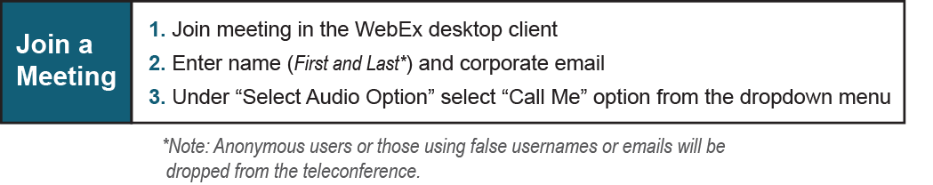
Provide feedback on the progress of this group: Facilitator Feedback Form
Visit learn.pjm.com, an easy-to-understand resource about the power industry and PJM’s role.

