DER Ride Through Task Force
PJM Conference and Training Center
January 15, 2019
9:00 a.m. – 3:00 p.m. EPT

Administration (9:00-9:15)
Welcome, review of Anti-Trust Policy, Code of Conduct, Media Participation Policy and roll call.

Education (9:15-12:00)
Problem Statement and Charge Document Review
Mr. Emanuel Bernabeu, PJM, will review the Problem Statement and Issue Charge for the DER Ride Through Task Force.
PJM Concern/Transmission Education/Workshop Summary
Mr. Andrew Levitt will present background on DER Ride Through, the concerns of DER Ride Through from a transmission operator perspective, and give a summary of previous DER workshops.
PJM 2031 DER Trip and Ride Through Impact Study
Ms. Christina Catalano will present PJM plans for a dynamic power flow simulation to study the impact of widespread fault-triggered DER tripping on PJM. The study will be performed with input from relevant utilities.
Dominion Arc Flash Study
Mr. Jonathan Deverick, Dominion, will present about Dominion’s Arc Flash Study.
Distribution Side Perspective on DER Ride Through
Mr. Mamadou Diong, Dominion, will give perspective from the distribution side on DER Ride Through.

CBIR Process (1:00-2:30)
CBIR Process Overview
Ms. Janell Fabiano, PJM, will present an overview of the CBIR Process.
Matrix Review
Ms. Susan McGill will review the initial matrix.
Workplan Review
Ms. Susan McGill will review the workplan.

Future Agenda Items (2:30-3:00)
Participants will have the opportunity to request the addition of any new items to the agenda of a future meeting

Future Meeting Dates
February 12, 2019 | 9:00 a.m. | PJM Conference & Training Center/ WebEx
March 13, 2019 | 9:00 a.m. | PJM Conference & Training Center/ WebEx
April 02, 2019 | 9:00 a.m. | PJM Conference & Training Center/ WebEx
April 23, 2019 | 9:00 a.m. | PJM Conference & Training Center/ WebEx
Author: Jonathan Thompson

Antitrust:
You may not discuss any topics that violate, or that might appear to violate, the antitrust laws including but not limited to agreements between or among competitors regarding prices, bid and offer practices, availability of service, product design, terms of sale, division of markets, allocation of customers or any other activity that might unreasonably restrain competition. If any of these items are discussed the chair will re-direct the conversation. If the conversation still persists, parties will be asked to leave the meeting or the meeting will be adjourned.

Code of Conduct:
As a mandatory condition of attendance at today's meeting, attendees agree to adhere to the PJM Code of Conduct as detailed in PJM Manual M-34 section 4.5, including, but not limited to, participants' responsibilities and rules regarding the dissemination of meeting discussion and materials.

Public Meetings/Media Participation:
Unless otherwise noted, PJM stakeholder meetings are open to the public and to members of the media. Members of the media are asked to announce their attendance at all PJM stakeholder meetings at the beginning of the meeting or at the point they join a meeting already in progress. Members of the Media are reminded that speakers at PJM meetings cannot be quoted without explicit permission from the speaker. PJM Members are reminded that "detailed transcriptional meeting notes" and white board notes from "brainstorming sessions" shall not be disseminated. Stakeholders are also not allowed to create audio, video or online recordings of PJM meetings. PJM may create audio, video or online recordings of stakeholder meetings for internal and training purposes, and your participation at such meetings indicates your consent to the same.
Participant Identification in WebEx:
When logging into the WebEx desktop client, please enter your real first and last name as well as a valid email address. Be sure to select the “call me” option.
PJM support staff continuously monitors WebEx connections during stakeholder meetings. Anonymous users or those using false usernames or emails will be dropped from the teleconference.



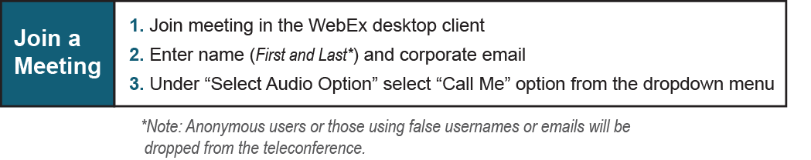

Provide feedback on the progress of this group: Facilitator Feedback Form
Visit learn.pjm.com, an easy-to-understand resource about the power industry and PJM’s role.

