Capacity Capability Senior Task Force
WebEx
April 7, 2020
9:00 a.m. – 4:00 p.m. EPT

Administration (9:00-9:05)
- Ms. Jaclynn Lukach, will provide welcome, announcements, and review of the Antitrust, Code of Conduct, and Public Meetings/Media Participation Guidelines Text.

Task Force Initiation (09:05-09:30)
- Mr. Andrew Levitt, PJM will lead a review of the Capacity Capability Senior Task Force Problem Statement and Issue Charge approved by the Markets & Reliability Committee at its March 26, 2020 meeting.
- Ms. Melissa Pilong will lead a discussion of the work plan and meeting schedule for CCSTF. An overview of how to sign up for the roster and email distribution list will also be provided.

Education & Next Steps (9:30 – 3:50)
- Dr. Patricio Rocha Garrido, PJM, will discuss the purpose, principles, and mechanics of Effective Load Carrying Capability (ELCC).
- Mr. Andrew Levitt, PJM will provide an overview of the ELCC methods and rules being applied in other ISOs and RTOs.
- Mr. Jerry Bell, PJM, and Mr. Bernie O’Hara, PJM, will review the current rules for:
  - Procedures for determination of capability, for new and existing resources, relationship of capability determinations and Capacity Interconnection Rights, and ongoing implications of and timing for capability determinations for a given delivery year.
  - Capacity Interconnection Right (CIR) transfers
  - Ms. Melissa Pilong, PJM, will engage stakeholders in a discussion on next steps within the CBIR process.
Break for Lunch (12:30-1:00)

Future Agenda Items (3:50-4:00)
- Ms. Jaclynn Lukach, PJM, will review meeting action items and discuss future agenda items.

Future Meeting Dates
April 27, 2020 | 9am – 4pm | Teleconference
May 2020 | TBD | Teleconference
June 22, 2020 | 9am – 4pm | Teleconference
July 10, 2020 | 9am – 4pm | Teleconference
July 28, 2020 | 9am – 4pm | Teleconference
August 17, 2020 | 9pm – 4pm | Teleconference
September 11, 2020 | 9am – 12pm | Teleconference
September 24, 2020 | 9am – 4pm | Teleconference
October 14, 2020 | 9am – 4pm | Teleconference

Author: Jaclynn Lukach

Antitrust:
You may not discuss any topics that violate, or that might appear to violate, the antitrust laws including but not limited to agreements between or among competitors regarding prices, bid and offer practices, availability of service, product design, terms of sale, division of markets, allocation of customers or any other activity that might unreasonably restrain competition. If any of these items are discussed the chair will re-direct the conversation. If the conversation still persists, parties will be asked to leave the meeting or the meeting will be adjourned.

Code of Conduct:
As a mandatory condition of attendance at today's meeting, attendees agree to adhere to the PJM Code of Conduct as detailed in PJM Manual M-34 section 4.5, including, but not limited to, participants' responsibilities and rules regarding the dissemination of meeting discussion and materials.

Public Meetings/Media Participation:
Unless otherwise noted, PJM stakeholder meetings are open to the public and to members of the media. Members of the media are asked to announce their attendance at all PJM stakeholder meetings at the beginning of the meeting or at the point they join a meeting already in progress. Members of the Media are reminded that speakers at PJM meetings cannot be quoted without explicit permission from the speaker. PJM Members are reminded that "detailed transcriptional meeting notes" and white board notes from "brainstorming sessions" shall not be disseminated. Stakeholders are also not allowed to create audio, video or online recordings of PJM meetings. PJM may create audio, video or online recordings of stakeholder meetings for internal and training purposes, and your participation at such meetings indicates your consent to the same.
Participant Identification in WebEx:
When logging into the WebEx desktop client, please enter your real first and last name as well as a valid email address. Be sure to select the “call me” option.
PJM support staff continuously monitors WebEx connections during stakeholder meetings. Anonymous users or those using false usernames or emails will be dropped from the teleconference.

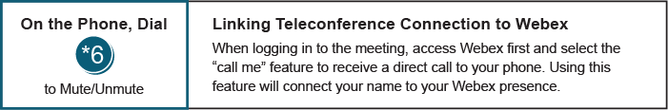

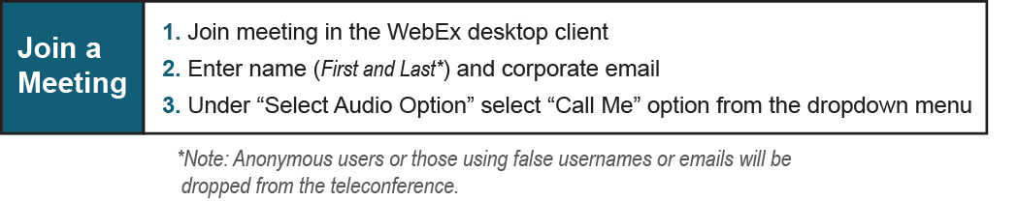
Provide feedback on the progress of this group: Facilitator Feedback Form
Visit learn.pjm.com, an easy-to-understand resource about the power industry and PJM’s role.

