Agenda
PJM General Session
Resource Adequacy and the Capacity Market: Framing the Future
Via WebEx
September 9, 2020
9:30-11:30 AM
9:30 a.m. | Welcome  Steve Lieberman, Chair, Members Committee  Manu Asthana, President and CEO, PJM Interconnection
9:35 a.m. | Keynote: The Public Policy Perspective  The Honorable Jay Robert “JB” Pritzker, Governor of Illinois
9:55 a.m.  10:10 a.m. | The Investment Picture  Stephen Byrd, ‎Head of North American Equity Research, Power/Utilities and Clean Tech, Morgan Stanley
9:55 a.m.  10:10 a.m. | Panel Discussion  Panel moderated by Stu Bresler, Sr. VP, Market Services, PJM
9:55 a.m.  10:10 a.m. | Gina McCarthy, ‎President and CEO, Natural Resources Defense Council | Todd Snitchler, President and CEO, Electric Power Supply Association
9:55 a.m.  10:10 a.m. | Travis Fisher, President and CEO, Electricity Consumers Resource Council | Matthew Crozat, ‎Sr. Dir, Policy Development, Nuclear Energy Institute
9:55 a.m.  10:10 a.m. | James Maiz, Partner, Rockland Capital
11:25 a.m. | Closing Remarks  Dr. Ake Almgren, Chair, PJM Board of Managers

Anti-trust:
You may not discuss any topics that violate, or that might appear to violate, the antitrust laws including but not limited to agreements between or among competitors regarding prices, bid and offer practices, availability of service, product design, terms of sale, division of markets, allocation of customers or any other activity that might unreasonably restrain competition. If any of these items are discussed the chair will re-direct the conversation. If the conversation still persists, parties will be asked to leave the meeting or the meeting will be adjourned.

Code of Conduct:
As a mandatory condition of attendance at today's meeting, attendees agree to adhere to the PJM Code of Conduct as detailed in PJM Manual M-34 section 4.5, including, but not limited to, participants' responsibilities and rules regarding the dissemination of meeting discussion and materials.

Public Meetings/Media Participation:
Unless otherwise noted, PJM stakeholder meetings are open to the public and to members of the media. Members of the media are asked to announce their attendance at all PJM stakeholder meetings at the beginning of the meeting or at the point they join a meeting already in progress. Members of the Media are reminded that speakers at PJM meetings cannot be quoted without explicit permission from the speaker. PJM Members are reminded that "detailed transcriptional meeting notes" and white board notes from "brainstorming sessions" shall not be disseminated. Stakeholders are also not allowed to create audio, video or online recordings of PJM meetings. PJM may create audio, video or online recordings of stakeholder meetings for internal and training purposes, and your participation at such meetings indicates your consent to the same.

Summary & Biographies
This General Session is designed to engage in discussion regarding resource adequacy in the PJM footprint. More specifically, this session will discuss the capacity market and any appropriate adaptations that could be needed to meet an ever-evolving resource mix and policy landscape. Now is an opportune time for this discussion given the discourse in many forums concerning future resource trends resulting from environmental and other state public policies and the longer-term impacts on the ability for resources to effectively participate in the capacity market.

THE HONORABLE JAY ROBERT “JB” PRITZKER
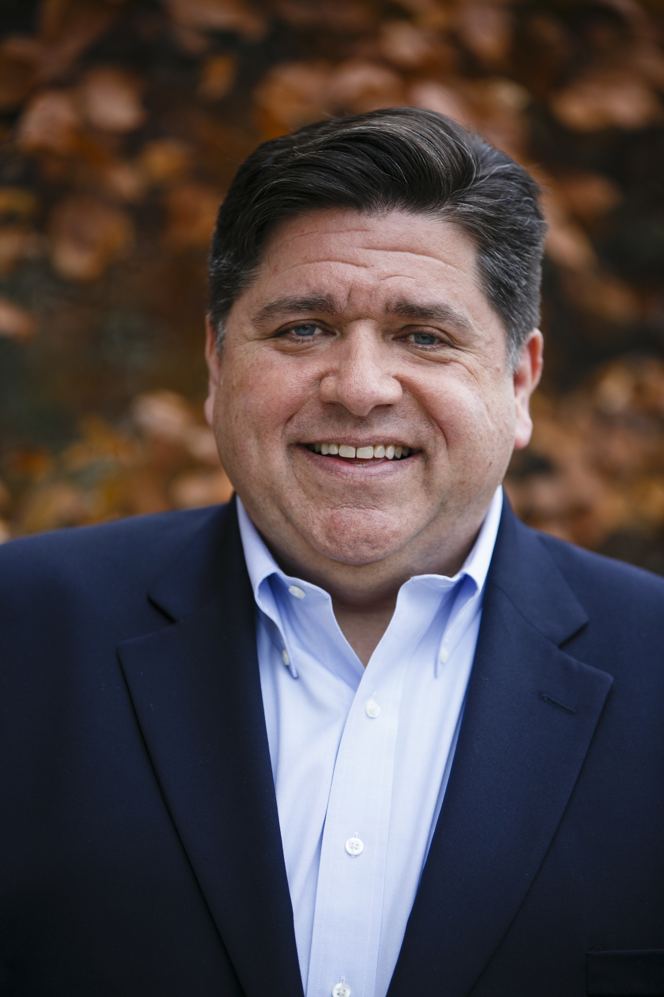
Governor JB Pritzker was sworn in as the 43rd governor of the state of Illinois on January 14, 2019 and won election with the largest margin of victory over a sitting governor in more than a century.
After taking the oath of office, Governor Pritzker immediately began working with Democrats and Republicans to accomplish one of the most ambitious and consequential legislative agendas in state history. During his first session, the governor passed a balanced budget with a bipartisan majority, making historic investments in education and human services, while restoring fiscal stability to Illinois. The governor also won bipartisan passage for legalization of adult-use recreational cannabis and for Rebuild Illinois, the largest investment in state history to upgrade roads, bridges, rail, broadband, and universities in every corner of the state.
The governor took bold action, putting state government back on the side of working families by creating hundreds of thousands of jobs, raising the minimum wage to a living wage, making college more affordable for nearly 10,000 additional students, and advancing equal pay for women.
A national leader in early childhood education for over 20 years and having organized President Obama’s White House Summit on Early Childhood Education, Governor Pritzker this year made childcare and preschool more affordable in Illinois for tens of thousands more families. He also partnered with the Greater Chicago Food Depository and Share our Strength to fight child poverty by expanding school breakfast programs in low income school districts across our state.
Before becoming governor, Pritzker founded 1871, the non-profit small business incubator in Chicago that has helped entrepreneurs create more than 11,000 jobs and more than 1,000 new companies. Since the creation of 1871, Chicago has been named one of the top ten technology startup hubs in the world, and 1871 was named the best incubator in the world. As governor, he has expanded support for new business incubators and cut taxes for hundreds of thousands of small businesses while incentivizing job creation and innovation. He also extended research and development tax credits to help manufacturing workers and businesses thrive, and he worked with the business community to create apprenticeship tax credits to promote job training.
The descendant of refugees, Governor Pritzker believes our state and our nation should welcome and protect its immigrant families and that we must fight against the wave of intolerance that has risen in recent years. Before becoming governor, he led the creation of the Illinois Holocaust Museum and Education Center, a nationally recognized institution where hundreds of thousands of students, teachers, police officers and others learn to fight bigotry and hatred. As governor, he has built the most diverse cabinet and governor’s office in Illinois history.
Governor Pritzker and First Lady MK Pritzker have been married for more than a quarter century, and they are the proud parents of two children.

STEPHEN BYRD


Managing Director, Power & Utilities and Clean Energy
Stephen.Byrd@morganstanley.com, (212) 761-3865
Stephen Byrd is a Managing Director and head of Morgan Stanley's North American Research for the Power & Utilities, Clean Energy and Midstream industries. Prior to joining Morgan Stanley Research, Stephen was head of Corporate Strategy at NRG Energy, a Fortune 500 power generation and renewable energy development company. Before that, he held a number of executive positions, including CEO of an energy storage company; senior vice president at PSEG, a Fortune 200 power company, where he was in charge of Treasury, Finance, Corporate Planning and Strategy; president of PSEG Energy Holdings, a business unit of PSEG; and investment banker for over 8 years in Morgan Stanley's Power & Utilities Group.
Stephen was named #2 in Alternative Energy and Runner-Up in Utilities in the 2019 Institutional Investor surveys. He has a JD and an MBA from the University of Virginia, and a BBA from the College of William and Mary. He is a member of the New York Bar.

FREDERICK S. BRESLER III

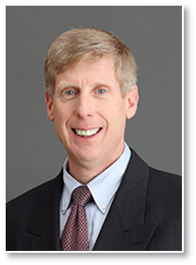
Senior Vice President – Market Services, PJM Interconnection
Frederick S. “Stu” Bresler, Senior Vice President – Market Services, is responsible for all aspects of PJM’s market functions. Mr. Bresler’s responsibilities cover all of the markets operated by PJM, including those for capacity, Day-Ahead and Real-Time Energy, ancillary services, Financial Transmission Rights and demand response operations. Mr. Bresler is responsible for the continued evolution of PJM’s markets, including the integration of renewable resources and the development of analytics around the performance of those markets.
Mr. Bresler has been involved with bulk power system operations and the development and implementation of electricity markets for capacity, energy, transmission rights and ancillary services for over 20 years. Mr. Bresler spent the first seven years of his career at PJM in system operations, directly supporting dispatch through day-to-day transmission and generation analysis. He then was also responsible for the development and implementation of PJM’s demand response programs, as well as the systems and market design development necessary to support the expansion of the PJM markets. He led the development of mechanisms by which PJM’s operations and markets are coordinated with those of surrounding balancing authorities and regional transmission organizations.
Mr. Bresler earned a Bachelor of Science in electrical engineering and a Master of Management in business administration from The Pennsylvania State University. He is a licensed professional engineer in the state of Pennsylvania.
Mr. Bresler is chair of the board of PJM Connext, Inc., a PJM subsidiary. Mr. Bresler is also chair of the board of APEx (the Association of Power Exchanges), an international organization of electricity and gas market operators, and is a member of the board of directors of the North American Energy Standards Board and Habitat for Humanity of Chester County. He is also on the External Advisory Board for the Department of Energy and Mineral Engineering in the Penn State College of Earth and Mineral Sciences.

GINA MCCARTHY

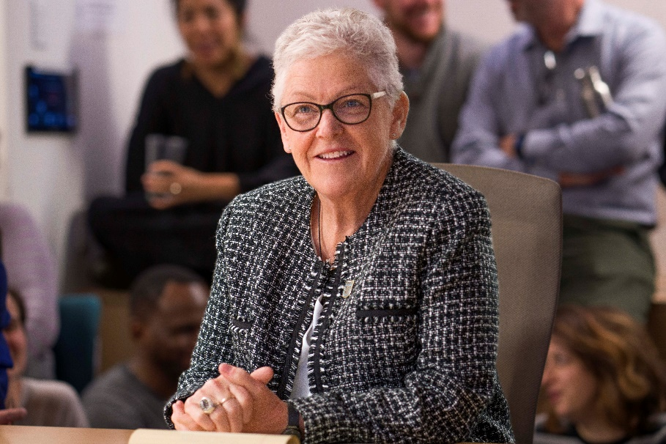
President & Chief Executive Officer, NRDC
Gina McCarthy became the president and chief executive officer of NRDC in January 2020, leading more than 700 attorneys, scientists, advocates, and policy experts that make NRDC one of the country’s most effective environmental action organizations. McCarthy has been a leading advocate for smart, successful strategies to protect public health and the environment for more than 30 years.
McCarthy served as the 13th administrator of the U.S. Environmental Protection Agency and as assistant administrator for the Office of Air and Radiation under President Obama. Her leadership led to significant federal, state, and local actions on critical issues related to the environment, economy, energy, and transportation. McCarthy ushered in a paradigm shift in national environmental policy, which expressly linked it to global public health. She led initiatives that cut air pollution, protected water resources, strengthened chemical safety, and reduced greenhouse gases to protect more communities from negative health impacts. McCarthy signed the Clean Power Plan, which set the first national standards for reducing carbon emissions from existing power plants, underscoring the country’s commitment to domestic climate action and spurring international efforts that helped secure the Paris Agreement.
As assistant administrator, McCarthy strengthened collaborative efforts with state environmental and public health agencies and organizations across the United States to identify and reduce threats to human health from harmful air and carbon pollution by updating health- and technology-based emissions standards, establishing greenhouse gas standards for cars and trucks, promoting energy efficiency and alternative fuels, and mitigating harmful exposures to indoor air pollution.
At the state level, McCarthy served as commissioner of the Connecticut Department of Environmental Protection, deputy secretary of the Massachusetts Office of Commonwealth Development, and undersecretary of policy for the Massachusetts Executive Office of Environmental Affairs. In Connecticut, she was instrumental in developing the Regional Greenhouse Gas Initiative, a multi-state effort to reduce emissions contributing to global warming, which has spurred economic growth, improved public health, decreased energy demand, and helped mitigate electricity price increases across the region. In Massachusetts, McCarthy advised five governors on environmental affairs, worked at the state and local levels on critical environmental issues, and coordinated policies on economic growth, energy, transportation, and the environment.
At the Harvard T.H. Chan School of Public Health, McCarthy was a professor of the practice of public health in the Department of Environmental Health and currently chair of the board of advisors at the Harvard Center for Climate, Health, and the Global Environment (C-CHANGE). She also serves as a member of the boards of the Energy Foundation and Ceres.
McCarthy holds a master's degree in environmental health engineering and planning and policy from Tufts University and a bachelor's in social anthropology from University of Massachusetts at Boston.

TODD SNITCHLER

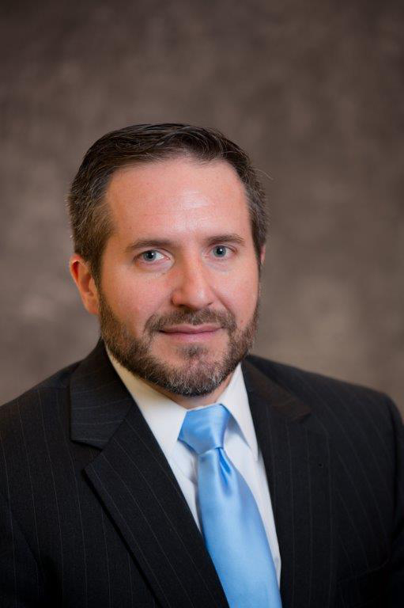
President & CEO, Electric Power Supply Association
Todd Snitchler is the president & CEO of the Electric Power Supply Association (EPSA). EPSA represents companies that own competitive power generation assets and advocates for policies that focus on achieving and maintaining well-functioning and properly regulated competitive wholesale electricity markets.
Prior to joining EPSA, Todd served as the vice president of market development at the American Petroleum Institute where he worked with industry, government, and customer stakeholders to promote increased demand for and continued availability of our nation’s abundant and clean natural gas resources.
Prior to that, Mr. Snitchler was a principal for Vorys Advisors, LLC in Ohio where he led government affairs efforts in the energy and utility space, representing competitive suppliers and independent power producers and developers. In that role, he established strong relationships in Ohio and nationally with policy makers and industry participants supportive of competitive markets.
Mr. Snitchler previously served as chairman of both the Public Utilities Commission of Ohio and the Ohio Power Siting Board. He was elected twice to represent the 50th House District in Stark County, Ohio.
Mr. Snitchler has published on numerous topics including the benefits of competitive energy markets; cyber security issues; electricity deregulation challenges; and the role of the federal Environmental Protection Agency. Mr. Snitchler received his J.D. from the University of Akron School of Law and his B.A. from Grove City College.

Travis Fisher

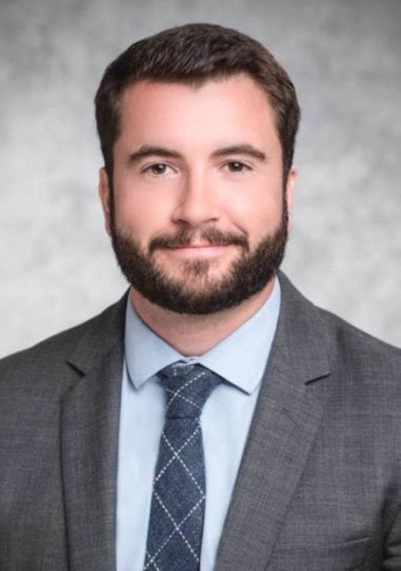
President & CEO, Electricity Consumers Resource Council
Travis Fisher is the President & CEO of the Electricity Consumers Resource Council (ELCON). ELCON is a Washington, DC-based national association representing large industrial consumers of electricity. ELCON’s multi-national member companies own and operate major manufacturing facilities throughout the United States and in foreign markets. They produce a wide range of products from virtually every segment of the manufacturing community. Many ELCON members also cogenerate steam/thermal energy and electricity.
As President & CEO of ELCON, Fisher actively advocates for electricity consumers before the Federal Energy Regulatory Commission (FERC), the North American Electric Reliability Corporation (NERC), the Department of Energy (DOE), and Congress. He also routinely speaks at conferences and drives the development of economically sound electricity policy. Fisher was first published in the journal of the US Association for Energy Economics in 2012 and has remained active in academic discussions of electricity policy. He presently serves on the Advisory Committee of the Future Power Markets Forum, a project of Columbia University and Johns Hopkins University.
Fisher has over 15 years of experience in energy policy. Before joining ELCON in April 2020, he served as Economic Advisor to FERC Commissioner Bernard L. McNamee from December 2018 until March 2020. He also held several roles at FERC in 2018 under the leadership of former Chairman Kevin J. McIntyre.
In January 2017, after serving on the Presidential Transition Teams at FERC and DOE, Fisher joined the DOE as a Senior Advisor in the Loan Programs Office and the Office of Electricity Delivery and Energy Reliability. At the DOE, he was responsible for leading the Department’s efforts on the Staff Report to the Secretary on Electricity Markets and Reliability.
Prior to joining DOE, Fisher was an economist at the Institute for Energy Research, where he oversaw and expanded the think tank’s research on electricity markets, FERC, and grid reliability. And prior to that, he served as a staff economist at FERC for seven years in the Office of Energy Market Regulation.
A native of North Carolina, Fisher holds a bachelor’s and a master’s degree in economics from North Carolina State University. He lives in Washington, DC with his wife and son.

MATTHEW P. CROZAT

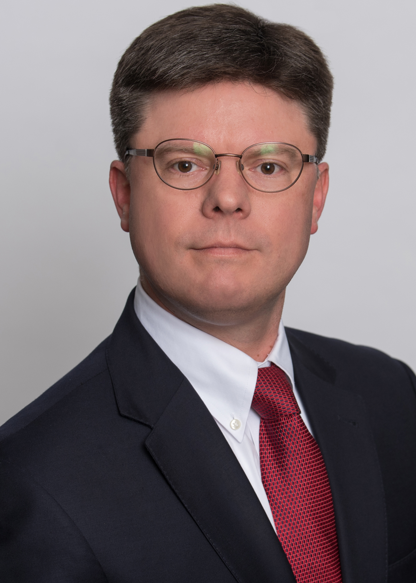
Senior Director, Strategy and Policy Development, Nuclear Energy Institute
Matt Crozat a Senior Director for Strategy and Policy Development and the Nuclear Energy Institute. He is responsible for directing NEI efforts to identify policy initiatives that will improve economic viability of operating plants and enhance prospects for new plant construction. Mr. Crozat examines market operations and proposed policies to assess their impact on nuclear energy. He also oversees analyses of nuclear industry cost performance and trends. Before joining NEI in 2015, Mr. Crozat was a Senior Policy Advisor in the Office of Nuclear Energy at the U.S. Department of Energy. Mr. Crozat is recognized as an international expert on nuclear energy economic issues. He served co-chair of the Working Party on Nuclear Energy Economics at the Nuclear Energy Agency of the OECD for over ten years. He holds an M.A. from Cornell University and a B.A. from Tulane University.

JAMES MAIZ

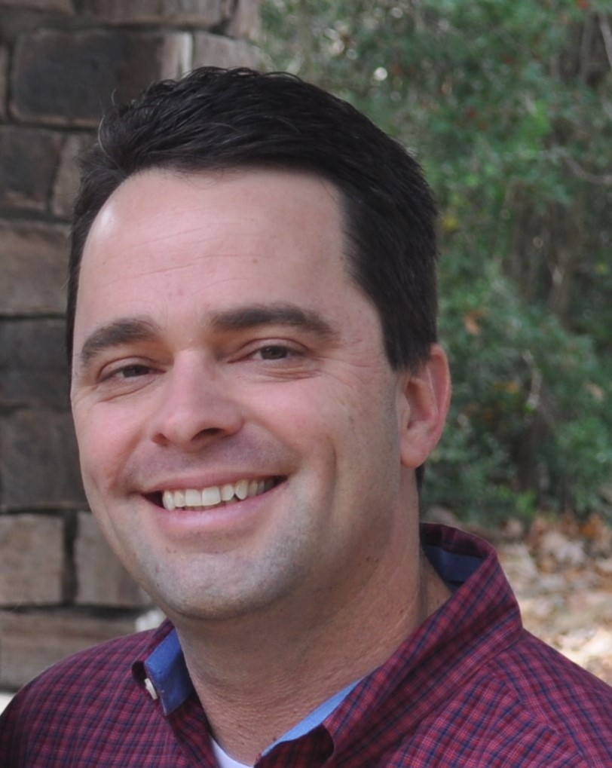
Partner, Rockland Capital
Mr. Maiz has been a lead investment professional with Rockland Capital, a private equity firm specializing in independent power, since early 2003 and is on the Investment Committee. He is responsible for the origination, evaluation and closing of Rockland acquisitions and has taken the lead on the commercial management of several Rockland portfolio companies.
Mr. Maiz has worked in the domestic energy industry since 1998. Mr. Maiz has both technical and commercial experience. Prior to joining Rockland, his focus was on executing acquisitions, restructurings and divestitures of independent power projects at El Paso Merchant Energy, where he led and supported several successful transactions. Prior to El Paso, Mr. Maiz spent eight years with the Royal Dutch/Shell group of companies. The commercial roles he held included both power plant development at Coral Energy and the acquisition and development of domestic natural gas properties at Shell Exploration and Production Company.
Mr. Maiz holds an MBA from Tulane University and a BS in Chemical Engineering from the University of South Florida.

