Tech Change Forum
PJM Conference and Training Center
March 14, 2022
2:30 p.m. – 4:30 p.m. EPT

Administration (2:30-2:35)
Welcome & Ground Rules
- Webex Name Display Instructions

Important Implementation Dates Review (2:35-2:40)
Important upcoming implementation dates will be reviewed
- Foluso Afelumo, PJM, will highlight important upcoming 2022 Q1 and Q2 implementation dates

Initiative Roadmap Updates (2:40-2:50)
- Initiatives
- PJM Cyber Security update [Steve McElwee]
- Retiring Use of Weak Encryption [Zeenath Fernandes]
- TO Planner [Bhavana Gagrani]
- PJM Cloud Training Environment [Jeff Falciani]

Product Roadmap Updates (2:50-3:50)
4. Roadmaps for individual products will be presented
A. eDART Roadmap [Chidi Ofoegbu]
- Account Manager, Bulletin Board, Data Viewer, Messages, Resource Tracker, Tools Home and Voting Roadmaps [Bhavana Gagrani]
- Tools Security Roadmap [Sunil Rachakonda]
- PJM.com Roadmap [Tawnya Luna]
- FTP Availability in Chrome [Tawnya Luna]
- Communities Roadmap [Monica Burkett]
- Networks Roadmap [Keith Rainer]
- DR Hub, Power Meter, InSchedule and Billing Line Item Transfer Roadmaps [Gerry McNamee]
- Markets Gateway Roadmap [Matt Pennell]
- Data Miner Roadmap [Swapna Kanury]

General Updates (3:50-3:55)
5. General updates will be presented
A. General Updates and Recent Production Issue Review [Foluso Afelumo]

Product Design Review & Feature Demonstrations (3:55-4:05)
6. Demonstrations (This educational topic is being recorded at the request of stakeholders. It will be posted)
- Membership Management Community

Product Roadmap Informational Detail Only (4:05-4:10)
7. Roadmaps for individual products not presented
A. Planning Center (Gen Model, Queue Point, Competitive Planner and TO Planner) and eGADS Roadmaps [Ian Mundell]
B. Secure Share [Kevin Hilyard]
C. Initial Margin Historical Simulation Project [Eric Endress]
D. Product Roadmap – No Updates [Foluso Afelumo]

General Feedback and Future Forum Topics (4:10)

Future Meeting Dates
Thursday, April 21, 2022 | 1:00 p.m. - 3:00 p.m. | WebEx
Monday, May 16, 2022 | 2:30 p.m. - 4:30 p.m. | WebEx
Tuesday, June 14, 2022 | 2:30 p.m. - 4:30 p.m. | WebEx
Monday, July 11, 2022 | 1:00 p.m. - 3:00 p.m. | WebEx
Tuesday, August 16, 2022 | 1:00 p.m. - 3:00 p.m. | WebEx
Wednesday, September 1, 2022 | 1:00 p.m. - 3:00 p.m. | WebEx
Tuesday, October 18, 2022 | 2:30 p.m. - 4:30 p.m. | WebEx
Tuesday, November 22, 2022 | 1:00 p.m. - 3:00 p.m. | WebEx
Tuesday, December 13, 2022 | 2:30 p.m. - 4:30 p.m. | WebEx

Author: Risa Holland

Antitrust:
You may not discuss any topics that violate, or that might appear to violate, the antitrust laws including but not limited to agreements between or among competitors regarding prices, bid and offer practices, availability of service, product design, terms of sale, division of markets, allocation of customers or any other activity that might unreasonably restrain competition. If any of these items are discussed the chair will re-direct the conversation. If the conversation still persists, parties will be asked to leave the meeting or the meeting will be adjourned.

Code of Conduct:
As a mandatory condition of attendance at today's meeting, attendees agree to adhere to the PJM Code of Conduct as detailed in PJM Manual M-34 section 4.5, including, but not limited to, participants' responsibilities and rules regarding the dissemination of meeting discussion and materials.

Public Meetings/Media Participation:
Unless otherwise noted, PJM stakeholder meetings are open to the public and to members of the media. Members of the media are asked to announce their attendance at all PJM stakeholder meetings at the beginning of the meeting or at the point they join a meeting already in progress. Members of the Media are reminded that speakers at PJM meetings cannot be quoted without explicit permission from the speaker. PJM Members are reminded that "detailed transcriptional meeting notes" and white board notes from "brainstorming sessions" shall not be disseminated. Stakeholders are also not allowed to create audio, video or online recordings of PJM meetings. PJM may create audio, video or online recordings of stakeholder meetings for internal and training purposes, and your participation at such meetings indicates your consent to the same.
Participant Identification in WebEx:
When logging into the WebEx desktop client, please enter your real first and last name as well as a valid email address. Be sure to select the “call me” option.
PJM support staff continuously monitors WebEx connections during stakeholder meetings. Anonymous users or those using false usernames or emails will be dropped from the teleconference.



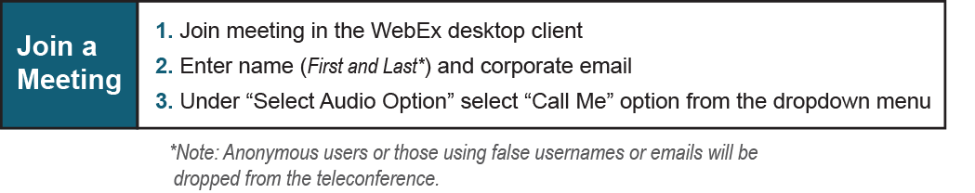

Provide feedback on the progress of this group: Facilitator Feedback Form
Visit learn.pjm.com, an easy-to-understand resource about the power industry and PJM’s role.

