Sub-regional RTEP Committee, Western area
Via teleconference
Wednesday, December 18, 2019
9:00 a.m. – 1:00 p.m. EPT

Administration
- Welcome, Announcements and Review of the Anti-trust, Code of Conduct, and Media Participation Guidelines
Review Agenda for this meeting
- Calendar for 2020 Meetings

Local Planning Assumptions
- AEP Local Planning Assumptions
AEP will present their 2020 Local Planning Assumptions
- AEP Pre-1930s Tower Lines
AEP will present their program for addressing needs on Pre-1930s Tower Lines.
- AMPT Local Planning Assumptions
AMPT will present their 2020 Local Planning Assumptions
- Exelon Local Planning Assumptions
Exelon will present their 2020 Local Planning Assumptions
- DPL Local Planning Assumptions
DPL will present their 2020 Local Planning Assumptions
- DLC Local Planning Assumptions
DLC will present their 2020 Local Planning Assumptions
- DEOK Local Planning Assumptions
DEOK will present their 2020 Local Planning Assumptions
- EKPC Local Planning Assumptions
EKPC will present their 2020 Local Planning Assumptions
- First Energy Local Planning Assumptions
First Energy will present their 2020 Local Planning Assumptions
- ITC Local Planning Assumptions
ITC will present their 2020 Local Planning Assumptions
- OVEC Local Planning Assumptions
OVEC will present their 2020 Local Planning Assumptions
- RMU Local Planning Assumptions
RMU will present their 2020 Local Planning Assumptions

RTEP Updates
- Dayton Supplemental Projects
Dayton will present 1 system need, 1 potential solution and 1 update to an existing supplemental project.
- APS - Supplemental Projects
APS will present 2 system needs and 1 potential solution.
- AEP Supplemental Projects
AEP will present 2 system needs and 18 potential solutions.
- Reliability Analysis Update
PJM will present 4 baseline upgrades for first review and 4 for second review.

Informational Only
- M-3 Process Needs Status

Meeting Wrap Up
- Discussion and Comments Regarding the Conduct of the Meeting

Future Meeting Dates
January 17, 2020 | 9:00 a.m. – 12:00 p.m. | Teleconference
February, 21, 2020 | 9:00 a.m. – 12:00 p.m. | Teleconference
Match 19, 2020 | 1:00 p.m. – 4:00 p.m. | Teleconference
April 17, 2020 | 9:00 a.m. – 12:00 p.m. | Teleconference
May 22, 2020 | 9:00 a.m. – 12:00 p.m. | Teleconference
June 19, 2020 | 9:00 a.m. – 12:00 p.m. | Teleconference
July 17, 2020 | 9:00 a.m. – 12:00 p.m. | Teleconference
August 14, 2020 | 9:00 a.m. – 12:00 p.m. | Teleconference
September 11, 2020 | 9:00 a.m. – 12:00 p.m. | Teleconference
October 16, 2020 | 9:00 a.m. – 12:00 p.m. | Teleconference
November 20, 2020 | 9:00 a.m. – 12:00 p.m. | Teleconference
December 18, 2020 | 9:00 a.m. – 12:00 p.m. | In-Person & Teleconference

Author: Larry Farmer

Antitrust, Code of Conduct and WebEx Instructions
Antitrust:
You may not discuss any topics that violate, or that might appear to violate, the antitrust laws including but not limited to agreements between or among competitors regarding prices, bid and offer practices, availability of service, product design, terms of sale, division of markets, allocation of customers or any other activity that might unreasonably restrain competition. If any of these items are discussed the chair will re-direct the conversation. If the conversation still persists, parties will be asked to leave the meeting or the meeting will be adjourned.
Code of Conduct:
As a mandatory condition of attendance at today's meeting, attendees agree to adhere to the PJM Code of Conduct as detailed in PJM Manual M-34 section 4.5, including, but not limited to, participants' responsibilities and rules regarding the dissemination of meeting discussion and materials.
Public Meetings/Media Participation:
Unless otherwise noted, PJM stakeholder meetings are open to the public and to members of the media. Members of the media are asked to announce their attendance at all PJM stakeholder meetings at the beginning of the meeting or at the point they join a meeting already in progress. Members of the Media are reminded that speakers at PJM meetings cannot be quoted without explicit permission from the speaker. PJM Members are reminded that "detailed transcriptional meeting notes" and white board notes from "brainstorming sessions" shall not be disseminated. Stakeholders are also not allowed to create audio, video or online recordings of PJM meetings. PJM may create audio, video or online recordings of stakeholder meetings for internal and training purposes, and your participation at such meetings indicates your consent to the same.
Participant Identification in WebEx:
When logging into the WebEx desktop client, please enter your real first and last name as well as a valid email address. Be sure to select the “call me” option.
PJM support staff continuously monitors WebEx connections during stakeholder meetings. Anonymous users or those using false usernames or emails will be dropped from the teleconference.


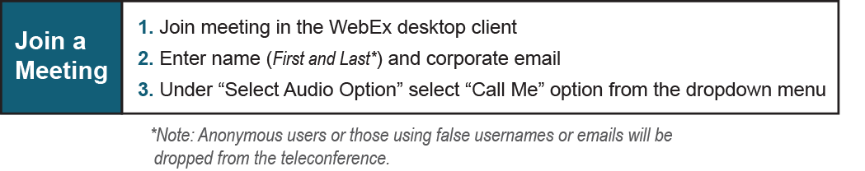
Provide feedback on the progress of this group: Facilitator Feedback Form
Visit learn.pjm.com, an easy-to-understand resource about the power industry and PJM’s role.

