December Planning Committee

**Teleconference / WebEx**

December 14, 2021

9:00 a.m. – 12:30 p.m. EPT

Administration (9:00 – 9:15)

1. Welcome, announcements and review of the Anti-trust, Code of Conduct, and Media Participation Guidelines.
2. Approve Planning Committee (PC) Agenda for this meeting.
3. Approve draft minutes from the November 2, 2021 PC meeting.

Endorsements (9:15 – 9:30)

1. Planning Committee Charter

David Souder, PJM, will review the Planning Committee Charter. No changes have been made to the Planning Committee Charter. The committee will be asked to endorse the Charter at today’s meeting.

First Reads (9:30 – 10:15)

1. Interconnection Process Reform

Jack Thomas, PJM, will provide a first read of the new interconnection process package(s) from the work done at the Interconnection Process Reform Task Force. The committee will be asked to vote on the package(s) at next month’s meeting.

Materials for task force can be found [here](https://www.pjm.com/committees-and-groups/task-forces/iprtf).

Informational Updates (10:15 – 12:30)

1. Generator Deliverability Proposal: Status and Next Steps

Jonathan Kern, PJM, will provide a generator deliverability proposal development timeline update.

1. Capacity Interconnection Rights for ELCC Resoures Update

Brian Chmielewski, PJM, will provide an update of the work done during the PC special session on Capacity Interconnection Rights (CIR) for ELCC Resources.

Materials for the special sessions can be found [here](https://www.pjm.com/committees-and-groups/committees/pc).

1. Preliminary 2022 Load Forecast

~~Andrew Gledhill~~ Tom Falin, PJM, will review the preliminary 2022 Load Forecast results.

1. PJM Rules on the Siting of New Load Behind the Meter of Existing Generation

Jeff Bastian, PJM, will provide an informational update on a posted Frequently Asked Questions document on PJM rules regarding the siting of new load directly behind the meter of an existing generation resource.

1. Transmission & Substation Subcommittee Update

Jay Liu, PJM, will provide an update on the Transmission & Substation Subcommittee (TSS) work activities through 2021.

1. Reliability Compliance Update  
   Becky Davis, PJM, will provide an update on the activities, issues and items of interest at NERC, SERC, and RF.

Informational Posting

Model Build Activity Update

* MMWG
  + Loadflow
    - PJM posted the 2022 summer study case to the SharePoint site
  + Dynamics
    - PJM is currently working on the second round of generator dynamic data
    - PJM is currently compiling all Transmission Owners dynamic device data
* RTEP
  + Loadflow
    - PJM will post the Trial 2 cases by December 27, 2021
  + Short Circuit
    - PJM will post the Trial 1 2024 case and associated files by January 15, 2022

PJM Interconnection Queue Status Update   
PJM has posted slides showing an update on the status of the PJM Interconnection Queues.

|  |  |  |  |  |
| --- | --- | --- | --- | --- |
| **Future Meeting Dates and Materials** | | | **Materials Due  to Secretary** | **Materials Published** |
| Date | Time | Meeting (Location) |
| Tuesday, December 14, 2021 | 9:00 a.m. – 12:00 p.m. | Planning Committee (WebEx) | Thursday, December 2, 2021 | Tuesday, December 7, 2021 |
| Tuesday, January 11, 2022 | 9:00 a.m. – 12:00 p.m. | Planning Committee (TBD) | Thursday, December 30, 2021 | Tuesday, January 4, 2022 |
| Tuesday, February 8, 2022 | 9:00 a.m. – 12:00 p.m. | Planning Committee (TBD) | Thursday, January 27, 2022 | Tuesday, February 1, 2022 |
| Tuesday, March 8, 2022 | 9:00 a.m. – 12:00 p.m. | Planning Committee (TBD) | Thursday, February 24, 2022 | Tuesday, March 1, 2022 |
| Tuesday, April 12, 2022 | 9:00 a.m. – 12:00 p.m. | Planning Committee (TBD) | Thursday, March 31, 2022 | Tuesday, April 5, 2022 |
| Tuesday, May 10, 2022 | 9:00 a.m. – 12:00 p.m. | Planning Committee (TBD) | Thursday, April 28, 2022 | Tuesday, May 3, 2022 |
| Tuesday, June 7, 2022 | 9:00 a.m. – 12:00 p.m. | Planning Committee (TBD) | Thursday, May 26, 2022 | Tuesday, May 31, 2022 |

Author: Molly Mooney

Antitrust:

You may not discuss any topics that violate, or that might appear to violate, the antitrust laws including but not limited to agreements between or among competitors regarding prices, bid and offer practices, availability of service, product design, terms of sale, division of markets, allocation of customers or any other activity that might unreasonably restrain competition. If any of these items are discussed the chair will re-direct the conversation. If the conversation still persists, parties will be asked to leave the meeting or the meeting will be adjourned.

Code of Conduct:

As a mandatory condition of attendance at today's meeting, attendees agree to adhere to the PJM Code of Conduct as detailed in PJM Manual M-34 section 4.5, including, but not limited to, participants' responsibilities and rules regarding the dissemination of meeting discussion and materials.

Public Meetings/Media Participation:

Unless otherwise noted, PJM stakeholder meetings are open to the public and to members of the media. Members of the media are asked to announce their attendance at all PJM stakeholder meetings at the beginning of the meeting or at the point they join a meeting already in progress. Members of the Media are reminded that speakers at PJM meetings cannot be quoted without explicit permission from the speaker. PJM Members are reminded that "detailed transcriptional meeting notes" and white board notes from "brainstorming sessions" shall not be disseminated. Stakeholders are also not allowed to create audio, video or online recordings of PJM meetings. PJM may create audio, video or online recordings of stakeholder meetings for internal and training purposes, and your participation at such meetings indicates your consent to the same.

Participant Identification in WebEx:

When logging into the WebEx desktop client, please enter your real first and last name as well as a valid email address. Be sure to select the “call me” option.

PJM support staff continuously monitors WebEx connections during stakeholder meetings. Anonymous users or those using false usernames or emails will be dropped from the teleconference.

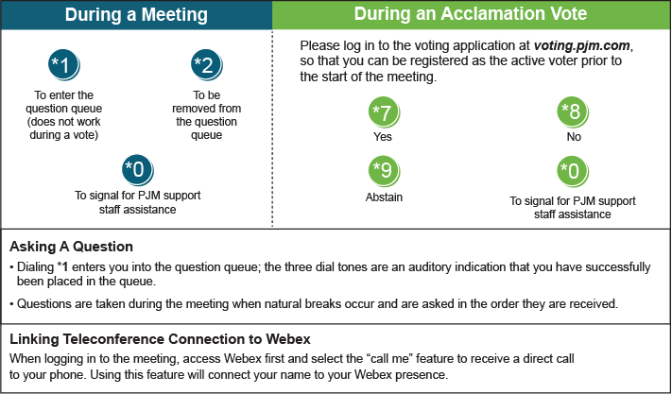

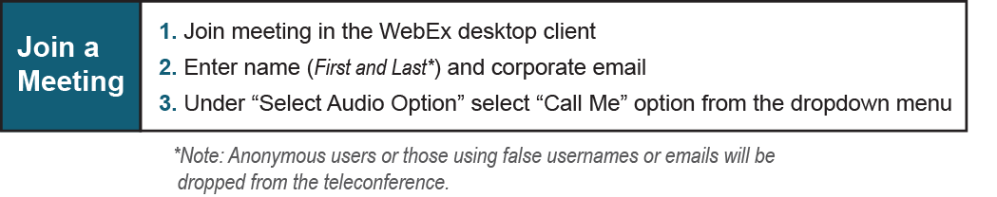

Provide feedback on the progress of this group: *Facilitator Feedback Form*   
Visit [*learn.pjm.com*](http://learn.pjm.com/), an easy-to-understand resource about the power industry and PJM’s role.