July Planning Committee

**Teleconference / WebEx**

July 13, 2021

9:00 a.m. – 12:00 p.m. EPT

Administration (9:00 – 9:20)

1. Welcome, announcements and review of the Anti-trust, Code of Conduct, and Media Participation Guidelines.
2. Approve Planning Committee (PC) Agenda for this meeting.
3. Approve draft minutes from the June 8, 2021 PC meeting.
4. Review of the PC Work Plan

Endorsements (9:20 – 10:20)

1. Manual 14A: New Services Request Process Update  
   Onyinye Caven, PJM, will provide a review of conforming Manual 14A language for the quick fix of close of queue date and application review timing changes. The committee will be asked to vote on the manual changes at today’s meeting.
2. Critical Infrastructure Stakeholder Oversight - Mitigation

Michael Herman, PJM, will review the Operating Agreement language associated with the approved Mitigation package. **The committee will be asked to vote on whether the amended draft Operating Agreement revisions accurately reflect the CISO Mitigation package (as contained in the matrix) which was endorsed by the PC at its February 2021 meeting at today’s meeting.**

First Reads (10:20 – 11:20)

1. Manual 20: Resource Adequacy Analysis  
   Patricio Rocha-Garrido, PJM, will provide a first read of a cover to cover review of Manual 20. The committee will be asked to vote on the manual changes at the August meeting.
2. Load Model Selection   
   Patricio Rocha-Garrido will present the results of the Load Model selection process for the 2021 Reserve Requirement Study. The committee will be requested to endorse this Load Model selection at the August meeting.

Informational Updates (11:20 – 12:00)

1. Capacity Interconnection Rights for ELCC Resoures Update

Brian Chmielewski, PJM, will provide an update on work being done during the PC special session on Capacity Interconnection Rights (CIR) for ELCC Resources.

Materials and upcoming meeting dates for special sessions can be found [here](https://www.pjm.com/committees-and-groups/committees/pc).

1. Interconnection Process Reform

Jack Thomas, PJM, will provide an update on the Interconnection Process Reform Task Force.

Materials and upcoming meeting dates for task force can be found [here](https://www.pjm.com/committees-and-groups/task-forces/iprtf).

1. Reliability Compliance Update  
   Becky Davis, PJM, will provide an update on the activities, issues and items of interest at NERC, SERC, and RF.
2. Designated Entity Agreements Update

Pauline Foley, PJM Legal, will provide an update regarding PJM’s use of the Designed Entity Agreements.

Informational Posting

Model Build Activity Update

2021 Series MMWG

* Powerflow
  + PowerTech will post the Trial 1 cases by July 16, 2021
  + Transmissions Owners will provide updates via idev to PJM by July 23, 2021
  + PJM will submit the Trial 1 updates to PowerTech by July 30, 2021
* Dynamics
  + PJM will send an email on July 12, 2021 requesting TO dynamic device and load models to be submitted by September 17, 2021

|  |  |  |  |  |
| --- | --- | --- | --- | --- |
| **Future Meeting Dates and Materials** | | | **Materials Due  to Secretary** | **Materials Published** |
| Date | Time | Meeting (Location) |
| Tuesday, July 13, 2021 | 9:00 a.m. – 12:00 p.m. | Planning Committee (WebEx) | Thursday, July 01, 2021 | Tuesday, July 06, 2021 |
| Monday, July 19, 2021 | 9:00 a.m. – 4:00 p.m. | Interconnection Process Reform Task Force (WebEx) | Friday, July 09, 2021 | Wednesday, July 14, 2021 |
| Thursday, July 22, 2021 | 9:00 a.m. – 12:00 p.m. | Special PC: CIR for ELCC Resources (WebEx) | Wednesday, July 14, 2021 | Monday, July 19, 2021 |
| Tuesday, August 10, 2021 | 9:00 a.m. – 12:00 p.m. | Planning Committee (WebEx) | Thursday, July 29, 2021 | Tuesday, August 03, 2021 |
| Friday, August 13, 2021 | 1:00 p.m. – 4:00 p.m. | Special PC: CIR for ELCC Resources (WebEx) | Thursday, August 05, 2021 | Tuesday, August 10, 2021 |
| Monday, August 23, 2021 | 9:00 a.m. – 4:00 p.m. | Interconnection Process Reform Task Force (WebEx) | Friday, August 13, 2021 | Wednesday, August 18, 2021 |
| Tuesday, August 31, 2021 | 9:00 a.m. – 12:00 p.m. | Planning Committee (WebEx) | Thursday, August 19, 2021 | Tuesday, August 24, 2021 |
| Tuesday, September 21, 2021 | 9:00 a.m. – 12:00 p.m. | Special PC: CIR for ELCC Resources (WebEx) | Tuesday, September 14, 2021 | Friday, September 17, 2021 |
| Tuesday, October 5, 2021 | 9:00 a.m. – 12:00 p.m. | Planning Committee (WebEx) | Thursday, September 23, 2021 | Tuesday, September 28, 2021 |
| Tuesday, November 2, 2021 | 9:00 a.m. – 12:00 p.m. | Planning Committee (WebEx) | Thursday, October 21, 2021 | Tuesday, October 26, 2021 |
| Tuesday, November 30, 2021 | 9:00 a.m. – 12:00 p.m. | Planning Committee (WebEx) | Thursday, November 18, 2021 | Tuesday, November 23, 2021 |

Author: Molly Mooney

Antitrust:

You may not discuss any topics that violate, or that might appear to violate, the antitrust laws including but not limited to agreements between or among competitors regarding prices, bid and offer practices, availability of service, product design, terms of sale, division of markets, allocation of customers or any other activity that might unreasonably restrain competition. If any of these items are discussed the chair will re-direct the conversation. If the conversation still persists, parties will be asked to leave the meeting or the meeting will be adjourned.

Code of Conduct:

As a mandatory condition of attendance at today's meeting, attendees agree to adhere to the PJM Code of Conduct as detailed in PJM Manual M-34 section 4.5, including, but not limited to, participants' responsibilities and rules regarding the dissemination of meeting discussion and materials.

Public Meetings/Media Participation:

Unless otherwise noted, PJM stakeholder meetings are open to the public and to members of the media. Members of the media are asked to announce their attendance at all PJM stakeholder meetings at the beginning of the meeting or at the point they join a meeting already in progress. Members of the Media are reminded that speakers at PJM meetings cannot be quoted without explicit permission from the speaker. PJM Members are reminded that "detailed transcriptional meeting notes" and white board notes from "brainstorming sessions" shall not be disseminated. Stakeholders are also not allowed to create audio, video or online recordings of PJM meetings. PJM may create audio, video or online recordings of stakeholder meetings for internal and training purposes, and your participation at such meetings indicates your consent to the same.

Participant Identification in WebEx:

When logging into the WebEx desktop client, please enter your real first and last name as well as a valid email address. Be sure to select the “call me” option.

PJM support staff continuously monitors WebEx connections during stakeholder meetings. Anonymous users or those using false usernames or emails will be dropped from the teleconference.

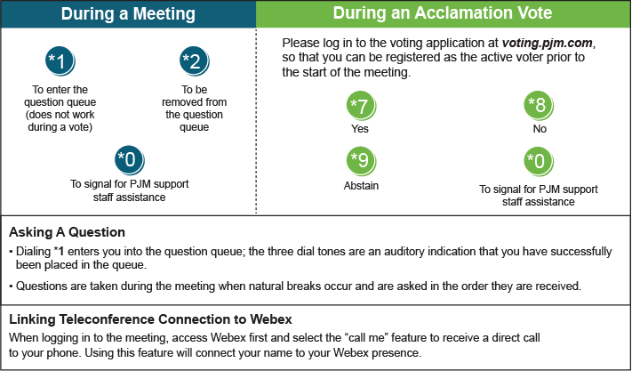

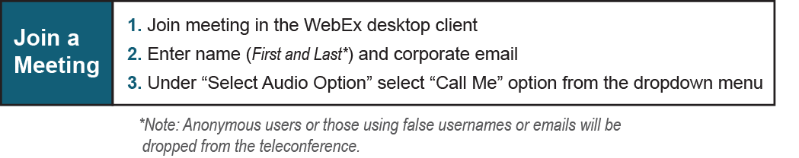

Provide feedback on the progress of this group: *Facilitator Feedback Form*   
Visit [*learn.pjm.com*](http://learn.pjm.com/), an easy-to-understand resource about the power industry and PJM’s role.