Planning Committee
PJM Conference and Training Center, Audubon, PA
May 4, 2017
9:30 a.m. – 12:15 p.m. [EPT]

Administration (9:30 – 9:35)
- Welcome, announcements and review of the Anti-trust, Code of Conduct, and Media Participation Guidelines. - Mr. Steve Herling
- Approve draft minutes from the April 13th, 2017 Planning Committing (PC) meeting.

Endorsements (9:35 – 9:50)
- PJM Manual 14A and Tariff Updates
Mr. Aaron Berner, PJM, will present updates to Manual 14A: Generation and Transmission Interconnection Process and the Tariff related to less than $5M cost allocation and the alternate queue. The committee will be asked to endorse these updates.

First Readings (9:50 – 10:35)
- PJM Manual 14F
Mr. Michael Herman, PJM, will present a first read of the draft PJM Manual 14F: Competitive Planning Process, including the decisional diagram. The committee will be asked to endorse this manual at its next meeting.
- Designated Entity Design Standards Task Force
Mr. Herman, PJM, will present the minimum design requirements document created by the DEDSTF. DEDSTF requirements must be followed for all proposals that will require the signing of a Designated Entity Agreement. The committee will be asked to endorse these updates at its next meeting.
- PJM Manual 14C
Ms. Sue Glatz, PJM, will present updates to Manual 14C: Generation and Transmission Interconnection Facility Construction. These updates are a result of aligning manual language with the work being completed through the Designated Entity Design Standards Taskforce. The committee will be asked to endorse these updates at its next meeting.
- IRM Study Assumptions Letter
Mr. Jason Quevada, PJM, will present the IRM study assumptions as developed in the Resource Adequacy Analysis Subcommittee. The committee will be asked to endorse the study assumptions at its next meeting.

- PJM Manual 20
Mr. Patricio Rocha-Garrido, PJM, will present updates to Manual 20: PJM Resource Adequacy Analysis regarding language describing Global Locational Deliverability Areas. The committee will be asked to endorse these updates at its next meeting.

Informational Updates (10:35 – 12:15)
- Winter Season Resource Adequacy and Capacity Requirements
Mr. Tom Falin, PJM, will provide an update on recent work related to the MRC problem statement regarding winter season resource adequacy and capacity requirements.
- RTEP Proposal Window Update
Mr. Herman will discuss 2017 RTEP Proposal Window implementation and communication enhancements.
- Multiregional Modeling Working Group and MOD-032 Update
Ms. Amber Thomas, PJM, will provide an update on the MMWG (Multiregional Modeling Working Group) and MOD-032.
- PJM Interconnection Queue Status Update
Ms. Lisa Krizenoskas, PJM, will provide an update on the status of PJM Interconnection Queues.
- NERC/RRO Update
Mr. Preston Walker, PJM, will provide an update on the activities, issues and items of interest at NERC, SERC, and RFC.
- PECO Remedial Action Scheme Retirement
Mr. Doug Dale, PECO, will present on the retirement of a Remedial Action Scheme at Linwood.

Informational Section
CETL Calculation Discussion Timeline
Slides are available under the May 4, 2017 Planning Committee materials which outline the anticipated schedule for discussions regarding the CETL Calculations.

Future Meeting Dates
June 8, 2017 | 9:30 a.m. | Planning Committee | PJM Conference and Training Center, Audubon, PA
July 13, 2017 | 9:30 a.m. | Planning Committee | PJM Conference and Training Center, Audubon, PA
August 10, 2017 | 9:30 a.m. | Planning Committee | PJM Conference and Training Center, Audubon, PA
September 14, 2017 | 9:30 a.m. | Planning Committee | PJM Conference and Training Center, Audubon, PA
October 12, 2017 | 9:30 a.m. | Planning Committee | PJM Conference and Training Center, Audubon, PA
November 9, 2017 | 9:30 a.m. | Planning Committee | PJM Conference and Training Center, Audubon, PA
December 14, 2017 | 9:30 a.m. | Planning Committee | PJM Conference and Training Center, Audubon, PA
Author: Bridgid Cummings

Anti-trust:
You may not discuss any topics that violate, or that might appear to violate, the antitrust laws including but not limited to agreements between or among competitors regarding prices, bid and offer practices, availability of service, product design, terms of sale, division of markets, allocation of customers or any other activity that might unreasonably restrain competition. If any of these items are discussed the chair will re-direct the conversation. If the conversation still persists, parties will be asked to leave the meeting or the meeting will be adjourned.

Code of Conduct:
As a mandatory condition of attendance at today's meeting, attendees agree to adhere to the PJM Code of Conduct as detailed in PJM Manual M-34 section 4.5, including, but not limited to, participants' responsibilities and rules regarding the dissemination of meeting discussion and materials.

Public Meetings/Media Participation:
Unless otherwise noted, PJM stakeholder meetings are open to the public and to members of the media. Members of the media are asked to announce their attendance at all PJM stakeholder meetings at the beginning of the meeting or at the point they join a meeting already in progress. Members of the Media are reminded that speakers at PJM meetings cannot be quoted without explicit permission from the speaker. PJM Members are reminded that "detailed transcriptional meeting notes" and white board notes from "brainstorming sessions" shall not be disseminated. Stakeholders are also not allowed to create audio, video or online recordings of PJM meetings.

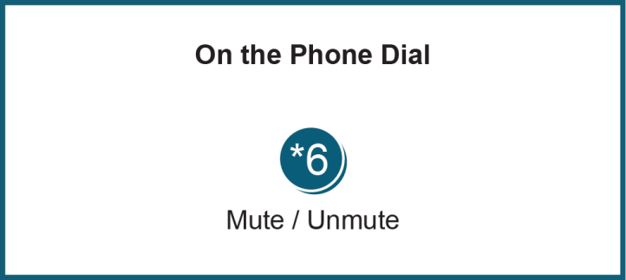

Facilitator Feedback Form: http://www.pjm.com/committees-and-groups/committees/form-facilitator-feedback.aspx

