Planning Committee
PJM Conference and Training Center, Audubon, PA
April 13, 2017
9:30 a.m. – 12:15 p.m. [EPT]

Administration (9:30 – 9:35)
- Welcome, announcements and review of the Anti-trust, Code of Conduct, and Media Participation Guidelines. - Mr. Steve Herling
- Approve draft minutes from the March 9th, 2017 Planning Committing (PC) meeting.

Endorsements (9:35 – 9:50)
- PJM Manual 14B Updates
Mr. Michael Herman will seek endorsement on administrative updates to PJM Manual 14B: PJM Region Transmission Planning Process. Updates include: correcting wording in the Baseline Thermal Analysis section to match analytical procedures and changing all occurrences of “Special Protection System” to “Remedial Action Scheme” per a change to the NERC glossary of terms. The committee will be asked to endorse these updates.

First Readings (9:50 – 10:35)
- PJM Manual 14F
Mr. Herman, PJM, will present a first read of the DRAFT PJM Manual 14F: Competitive Planning Process, including the decisional diagram. PJM has updated this manual based on feedback resulting from the March Planning Committee meeting. This manual has been reviewed via the Special PC sessions for the past 3 months.
- Designated Entity Design Standards Task Force
Mr. Herman, PJM, will present the minimum design requirements document created by the DEDSTF. DEDSTF requirements must be followed for all proposals that will require the signing of a Designated Entity Agreement.
- Manual 14A and Tariff Updates
Mr. Aaron Berner, PJM, will present updates to Manual 14A: Generation and Transmission Interconnection Process and the Tariff related to <$5M cost allocation and the alternate queue. This language was reviewed by members at the Special PC Session held on March 30th and is being brought as a first read to the Planning Committee.

Informational Updates (10:35 – 12:15)
- Transmission Service and Upgrade Requests
Mr. Berner, PJM, will provide an update on the work being conducted at the Special PC Session related to Transmission Service and Upgrade Requests.
- Transitional Seasonal Capacity Study
Mr. Berner, PJM, will provide an update regarding the study for transitional seasonal capacity.
- EQSTF Tariff Clean Up
Mr. Dave Egan, PJM, will present Tariff language changes to reflect updates related to the Earlier Queue Submittal Task Force. These language changes are administrative and are being made to conform to the approvals of the EQSTF.
- Upgrade Construction Service Agreement Definitions Change
Mr. Egan, PJM, will provide an update on proposed changes to the Upgrade Construction Service Agreement being presented at the Governing Document Enhancement & Clarification Subcommittee (GDECS).
- CETLs for NY Imports
Mr. Mark Sims, PJM, will provide an update on CETL calculation methodology, including import assumptions.
- TEAC Redesign Update
Mr. Sims, PJM, will present an update on the TEAC (Transmission Expansion Advisory Committee) Redesign.
- Planning Community Tool
Ms. Lauren Strella, PJM, will provide an update on the progress of the newly developed Planning Community Tool.
- Multiregional Modeling Working Group and MOD-032 Update
Ms. Amber Thomas, PJM, will provide an update on the MMWG (Multiregional Modeling Working Group) and MOD-032.
- TO Load Development and Modeling
Mr. Alex Worcester, PJM, will provide an overview of how TOs develop the load models that PJM incorporates into the planning cases.
- NERC/RRO Update
Mr. Preston Walker, PJM, will provide an update on the activities, issues and items of interest at NERC, SERC, and RFC.
- PPL Planning Criteria
Mr. Phil Penny, PPL, will present an update regarding the PPL Planning Criteria.
- ITC Planning Criteria
Mr. John Kopinski, ITC, will present ITCI Planning Criteria related to the ITCI facilities that went into service last year.
- BGE Remedial Action Scheme Retirement
Mr. Eric Yeh, PJM, will present on the removal of the Concord Street 115kV Remedial Action Scheme.
- Automatic Sectionalizing Schemes
Mr. Lagy Mathew, PJM, will provide an update regarding Automatic Sectionalizing Schemes.
- OATT and Manual 14D Updates
Mr. Joe Mulhern, PJM, will present updates to the OATT and Manual 14D: Generator Operational Requirements related to requirements for Solar Parks.

Informational Section
Manual 3 - Transmission Operations Review
Ms. Nicole Scott, PJM, will be available to answer questions on updates to Manual 3 – Transmission Operations. Materials are posted as Informational Only.

Future Meeting Dates
May 4, 2017 | 9:30 a.m. | Planning Committee | PJM Conference and Training Center, Audubon, PA
June 8, 2017 | 9:30 a.m. | Planning Committee | PJM Conference and Training Center, Audubon, PA
July 13, 2017 | 9:30 a.m. | Planning Committee | PJM Conference and Training Center, Audubon, PA
August 10, 2017 | 9:30 a.m. | Planning Committee | PJM Conference and Training Center, Audubon, PA
September 14, 2017 | 9:30 a.m. | Planning Committee | PJM Conference and Training Center, Audubon, PA
October 12, 2017 | 9:30 a.m. | Planning Committee | PJM Conference and Training Center, Audubon, PA
November 9, 2017 | 9:30 a.m. | Planning Committee | PJM Conference and Training Center, Audubon, PA
December 14, 2017 | 9:30 a.m. | Planning Committee | PJM Conference and Training Center, Audubon, PA
Author: Bridgid Cummings

Anti-trust:
You may not discuss any topics that violate, or that might appear to violate, the antitrust laws including but not limited to agreements between or among competitors regarding prices, bid and offer practices, availability of service, product design, terms of sale, division of markets, allocation of customers or any other activity that might unreasonably restrain competition. If any of these items are discussed the chair will re-direct the conversation. If the conversation still persists, parties will be asked to leave the meeting or the meeting will be adjourned.

Code of Conduct:
As a mandatory condition of attendance at today's meeting, attendees agree to adhere to the PJM Code of Conduct as detailed in PJM Manual M-34 section 4.5, including, but not limited to, participants' responsibilities and rules regarding the dissemination of meeting discussion and materials.

Public Meetings/Media Participation:
Unless otherwise noted, PJM stakeholder meetings are open to the public and to members of the media. Members of the media are asked to announce their attendance at all PJM stakeholder meetings at the beginning of the meeting or at the point they join a meeting already in progress. Members of the Media are reminded that speakers at PJM meetings cannot be quoted without explicit permission from the speaker. PJM Members are reminded that "detailed transcriptional meeting notes" and white board notes from "brainstorming sessions" shall not be disseminated. Stakeholders are also not allowed to create audio, video or online recordings of PJM meetings.

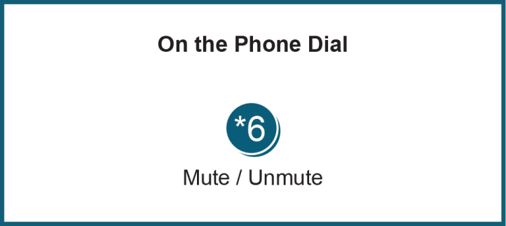
Facilitator Feedback Form: http://www.pjm.com/committees-and-groups/committees/form-facilitator-feedback.aspx

