Planning Committee
PJM Conference and Training Center, Audubon, PA
March 9, 2017
9:30 a.m. – 12:15 p.m. [EPT]

Administration (9:30 – 9:35)
- Welcome, announcements and review of the Anti-trust, Code of Conduct, and Media Participation Guidelines. - Mr. Steve Herling
- Approve draft minutes from the February 9th, 2017 Planning Committing (PC) meeting.

First Readings (9:35 – 10:30)
- PJM Manual 14B Update for Remedial Action Scheme
Mr. Michael Herman, PJM, will provide a first read on two administrative updates to PJM Manual 14B: PJM Region Transmission Planning Process. The first corrects wording in the Baseline Thermal Analysis section to match analytical procedures and the second changes all occurrences of “Special Protection System” to “Remedial Action Scheme” per a change to the NERC glossary of terms
- PJM Manual 14F
Mr. Herman and Ms. Christina Catalano, PJM, will present a first read of the DRAFT PJM Manual 14F: Competitive Planning Process, including the decisional diagram. This manual has been reviewed via the Special PC sessions for the past 3 months.

Informational Updates (10:30 – 12:15)
- TEAC Redesign Update
Ms. Long, PJM, will present an update on the TEAC (Transmission Expansion Advisory Committee) Redesign.
- DEDSTF Update
Mr. Herman, PJM, will provide an update on the progress of the Designated Entity Design Standards Task Force.
- MOD-032 Documentation Review
Mr. Jonathan Thompson, PJM, will provide an update on MOD-032 including revisions to the documentation available for the MOD-032 process and the 2017 schedule.

- Geomagnetic Disturbance Update
Mr. Stan Sliwa, PJM, will provide an update on efforts being made to PJM Planning processes in light of NERC Reliability Standard TPL-007-1: Transmission System Planned Performance for Geomagnetic Disturbance Events.
- Winter Season Resource Adequacy and Capacity Requirements
Mr. Tom Falin, PJM, will provide an update on recent work related to the MRC problem statement regarding winter season resource adequacy and capacity requirements.
- Generator Interconnection NOPR Update
Mr. Aaron Berner, PJM, will provide an update on the Generator Interconnection NOPR (Notice of Proposed Rulemaking).
- NERC/RRO Update
Mr. Preston Walker, PJM, will provide an update on the activities, issues and items of interest at NERC, SERC, and RFC.
- COMED Planning Criteria
Mr. John Garavaglia, COMED, will provide an review of updates to the COMED Planning Criteria.
- Upcoming Planning Committee Items
Mr. Mark Sims, PJM, will provide an overview on upcoming items to be discussed at future Planning Committee Meetings, including but not limited to, new CETLs for NY Imports and Light Load Reliability Analysis methodology update. PJM will be soliciting feedback from members during this item for future considerations and comments on topics discussed.

Informational Section
Order 1000 Update
No Special PC Sessions on Order 1000 Lessons Learned are presently scheduled. Work continues on TEAC Redesign, RTEP schedule, and Manual 14F (Competitive Planning). Discussions will be held at the Planning Committee as necessary.

Future Meeting Dates
March 9, 2017 | 9:30 a.m. | Planning Committee | PJM Conference and Training Center, Audubon, PA
April 13, 2017 | 9:30 a.m. | Planning Committee | PJM Conference and Training Center, Audubon, PA
May 4, 2017 | 9:30 a.m. | Planning Committee | PJM Conference and Training Center, Audubon, PA
June 8, 2017 | 9:30 a.m. | Planning Committee | PJM Conference and Training Center, Audubon, PA
July 13, 2017 | 9:30 a.m. | Planning Committee | PJM Conference and Training Center, Audubon, PA
August 10, 2017 | 9:30 a.m. | Planning Committee | PJM Conference and Training Center, Audubon, PA
September 14, 2017 | 9:30 a.m. | Planning Committee | PJM Conference and Training Center, Audubon, PA
October 12, 2017 | 9:30 a.m. | Planning Committee | PJM Conference and Training Center, Audubon, PA
November 9, 2017 | 9:30 a.m. | Planning Committee | PJM Conference and Training Center, Audubon, PA
December 14, 2017 | 9:30 a.m. | Planning Committee | PJM Conference and Training Center, Audubon, PA
Author: Bridgid Cummings

Anti-trust:
You may not discuss any topics that violate, or that might appear to violate, the antitrust laws including but not limited to agreements between or among competitors regarding prices, bid and offer practices, availability of service, product design, terms of sale, division of markets, allocation of customers or any other activity that might unreasonably restrain competition. If any of these items are discussed the chair will re-direct the conversation. If the conversation still persists, parties will be asked to leave the meeting or the meeting will be adjourned.

Code of Conduct:
As a mandatory condition of attendance at today's meeting, attendees agree to adhere to the PJM Code of Conduct as detailed in PJM Manual M-34 section 4.5, including, but not limited to, participants' responsibilities and rules regarding the dissemination of meeting discussion and materials.

Public Meetings/Media Participation:
Unless otherwise noted, PJM stakeholder meetings are open to the public and to members of the media. Members of the media are asked to announce their attendance at all PJM stakeholder meetings at the beginning of the meeting or at the point they join a meeting already in progress. Members of the Media are reminded that speakers at PJM meetings cannot be quoted without explicit permission from the speaker. PJM Members are reminded that "detailed transcriptional meeting notes" and white board notes from "brainstorming sessions" shall not be disseminated. Stakeholders are also not allowed to create audio, video or online recordings of PJM meetings.
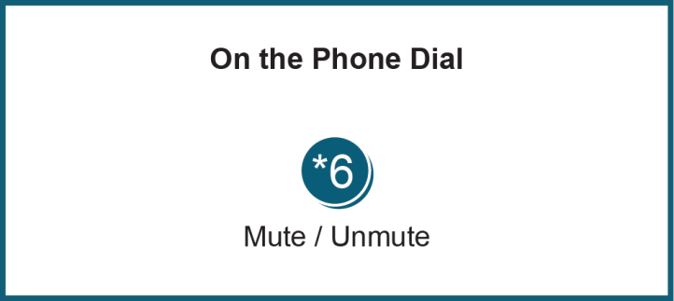

Facilitator Feedback Form: http://www.pjm.com/committees-and-groups/committees/form-facilitator-feedback.aspx

