Planning Committee
PJM Conference and Training Center, Audubon, PA
January 12, 2017
9:30 a.m. – 12:15 p.m. [EPT]

Administration (9:30 – 9:35)
- Welcome, announcements and review of the Anti-trust, Code of Conduct, and Media Participation Guidelines. - Mr. Steve Herling
- Approve draft minutes from the December 15th, 2016 Planning Committing (PC) meeting.

Endorsements (9:35 – 9:50)
- Transmission and Substation Subcommittee (TSS) Charter Revisions
Mr. Ray Rouault, TSS Chairman, will present modifications to the TSS Charter regarding Annual EHV/Bulk Equipment Record and the bulk transformer failure tracking sheet. The committee will be asked to endorse this revision.

First Readings (9:50 – 10:30)
- Manual 22 Updates
Mr. Jerry Bell, PJM, will present administrative updates to Manual 22. The committee will be asked to endorse the proposed revisions at its next meeting.
- Sunset the Earlier Queue Submittal Task Force (EQSTF) Sunset
Mr. Andrew Gledhill, PJM, will discuss sun-setting the Earlier Queue Submittal Task Force (EQSTF). The committee will be asked to endorse sun-setting the EQSTF at its next meeting.
- Transmission Substation Equipment in FERC Order 1000
Mr. Mark Sims, PJM, will discuss Regional Transmission Expansion Plan (RTEP) process enhancements related to the treatment of transmission substation equipment in PJM FERC Order 1000 Proposal Windows. Mr. Sims will also present PJM Operating Agreement revisions to implement the proposed changes. The committee will be asked to endorse the proposed revisions at its next meeting.

Informational Updates (10:30 – 12:15)
- NERC/RRO Update
Mr. Mark Kuras, PJM, will provide an update on the activities, issues and items of interest at NERC, SERC, and RFC.
- Regional Transmission Expansion Plan (RTEP) Case Updates
Mr. Jonathan Thompson, PJM, will provide an update on the Regional Transmission Expansion Plan (RTEP) base case build schedule.
- PJM Interconnection Queue Status Update
Mr. Dave Egan, PJM, will provide an update on the status of PJM Interconnection Queues.
- Generator Interconnection
Mr. Aaron Berner, PJM, will review the recently issued Notice Of Public Rulemaking (NOPR) regarding generator interconnection.
- Dominion Temporary Remedial Action Scheme (RAS)
Mr. Ronnie Bailey, Dominion, will review a temporary RAS in the Dominion Transmission Zone

Informational Section
DEDSTF Update
The Designated Entity Design Standards Task Force (DEDSTF) last met on 12/12/2016. At that meeting the three sub groups (Substations, lines and protection) continued discussions on the organization/development of the Design Standards as well as the process of reviewing the existing materials. Michael Herman gave an update to the Planning Committee on December 15th, indicating that the major assignments of the DEDSTF would be presented to the Planning Committee in the first or second quarter of 2017. The next meeting of the DEDSTF is 1/24/2017, all registrations are available on the DEDSTF website.
Order 1000 Update
A Special PC Sessions on Order 1000 was held on December 8. An additional session is scheduled for January 13, 2017 (9am – 12 Noon). The focus at these sessions is the following: (1) TEAC Redesign and (2) RTEP Schedule. The Market Efficiency Project Selection Guidelines were endorsed by the Planning Committee at its December meeting.

Future Meeting Dates
January 12, 2017 | 9:30 a.m. | Planning Committee | PJM Conference and Training Center, Audubon, PA
January 13, 2017 | 9:00 a.m. | Special PC Session: TEAC Redesign and RTEP Cycle | PJM Conference and Training Center, Audubon, PA
February 9, 2017 | 9:30 a.m. | Planning Committee | PJM Conference and Training Center, Audubon, PA
February 10, 2017 | 9:00 a. m. | Special PC Session: TEAC Redesign and RTEP Cycle | PJM Conference and Training Center, Audubon, PA
March 9, 2017 | 9:30 a.m. | Planning Committee | PJM Conference and Training Center, Audubon, PA
April 13, 2017 | 9:30 a.m. | Planning Committee | PJM Conference and Training Center, Audubon, PA
May 4, 2017 | 9:30 a.m. | Planning Committee | PJM Conference and Training Center, Audubon, PA
June 8, 2017 | 9:30 a.m. | Planning Committee | PJM Conference and Training Center, Audubon, PA
July 13, 2017 | 9:30 a.m. | Planning Committee | PJM Conference and Training Center, Audubon, PA
August 10, 2017 | 9:30 a.m. | Planning Committee | PJM Conference and Training Center, Audubon, PA
September 14, 2017 | 9:30 a.m. | Planning Committee | PJM Conference and Training Center, Audubon, PA
October 12, 2017 | 9:30 a.m. | Planning Committee | PJM Conference and Training Center, Audubon, PA
November 9, 2017 | 9:30 a.m. | Planning Committee | PJM Conference and Training Center, Audubon, PA
December 14, 2017 | 9:30 a.m. | Planning Committee | PJM Conference and Training Center, Audubon, PA

Author: Bridgid Cummings

Anti-trust:
You may not discuss any topics that violate, or that might appear to violate, the antitrust laws including but not limited to agreements between or among competitors regarding prices, bid and offer practices, availability of service, product design, terms of sale, division of markets, allocation of customers or any other activity that might unreasonably restrain competition. If any of these items are discussed the chair will re-direct the conversation. If the conversation still persists, parties will be asked to leave the meeting or the meeting will be adjourned.

Code of Conduct:
As a mandatory condition of attendance at today's meeting, attendees agree to adhere to the PJM Code of Conduct as detailed in PJM Manual M-34 section 4.5, including, but not limited to, participants' responsibilities and rules regarding the dissemination of meeting discussion and materials.

Public Meetings/Media Participation:
Unless otherwise noted, PJM stakeholder meetings are open to the public and to members of the media. Members of the media are asked to announce their attendance at all PJM stakeholder meetings at the beginning of the meeting or at the point they join a meeting already in progress. Members of the Media are reminded that speakers at PJM meetings cannot be quoted without explicit permission from the speaker. PJM Members are reminded that "detailed transcriptional meeting notes" and white board notes from "brainstorming sessions" shall not be disseminated. Stakeholders are also not allowed to create audio, video or online recordings of PJM meetings.
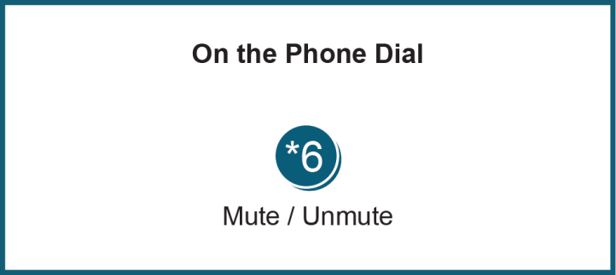

Facilitator Feedback Form: http://www.pjm.com/committees-and-groups/committees/form-facilitator-feedback.aspx

