Planning Committee
PJM Interconnection
December 3, 2015
9:30 a.m. – 12:15 p.m. [EST]

Administration (9:30 – 9:45)
- Administrative Items
- Call to order, roll call, and request for additional agenda items.
- The Planning Committee will review and approve the draft minutes from the November 5, 2015 Planning Committee meeting.
- 2015 RTEP Proposal Window Update
- Earlier Queue Submittals Update
- DEDSTF Update
- Model On Demand Update
- RAAS Update

Endorsements/Approvals (9:45 – 10:00)
- Load Forecast Update
Mr. Reynolds will be seeking endorsement of Manual 19 changes related to enhancements to the load forecast model.

First Readings (10:00 – 11:15)
- Voltage Threshold and Administrative Update
Ms. Glatz will be reviewing draft Operating Agreement language regarding voltage threshold and administrative changes.
- Long Term Firm Transmission Service Task Force Update
Mr. Baker will present a first read of the solution package to modify existing and expand Long Term Firm Transmission Service methodologies.
- PARTF Update
Mr. Berner will provide a first read of Manual 14 series updates regarding PAR withdrawal and inject rights
- DEDSTF Update
Mr. Herman will provide a first read of the DEDSTF Charter.
.

Education (11:15 – 12:15)
- NERC/RRO Update
Mr. Kuras will provide an update to the membership on the activities, issues and items of interest at NERC, SERC, and RFC.
- FERC Activities and Proceedings
Ms. Foley will provide an update of current FERC activities and proceedings.
- Status of PJM Interconnection Queues
Mr. Egan will provide information on the status of PJM’s Interconnection Queues.
- 2016 Load Forecast Review
Mr. Reynolds will review the 2016 Load Forecast Report.

Future Meeting Dates
January 7, 2016 | 9:30 AM | PJM Conference and Training Center, Valley Forge, PA
February 11, 2016 | 9:30 AM | PJM Conference and Training Center, Valley Forge, PA
March 10, 2016 | 9:30 AM | PJM Conference and Training Center, Valley Forge, PA
April 7, 2016 | 9:30 AM | PJM Conference and Training Center, Valley Forge, PA
May 12, 2016 | 9:30 AM | PJM Conference and Training Center, Valley Forge, PA
June 9, 2016 | 9:30 AM | PJM Conference and Training Center, Valley Forge, PA
July 14, 2016 | 9:30 AM | PJM Conference and Training Center, Valley Forge, PA
August 11, 2016 | 9:30 AM | PJM Conference and Training Center, Valley Forge, PA
September 15, 2016 | 9:30 AM | PJM Conference and Training Center, Valley Forge, PA
October 6, 2016 | 9:30 AM | PJM Conference and Training Center, Valley Forge, PA
November 3, 2016 | 9:30 AM | PJM Conference and Training Center, Valley Forge, PA
December 15, 2016 | 9:30 AM | PJM Conference and Training Center, Valley Forge, PA

Author: Amber Thomas

Anti-trust:
You may not discuss any topics that violate, or that might appear to violate, the antitrust laws including but not limited to agreements between or among competitors regarding prices, bid and offer practices, availability of service, product design, terms of sale, division of markets, allocation of customers or any other activity that might unreasonably restrain competition. If any of these items are discussed the chair will re-direct the conversation. If the conversation still persists, parties will be asked to leave the meeting or the meeting will be adjourned.

Code of Conduct:
As a mandatory condition of attendance at today's meeting, attendees agree to adhere to the PJM Code of Conduct as detailed in PJM Manual M-34 section 4.5, including, but not limited to, participants' responsibilities and rules regarding the dissemination of meeting discussion and materials.

Public Meetings/Media Participation:
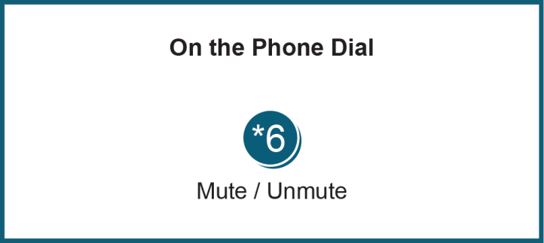
Unless otherwise noted, PJM stakeholder meetings are open to the public and to members of the media. Members of the media are asked to announce their attendance at all PJM stakeholder meetings at the beginning of the meeting or at the point they join a meeting already in progress. Members of the Media are reminded that speakers at PJM meetings cannot be quoted without explicit permission from the speaker. PJM Members are reminded that "detailed transcriptional meeting notes" and white board notes from "brainstorming sessions" shall not be disseminated. Stakeholders are also not allowed to create audio, video or online recordings of PJM meetings.

