Operating Committee
Webex Only
November 6, 2020
9:00 a.m. – 4:00 p.m. EPT

Administration (9:00-9:15)
Danielle Croop, PJM, will provide announcements; review the Antitrust, Code of Conduct, Public Meetings/Media Participation, and the WebEx Participant Identification Requirement.
  - Review and approve draft minutes of the October 8, 2020 OC meeting and October 21, 2020 OC Special Session meeting.
  - Review of the OC work plan.

Review of Operations (9:15-9:30)
PJM COVID-19 Update
Paul McGlynn, PJM, will provide an update on PJM’s operations plan in response to COVID-19. https://pjm.com/committees-and-groups/pandemic-coordination.aspx

Review of Operating Metrics
Stephanie Monzon, PJM, will review the October 2020 PJM operating metrics slides. Metrics will include PJM’s load forecast error, BAAL performance, and transmission / generation outage statistics.

Endorsements (9:30-11:00)
- Black Start Unit Testing, CRF, Involuntary Termination, MTSL and Substitution Rules

  - Dr. Paul Sotkiewicz, Elwood Energy, will make a motion for the OC to adopt proposed amendments to the Issue Charge; Sharon Midgley, Exelon, will second the motion. The Operating Committee will be asked to approve the amendment at its first read.

  - Becky Davis, PJM, will review the solution packages (PJM solution package and IMM solution package). The Operating Committee will be asked to endorse a proposed solution package at today’s meeting.

- Manual 3A: EMS Model Updates & Quality Assurance Changes
Maria Baptiste, PJM, will review updates to Manual 3A: EMS Model Updates & QA. The Operating Committee will be asked to endorse these changes.

- Manual 3: Transmission Operations Changes
Lagy Mathew, PJM, will review updates to Manual 3: Transmission Operations. The Operating Committee will be asked to endorse these changes.

- Manual 12: Balancing Operations Change
Kevin Hatch, PJM, will review updates to Manual 12: Balancing Operations to address change from the 5 minute pricing and dispatch MIC special sessions. The Operating Committee will be asked to endorse these changes.

- Day Ahead Schedule Reserve (DASR) Update
David Kimmel, PJM, will review preliminary proposed changes to the 2021 Day Ahead Scheduling Reserve (DASR) requirement. The Operating Committee will be asked to endorse these changes.

- Winter Weekly Reserve Target Update
Patricio Rocha Garrido, PJM, will review the results of the 2020/21 Winter Weekly Reserve Target (WWRT) analysis. The Operating Committee will be asked to endorse these changes.

First Reading (11:00-11:15)
- Manual 14D: Generation Changes
Natalie Tacka, PJM, will review Manual 14D changes associated with updates for the Public Distribution Microgrids as discussed in the DIRS.

- Manual 3: Transmission Operation Changes
Joseph Ciabattoni, PJM, will review Manual 3 and Manual 28 changes associated with updates for stability limits as discussed in the MIC.

Informational Update (11:15-16:00)
- Intelligent Reserve Deployment (IRD) Rollout Education
  - Mike Zhang, PJM, will provide education on the Intelligent Reserve Deployment.

  - Joe Bowring, Monitoring Analytics, will provide additional information regarding Intelligent Reserve Deployment.

- Operations Assessment Task Force Review
Todd Bickel, PJM, will provide a review the OATF winter 2020/21 study.

- Primary Frequency Response Update
Becky Davis, PJM, will provide a review of PJM’s primary frequency response performance.

- Regulation Performance Update
Gabrielle Genuario, PJM, will provide an update on Regulation performance.

- Applications of Synchro-Phasor Data
Shaun Murphy, PJM, will provide an update on PMU activities in RTEP and Manual 01 and 14B updates recently approved at the MRC.

- Fuel Security
Patricio Rocha Garrido, PJM, will provide a fuel security update.

- Load Management Event Review
Jack O’Neill, PJM, will provide the annual load management event review.

- System Operations Subcommittee (SOS) Report
Rebecca Carroll, PJM, will provide a summary of the most recent SOS meeting.

- Unit Specific Parameter 2021/2022 DY Update
Tom Hauske, PJM, will provide an update on Unit Specific Parameters for the 2021/2022 DY.

- NERC Lessons Learned
Donnie Bielak, PJM, will review new NERC Lessons Learned.

- Reliability Compliance Update
Mark Kuras, PJM, will provide an update on NERC, SERC and RFC standards, and other pertinent regulatory and compliance information, and solicit feedback from the members on Reliability Compliance efforts.
- PJM Response to Show Cause Order
Jim Burlew, PJM, will review tariff language associated with FERC Show Cause Order in EL20-30 & EL20-56 pertaining to PJM’s station power tariff provisions and review PJM’s plan for compliance filing.

Informational Posting
- PJM Summer Operations
An informational presentation is available with today’s meeting material on PJM Summer Operations performance. Becky Carroll will be available during the meeting to answer any question on this material.

OC Subcommittee/ Task Force Informational Section
System Operations Subcommittee (SOS): SOS Website

Data Management Subcommittee (DMS): DMS Website

DER & Inverter-Based Resources Subcommittee (DIRS): DIRS Website

System Restoration Coordinators Subcommittee (SRCS): SRCS Website

Fuel Requirements for Black Start Resources: Fuel Reqt. for Black Start Resources Issue Tracker

Future Meeting Dates
December 3, 2020 | 9:00 a.m. | PJM Conference & Training Center/ WebEx

Author: D. Croop

Antitrust:
You may not discuss any topics that violate, or that might appear to violate, the antitrust laws including but not limited to agreements between or among competitors regarding prices, bid and offer practices, availability of service, product design, terms of sale, division of markets, allocation of customers or any other activity that might unreasonably restrain competition. If any of these items are discussed the chair will re-direct the conversation. If the conversation still persists, parties will be asked to leave the meeting or the meeting will be adjourned.

Code of Conduct:
As a mandatory condition of attendance at today's meeting, attendees agree to adhere to the PJM Code of Conduct as detailed in PJM Manual M-34 section 4.5, including, but not limited to, participants' responsibilities and rules regarding the dissemination of meeting discussion and materials.

Public Meetings/Media Participation:
Unless otherwise noted, PJM stakeholder meetings are open to the public and to members of the media. Members of the media are asked to announce their attendance at all PJM stakeholder meetings at the beginning of the meeting or at the point they join a meeting already in progress. Members of the Media are reminded that speakers at PJM meetings cannot be quoted without explicit permission from the speaker. PJM Members are reminded that "detailed transcriptional meeting notes" and white board notes from "brainstorming sessions" shall not be disseminated. Stakeholders are also not allowed to create audio, video or online recordings of PJM meetings. PJM may create audio, video or online recordings of stakeholder meetings for internal and training purposes, and your participation at such meetings indicates your consent to the same.
Participant Identification in WebEx:
When logging into the WebEx desktop client, please enter your real first and last name as well as a valid email address. Be sure to select the “call me” option.
PJM support staff continuously monitors WebEx connections during stakeholder meetings. Anonymous users or those using false usernames or emails will be dropped from the teleconference.

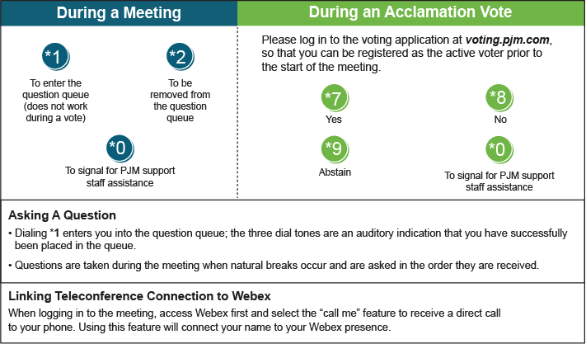

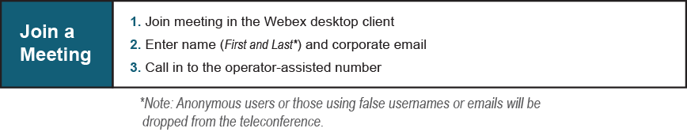
Provide feedback on the progress of this group: Facilitator Feedback Form
Visit learn.pjm.com, an easy-to-understand resource about the power industry and PJM’s role.

