Market Implementation Committee

WebEx Only

May 11, 2022

9:00 a.m. – 4:00 p.m. EPT

Administration (9:00 – 9:15)

Nicholas DiSciullo will review the Antitrust, Code of Conduct, Public Meetings/Media Participation and the WebEx Participant Identification Requirements.

The Committee will be asked to approve the draft minutes from the April 13, 2022 Market Implementation Committee.

1. **Guidance for In Person Stakeholder Meeting Attendance**

Michele Greening will provide an update on the return to campus plan for stakeholder meetings.

Endorsements/Approvals (9:15 – 10:25)

1. **Manual 29 Revisions (9:15 – 9:30)**

Natasha Holter will review revisions to Manual 29: Billing as part of the periodic review.

**The committee will be asked to endorse the revisions at this meeting**.

1. **Manuals 11 and 28: Stability Limit Changes (9:30 – 9:50)**

Zhenyu Fan and Rebecca Stadelmeyer will review conforming updates to Manual 11: Energy & Ancillary Services Market Operations and Manual 28: Operating Agreement Accounting.

**The committee will be asked to endorse these revisions at this meeting.**

[Issue Tracking: Stability Limits in Markets and Operations](https://www.pjm.com/committees-and-groups/issue-tracking/issue-tracking-details.aspx?Issue=e2cf01c5-2504-49d7-8b1a-66b867bba081)

1. **Manuals 11 and 28: Intelligent Reserve Deployment Changes (9:50 – 10:05)**

Damon Fereshetian and Rebecca Stadelmeyer will review updates to Manual 11: Energy & Ancillary Services Market Operations and Manual 28: Operating Agreement Accounting.

**The committee will be asked to endorse these revisions at this meeting.**

[Issue Tracking: Synchronized Reserve Event Actions and Expectations](https://pjm.com/committees-and-groups/issue-tracking/issue-tracking-details.aspx?Issue=88b492a5-1547-4558-a242-456d99b87a37)

1. **Market Suspension (10:05 – 10:25)**

Stefan Starkov will review the PJM/IMM Package addressing the treatment of long-term market suspensions.

**The committee will be asked to endorse the package at this meeting.**

[Issue Tracking: Rules Related to Market Suspension](https://www.pjm.com/committees-and-groups/issue-tracking/issue-tracking-details.aspx?Issue=214df9c5-db87-4a02-84be-b917c118d6ed)

First Readings (10:25 – 11:00)

1. **Variable Environmental Costs and Credits (10:25-10:45)**

Melissa Pilong will provide a first read of a proposal providing detailed guidance and updates to rules related to variable environmental charges and/or credits and their inclusion in cost-based energy offers. The committee will be asked to endorse the package at its next meeting.

[Issue Tracking: Variable Environmental Costs and Credits](https://www.pjm.com/committees-and-groups/issue-tracking/issue-tracking-details.aspx?Issue=c95724bc-c61d-4226-9772-ac411886523e)

1. **Manuals 18 and 28: Load Management / Price Responsive Demand Testing Changes (10:45-11:00)**

Jack O’Neill will provide a first read of conforming changes to Manual 18: PJM Capacity Market and Manual 28: Operating Agreement Accounting to support the implementation of new testing requirements which were approved in Docket No. ER19-1590 and will become effective with the 2023/2023 Delivery Year. The committee will be asked to endorse the revisions at its next meeting.

[Issue Tracking: Load Management Testing Requirements](https://www.pjm.com/committees-and-groups/issue-tracking/issue-tracking-details.aspx?Issue=51c7a25c-4ee6-42a5-a6d6-3ca46581e9a9)

Working Items – Part 1 (11:00 – 12:00)

1. **Quadrennial Review (11:00 – 12:00)**
   1. Rebecca Carroll will review the Quadrennial Review work plan.
   2. Melissa Pilong will provide an overview of PJM’s proposal resulting from the Quadrennial Review of the capacity market.

[Issue Tracking: 2022 Quadrennial Review](https://www.pjm.com/committees-and-groups/issue-tracking/issue-tracking-details-non-stakeholder.aspx?Issue=8d764b81-1e26-4ed6-98ad-0b1db80ebb08)

Lunch (12:00 – 12:45)

Working Items – Part 2 (12:45 – 3:15)

1. **Operating Reserve Clarification for Resources Operating as Requested by PJM (12:45 – 2:15)** 
   1. Brian Weathers will provide education on the incentives that currently exist in the PJM market for resources to operate as requested by PJM, including the assessment of balancing operating reserve deviation charges.
   2. Madalyn Beban will review how other ISOs/RTOs measure whether resources operate as requested and some associated incentives.
   3. Joel Luna, IMM, will review balancing operating reserve credit and deviation charge metrics.
   4. Nick DiSciullo will facilitate a discussion around the Interest Identification portion of the Consensus Based Issue Resolution process.

[Issue Tracking: Operating Reserve Clarification for Resources Operating as Requested by PJM](https://www.pjm.com/committees-and-groups/issue-tracking/issue-tracking-details.aspx?Issue=6897c7e7-d8b7-438e-9e3f-b6099f9dd7ec)

1. **Capacity Offer Opportunities for Generation with Co-Located Load (2:15 – 3:15)**

Lisa Morelli will facilitate a discussion to begin developing solution options for the Capacity Offer Opportunities for Generation with Co-Located Load matrix.

[Issue Tracking: Capacity Offer Opportunities for Generation with Co-Located Load](https://www.pjm.com/committees-and-groups/issue-tracking/issue-tracking-details.aspx?Issue=6897c7e7-d8b7-438e-9e3f-b6099f9dd7ec)

Additional Items (3:15 – 3:35)

1. **Reserve Price Formation Implementation Plan (3:15 – 3:30)**

Brian Chmielewski will provide an overview of upcoming education sessions that will address the details surrounding the October 2022 implementation of several reserve market price formation changes (FERC Docket No EL19-58).

1. Cost Development Subcommittee Update (3:30 – 3:35)

Nicole Scott will provide an informational update on the work to be performed at the Cost Development Subcommittee.

Informational Section

**Interregional Coordination Update**

Materials are posted as informational only.

**Fast Start Pricing Monthly Metrics Update**

Materials are posted as informational only.

**PJM Net Energy Injections Quarterly Review**

Materials are posted as informational only.

**ARR FTR Market Task Force (AFMTF)**   
Meeting materials are posted to the [AFMTF website](https://www.pjm.com/committees-and-groups/task-forces/afmtf).

**Reactive Power Compensation Task Force (RPCTF)**   
Meeting materials are posted to the [RPCTF website.](https://www.pjm.com/committees-and-groups/task-forces/rpctf)

**Cost Development Subcommittee (CDS)**   
Meeting materials are posted to the [CDS website](https://www.pjm.com/committees-and-groups/subcommittees/cds).

**Demand Response Subcommittee (DRS)**   
Meeting materials are posted to the [DRS website](http://www.pjm.com/committees-and-groups/subcommittees/drs.aspx).

**DER & Inverter-based Resources Subcommittee (DIRS)**

Meeting materials are posted to the [DIRS website.](https://www.pjm.com/committees-and-groups/subcommittees/dirs.aspx)

**Market Settlements Subcommittee (MSS)**

Meeting materials are posted to the [MSS website](http://www.pjm.com/committees-and-groups/subcommittees/mss.aspx).

OC/MIC Fuel Requirements for Black Start Resources

Meeting materials are posted to the [Operating Committee website](https://www.pjm.com/committees-and-groups/committees/oc).

Report on Market Operations

The Report on Market Operations will be reviewed during the [MC Webinar](http://www.pjm.com/committees-and-groups/committees/mc.aspx).

|  |  |  |  |  |
| --- | --- | --- | --- | --- |
| **Future Meeting Dates and Materials** | | | **Materials Due  to Secretary** | **Materials Published** |
| Date | Time | Location | 5 p.m. | 4 p.m. |
| June 8 | 9 a.m. | WebEx / Conference & Training Center | May 26 | June 1 |
| July 13 | 9 a.m. | WebEx / Conference & Training Center | June 30 | July 6 |
| August 10 | 9 a.m. | WebEx / Conference & Training Center | July 29 | August 3 |
| September 7 | 9 a.m. | WebEx / Conference & Training Center | August 26 | August 31 |
| October 6 | 9 a.m. | WebEx / Conference & Training Center | September 26 | September 29 |
| November 2 | 9 a.m. | WebEx / Conference & Training Center | October 21 | October 26 |
| December 7 | 9 a.m. | WebEx / Conference & Training Center | November 23 | November 30 |

Author: Nick DiSciullo

Antitrust:

You may not discuss any topics that violate, or that might appear to violate, the antitrust laws including but not limited to agreements between or among competitors regarding prices, bid and offer practices, availability of service, product design, terms of sale, division of markets, allocation of customers or any other activity that might unreasonably restrain competition. If any of these items are discussed the chair will re-direct the conversation. If the conversation still persists, parties will be asked to leave the meeting or the meeting will be adjourned.

Code of Conduct:

As a mandatory condition of attendance at today's meeting, attendees agree to adhere to the PJM Code of Conduct as detailed in PJM Manual M-34 section 4.5, including, but not limited to, participants' responsibilities and rules regarding the dissemination of meeting discussion and materials.

Public Meetings/Media Participation:

Unless otherwise noted, PJM stakeholder meetings are open to the public and to members of the media. Members of the media are asked to announce their attendance at all PJM stakeholder meetings at the beginning of the meeting or at the point they join a meeting already in progress. Members of the Media are reminded that speakers at PJM meetings cannot be quoted without explicit permission from the speaker. PJM Members are reminded that "detailed transcriptional meeting notes" and white board notes from "brainstorming sessions" shall not be disseminated. Stakeholders are also not allowed to create audio, video or online recordings of PJM meetings. PJM may create audio, video or online recordings of stakeholder meetings for internal and training purposes, and your participation at such meetings indicates your consent to the same.

Participant Identification in WebEx:

When logging into the WebEx desktop client, please enter your real first and last name as well as a valid email address. Be sure to select the “call me” option.

PJM support staff continuously monitors WebEx connections during stakeholder meetings. Anonymous users or those using false usernames or emails will be dropped from the teleconference.

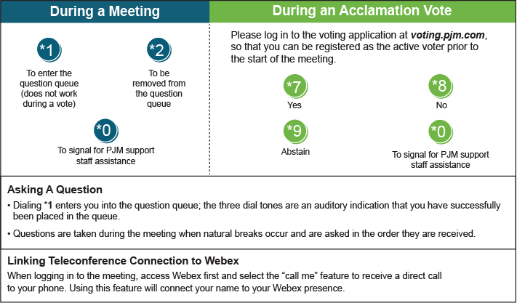

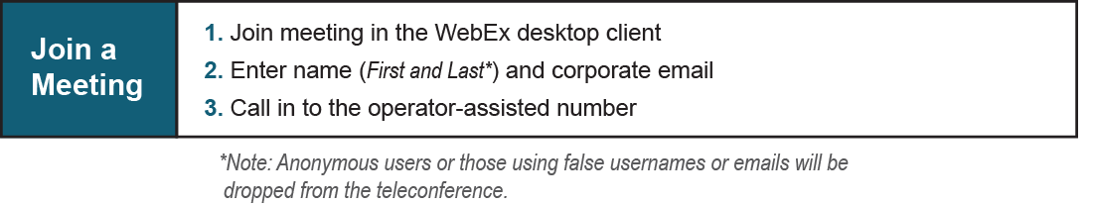

Provide feedback on the progress of this group: [*Facilitator Feedback Form*](https://www.pjm.com/committees-and-groups/committees/form-facilitator-feedback.aspx)   
Visit [*learn.pjm.com*](https://learn.pjm.com/), an easy-to-understand resource about the power industry and PJM’s role.