Market Implementation Committee

WebEx Only

March 9, 2022

9:00 a.m. – 12:40 p.m. EPT

Administration (9:00 – 9:10)

Nicholas DiSciullo will review the Antitrust, Code of Conduct, Public Meetings/Media Participation and the WebEx Participant Identification Requirements.

The Committee will be asked to approve the draft minutes from the February 9, 2022 Market Implementation Committee.

1. Nicholas DiSciullo will provide an update on the MIC Work Plan.

Endorsements/Approvals (9:10 – 10:10)

***Action Required:  Members are reminded to complete the necessary steps to update their browser prior to the meeting to avoid impact to Voting Application access. Reference:***[***Weak Encryption***](https://www.pjm.com/-/media/committees-groups/committees/mic/2022/20220209/20220209-item-x-pjm-retiring-use-of-weak-encryption-for-voting.ashx)

1. **Pseudo Modeled Combined Cycle Minimum Run Time Guidance (9:10 – 9:25)**

Tom Hauske will review Package A addressing Pseudo Modeled Combined Cycle Minimum Run Time Guidance.

**The committee will be asked to endorse the proposal at this meeting.**

[Issue Tracking: Pseudo Modeled Combined Cycle Minimum Run Time Guidance](https://www.pjm.com/committees-and-groups/issue-tracking/issue-tracking-details.aspx?Issue=718897c5-9ce7-4444-b9b6-1e5363f595d8)

1. **Manual 18 Revisions – MOPR, MSOC, Historic Net EAS (9:25 – 9:40)**

Jeff Bastian will review revisions to Manual 18: PJM Capacity Market conforming with PJM’s 7/30/21 filing to reform application of the MOPR, PJM’s 10/21 compliance filing made in accordance with FERC’s 9/2/21 Order to amend the default MSOC, and FERC’s 12/22/21 order directing PJM to reinstate the historic net EAS methodology, and FERC’s 1/20/22 order directing PJM to remove the 10% adder from the net EAS calculation for the reference resource CT.

**The committee will be asked to endorse the revisions at this meeting.**

1. **Critical Gas Infrastructure – Demand Response Participation (9:40 – 9:55)**

Jack O’Neill will review a Problem Statement and Issue Charge addressing the Critical Gas Infrastructure recommendation for Demand Response. This stems from the FERC/NERC report on the severe cold weather event in Texas and South Central US last February.

**The committee will be asked to approve the Issue Charge at this meeting.**

1. **Operating Reserve Clarification for Resources Operating as Requested by PJM (9:55 – 10:10)**

Phil D’Antonio will review a Problem Statement and Issue Charge addressing clarifications and potential enhancements to the rules for paying Operating Reserve credits to resources operating as requested by PJM.

**The committee will be asked to approve the Issue Charge at this meeting.**

First Readings (10:10 – 10:40)

1. **Start-Up Cost Offer Development (10:10 – 10:40)**

Tom Hauske will provide a first read of the Revised PJM/IMM Proposal addressing Start-Up Cost Offer Development developed through the Cost Development Subcommittee.

The committee will be asked to endorse the proposals at its next meeting.

Working Items (10:40 – 12:10)

1. **Capacity Offer Opportunities for Generation with Co-Located Load (10:40 – 12:10)**
2. Jeff Bastian will provide education regarding the comparison of consumer costs from status quo versus various co-location configurations.
3. Joe Bowring, IMM, will provide education on Capacity Offer Opportunities for Generation with Co-Located Load.
4. Lisa Morelli will facilitate a discussion to identify interests and design components for the Capacity Offer Opportunities for Generation with Co-Located Load matrix.

[Issue Tracking: Capacity Offer Opportunities for Generation with Co-Located Load](https://www.pjm.com/committees-and-groups/issue-tracking/issue-tracking-details.aspx?Issue=6897c7e7-d8b7-438e-9e3f-b6099f9dd7ec)

Additional Items (12:10 – 12:40)

1. **Fast Start Capable Adjustment Process (12:10 – 12:20)**

Vijay Shah will review the process to become a fast start capable resource.

1. Cost Development Subcommittee Update (12:20 – 12:40)

Nicole Scott will provide an informational update on the work to be performed at the Cost Development Subcommittee and will review a new Issue Charge addressing Variable Environmental Costs and Credits that will be worked at the Cost Development Subcommittee and will provide an opportunity for the committee to provide feedback.

Informational Section

**Interregional Coordination Update**

Materials are posted as informational only.

**Fast Start Pricing Monthly Metrics Update**

Materials are posted as informational only.

**ARR FTR Market Task Force (AFMTF)**   
Meeting materials are posted to the [AFMTF website](https://www.pjm.com/committees-and-groups/task-forces/afmtf).

**Reactive Power Compensation Task Force (RPCTF)**   
Meeting materials are posted to the [RPCTF website.](https://www.pjm.com/committees-and-groups/task-forces/rpctf)

**Cost Development Subcommittee (CDS)**   
Meeting materials are posted to the [CDS website](https://www.pjm.com/committees-and-groups/subcommittees/cds).

**Demand Response Subcommittee (DRS)**   
Meeting materials are posted to the [DRS website](http://www.pjm.com/committees-and-groups/subcommittees/drs.aspx).

**DER & Inverter-based Resources Subcommittee (DIRS)**

Meeting materials are posted to the [DIRS website.](https://www.pjm.com/committees-and-groups/subcommittees/dirs.aspx)

**Market Settlements Subcommittee (MSS)**

Meeting materials are posted to the [MSS website](http://www.pjm.com/committees-and-groups/subcommittees/mss.aspx).

Report on Market Operations

The Report on Market Operations will be reviewed during the [MC Webinar](http://www.pjm.com/committees-and-groups/committees/mc.aspx).

|  |  |  |  |  |  |  |  |  |  |
| --- | --- | --- | --- | --- | --- | --- | --- | --- | --- |
| **Future Meeting Dates and Materials** | | | | | | **Materials Due  to Secretary** | | **Materials Published** | |
| Date | | Time | | Location | 5 p.m. | | 4 p.m. | |
| April 13 | 9 a.m. | | WebEx | | April 1 | | April 6 | |
| May 11 | 9 a.m. | | WebEx | | April 29 | | May 4 | |
| June 8 | 9 a.m. | | WebEx | | May 26 | | June 1 | |

Author: Nicholas DiSciullo

Antitrust:

You may not discuss any topics that violate, or that might appear to violate, the antitrust laws including but not limited to agreements between or among competitors regarding prices, bid and offer practices, availability of service, product design, terms of sale, division of markets, allocation of customers or any other activity that might unreasonably restrain competition. If any of these items are discussed the chair will re-direct the conversation. If the conversation still persists, parties will be asked to leave the meeting or the meeting will be adjourned.

Code of Conduct:

As a mandatory condition of attendance at today's meeting, attendees agree to adhere to the PJM Code of Conduct as detailed in PJM Manual M-34 section 4.5, including, but not limited to, participants' responsibilities and rules regarding the dissemination of meeting discussion and materials.

Public Meetings/Media Participation:

Unless otherwise noted, PJM stakeholder meetings are open to the public and to members of the media. Members of the media are asked to announce their attendance at all PJM stakeholder meetings at the beginning of the meeting or at the point they join a meeting already in progress. Members of the Media are reminded that speakers at PJM meetings cannot be quoted without explicit permission from the speaker. PJM Members are reminded that "detailed transcriptional meeting notes" and white board notes from "brainstorming sessions" shall not be disseminated. Stakeholders are also not allowed to create audio, video or online recordings of PJM meetings. PJM may create audio, video or online recordings of stakeholder meetings for internal and training purposes, and your participation at such meetings indicates your consent to the same.

Participant Identification in WebEx:

When logging into the WebEx desktop client, please enter your real first and last name as well as a valid email address. Be sure to select the “call me” option.

PJM support staff continuously monitors WebEx connections during stakeholder meetings. Anonymous users or those using false usernames or emails will be dropped from the teleconference.

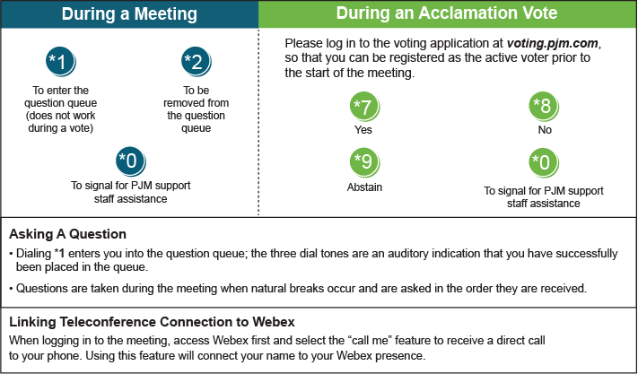

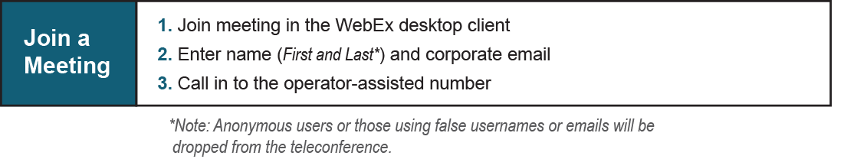

Provide feedback on the progress of this group: [*Facilitator Feedback Form*](https://www.pjm.com/committees-and-groups/committees/form-facilitator-feedback.aspx)   
Visit [*learn.pjm.com*](https://learn.pjm.com/), an easy-to-understand resource about the power industry and PJM’s role.