Market Implementation Committee

WebEx Only

December 1, 2021

9:00 a.m. – 12:25 p.m. EPT

Administration (9:00 – 9:15)

Nicholas DiSciullo will review the Antitrust, Code of Conduct, Public Meetings/Media Participation and the WebEx Participant Identification Requirements.

The Committee will be asked to approve the draft minutes from the November 3, 2021 Market Implementation Committee.

Nicholas DiSciullo will review the 2022 MIC Work Plan.

Start-Up Cost Offer Development Update

Endorsements/Approvals (9:15 – 9:55)

1. **Fuel Cost Policy Standards and Schedule 2 Penalties (9:15 – 9:30)**

Melissa Pilong will review the PJM/IMM Package elaborating upon and addressing clarifications to Fuel Cost Policy standards and Schedule 2 Penalty language developed through the Cost Development Subcommittee.

The committee will be asked to endorse the proposal at this meeting.

[Issue Tracking: Fuel Cost Policy](https://www.pjm.com/committees-and-groups/issue-tracking/issue-tracking-details.aspx?Issue=507b0c86-d058-4d4b-8f8f-79008c49126b)

1. **Manual 6 Revisions (9:30 – 9:40)**

Emmy Messina will review conforming changes to Manual 6: Financial Transmission Rights resulting from the endorsement of the AFMTF PJM/Joint Stakeholder package at the October MRC.

**The committee will be asked to endorse the revisions at this meeting.**

[Issue Tracking: ARR/FTR Market Review](https://www.pjm.com/committees-and-groups/issue-tracking/issue-tracking-details.aspx?Issue=83fce36d-af05-4ed7-8231-ee8f41c74e0c)

1. **Regulation for Virtual Combined Cycles (9:40 – 9:55)**

Michael Olaleye will review Package A addressing Regulation for Virtual Combined Cycles.

**The committee will be asked to endorse the proposal at this meeting.**

[Issue Tracking: Regulation for Virtual Combined Cycles](https://www.pjm.com/committees-and-groups/issue-tracking/issue-tracking-details.aspx?Issue=4156560d-cfb4-45e6-aacd-33ec5c9447ed)

First Readings (9:55 – 10:40)

1. **Pseudo Modeled Combined Cycle Minimum Run Time Guidance (9:55 – 10:25)**

Tom Hauske will provide education and a first read a Problem Statement and Issue Charge addressing Pseudo Modeled Combined Cycle Minimum Run Time Guidance. The committee will be asked to approve the issue charge as part of the “CBIR Lite” process outlined in Section 8.6.2 of Manual 34 at its next meeting.

1. **De-Energized Bus Replacement (10:25 – 10:40)**

Vijay Shah will provide a first read of conforming revisions to Manual 11: Energy and Ancillary Services Market Operations as part of 5 Minute Dispatch and Pricing. The changes address enhancements to the Dead Bus Replacement logic for assigning prices to de-energized pricing nodes. The committee will be asked to endorse the Manual revisions at its next meeting.

1. **Capacity Offer Opportunities for Generation with Co-Located Load (11:50 – 12:10)**

Jason Barker, Exelon, will provide a first read of a new problem statement and issue charge addressing the treatment of generation with co-located load. The committee will be asked to approve the issue charge at its next meeting.

Because this issue charge is directly related to the content addressed in Item 10 on this agenda, this material will be covered following item 10, rather than during the First Readings section of the meeting.

Working Items (10:40 – 11:10)

1. Market Suspension (10:40 – 11:10)

Stefan Starkov, PJM, and David Scarpignato, Calpine, will provide an update on the additional considerations related to the Market Suspension issue.

Lisa Morelli will facilitate a discussion to review and identify additional interests, design components and solution options on the Market Suspension matrix as part of the Consensus Based Issue Resolution process.

[Issue Tracking: Rules Related to Market Suspension](https://www.pjm.com/committees-and-groups/issue-tracking/issue-tracking-details.aspx?Issue=214df9c5-db87-4a02-84be-b917c118d6ed)

Additional Items (11:10 – 12:25)

1. **Offer Verification (11:10 – 11:15)**

Vijay Shah will provide an informational update on an upcoming Offer Verification education session.

1. Fuel Requirements for Black Start Resources Update (11:15 – 11:30)

Dan Bennett will provide a status update on FRBSR hiatus work.

1. Rules for Siting New Load behind POI of Existing Generation (11:30 – 11:50)

Jeff Bastian will provide an informational update on a Frequently Asked Questions document on PJM rules regarding the siting of new host load directly behind the meter of an existing generation resource.

1. Cost Development Subcommittee Update (12:10 – 12:20)

Nicole Scott will provide an informational update on the work to be performed at the Cost Development Subcommittee.

1. DER and Inverter-Based Resources Subcommittee Update (12:20 – 12:25)

Scott Baker will provide an informational update on the FERC Order 2222 compliance.

Informational Section

**Unit Specific Parameter Adjustment Process**

Materials are posted as informational only.

**Fast Start Pricing Monthly Metrics Update**

Materials are posted as informational only.

**ARR FTR Market Task Force (AFMTF)**   
Meeting materials are posted to the [AFMTF website](https://www.pjm.com/committees-and-groups/task-forces/afmtf).

**Reactive Power Compensation Task Force (RPCTF)**   
Meeting materials are posted to the [RPCTF website.](https://www.pjm.com/committees-and-groups/task-forces/rpctf)

**Cost Development Subcommittee (CDS)**   
Meeting materials are posted to the [CDS website](https://www.pjm.com/committees-and-groups/subcommittees/cds).

**Demand Response Subcommittee (DRS)**   
Meeting materials are posted to the [DRS website](http://www.pjm.com/committees-and-groups/subcommittees/drs.aspx).

**DER & Inverter-based Resources Subcommittee (DIRS)**

Meeting materials are posted to the [DIRS website.](https://www.pjm.com/committees-and-groups/subcommittees/dirs.aspx)

**Market Settlements Subcommittee (MSS)**

Meeting materials are posted to the [MSS website](http://www.pjm.com/committees-and-groups/subcommittees/mss.aspx).

Report on Market Operations

The Report on Market Operations will be reviewed during the [MC Webinar](http://www.pjm.com/committees-and-groups/committees/mc.aspx).

|  |  |  |  |  |  |  |  |  |  |
| --- | --- | --- | --- | --- | --- | --- | --- | --- | --- |
| **Future Meeting Dates and Materials** | | | | | | **Materials Due  to Secretary** | | **Materials Published** | |
| Date | | Time | | Location | 5 p.m. | | 4 p.m. | |
| January 12 | 9 a.m. | | WebEx | | December 30 | | January 5 | |
| February 9 | 9 a.m. | | WebEx | | January 28 | | February 2 | |
| March 9 | 9 a.m. | | WebEx | | February 25 | | March 2 | |
| April 13 | 9 a.m. | | WebEx | | April 1 | | April 6 | |
| May 11 | 9 a.m. | | WebEx | | May 4 | | April 29 | |
| June 8 | 9 a.m. | | WebEx | | June 1 | | May 26 | |

Author: Nicholas DiSciullo

Antitrust:

You may not discuss any topics that violate, or that might appear to violate, the antitrust laws including but not limited to agreements between or among competitors regarding prices, bid and offer practices, availability of service, product design, terms of sale, division of markets, allocation of customers or any other activity that might unreasonably restrain competition. If any of these items are discussed the chair will re-direct the conversation. If the conversation still persists, parties will be asked to leave the meeting or the meeting will be adjourned.

Code of Conduct:

As a mandatory condition of attendance at today's meeting, attendees agree to adhere to the PJM Code of Conduct as detailed in PJM Manual M-34 section 4.5, including, but not limited to, participants' responsibilities and rules regarding the dissemination of meeting discussion and materials.

Public Meetings/Media Participation:

Unless otherwise noted, PJM stakeholder meetings are open to the public and to members of the media. Members of the media are asked to announce their attendance at all PJM stakeholder meetings at the beginning of the meeting or at the point they join a meeting already in progress. Members of the Media are reminded that speakers at PJM meetings cannot be quoted without explicit permission from the speaker. PJM Members are reminded that "detailed transcriptional meeting notes" and white board notes from "brainstorming sessions" shall not be disseminated. Stakeholders are also not allowed to create audio, video or online recordings of PJM meetings. PJM may create audio, video or online recordings of stakeholder meetings for internal and training purposes, and your participation at such meetings indicates your consent to the same.

Participant Identification in WebEx:

When logging into the WebEx desktop client, please enter your real first and last name as well as a valid email address. Be sure to select the “call me” option.

PJM support staff continuously monitors WebEx connections during stakeholder meetings. Anonymous users or those using false usernames or emails will be dropped from the teleconference.

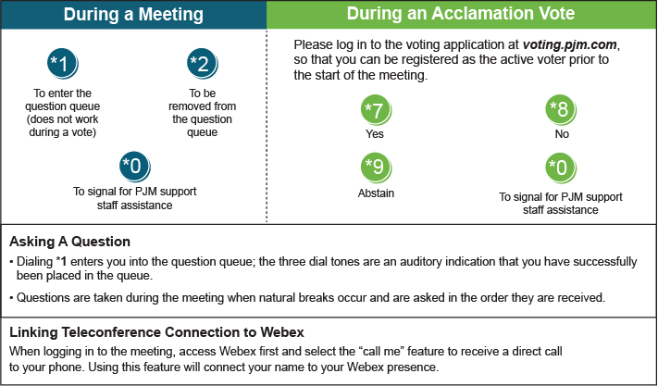

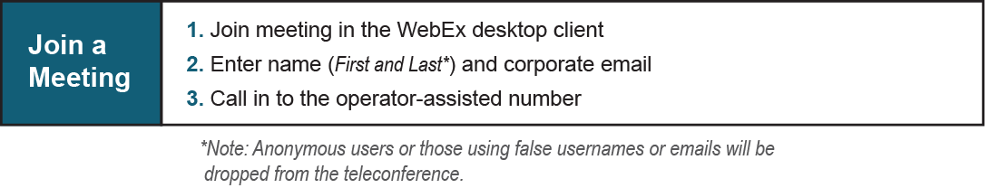

Provide feedback on the progress of this group: [*Facilitator Feedback Form*](https://www.pjm.com/committees-and-groups/committees/form-facilitator-feedback.aspx)   
Visit [*learn.pjm.com*](https://learn.pjm.com/), an easy-to-understand resource about the power industry and PJM’s role.