Market Implementation Committee
PJM Conference & Training Center, Audubon, PA
December 12, 2018
9:00 a.m. – 4:00 p.m. EPT

Administration (9:00-9:10)
Ms. Bhavana Keshavamurthy and Ms. Chantal Hendrzak will provide announcements; review the Antitrust, Code of Conduct, Public Meetings/Media Participation, the WebEx Participant Identification Requirement, and Issue Tracking.

The Committee will be asked to approve the draft minutes from the November 7, 2018 MIC meeting.

Endorsements/Approvals (9:10 - 09:45)
- FTR Mark-to-Auction Credit Requirements (9:10 - 9:45)
Ms.Bridgid Cummings, PJM, will present the Mark-to-Auction proposals.
Issue Tracking: FTR Mark-to-Auction Credit Requirements

The committee will be asked to vote on all packages. If a package receives greater than 50%, a second non-binding vote will be taken asking whether participants prefer the option with the highest percentage in favor greater than 50% over the status quo.

Additional Items (9:45-11:00)
- Fuel Cost Policy (9:45 - 10:45)
Ms.Bhavana Keshavamurthy, PJM, will review the interests identified and lead a discussion to develop design components. Design components and options can be provided in advance of the meeting (email :Diane.Antonelli@pjm.com) or during the meeting.
Issue Tracking: Fuel Cost Policy

- RTO wide black start RFP process (10:45 - 11:00)
Mr. David Schweizer, PJM, will provide an update on the RTO wide Black Start RFP process.

Lunch (11:30 - 12:30)

Informational Section
Credit Subcommittee (CS)
Meeting materials will be posted to the CS website.

Demand Response Subcommittee (DRS)
Meeting materials will be posted to the DRS web site.

Intermittent Resources Subcommittee (IRS)
Meeting materials will be posted to the IRS web site.

Interregional Coordination Update
Materials are posted as informational only.

Market Settlements Subcommittee (MSS)
Meeting materials are posted to the MSS web site.

Report on Market Operations
The Report on Market Operations will be reviewed during the MC Webinar.

Future Meeting Dates
January 9, 2019 | 9:00 a.m. | PJM Conference & Training Center/ WebEx
February 6, 2019 | 9:00 a.m. | PJM Conference & Training Center/ WebEx
March 6, 2019 | 9:00 a.m. | PJM Conference & Training Center/ WebEx
April 10, 2019 | 9:00 a.m. | PJM Conference & Training Center/ WebEx
May 15, 2019 | 9:00 a.m. | PJM Conference & Training Center/ WebEx
June 12, 2019 | 9:00 a.m. | PJM Conference & Training Center/ WebEx

Author: Bhavana Keshavamurthy

Antitrust:
You may not discuss any topics that violate, or that might appear to violate, the antitrust laws including but not limited to agreements between or among competitors regarding prices, bid and offer practices, availability of service, product design, terms of sale, division of markets, allocation of customers or any other activity that might unreasonably restrain competition. If any of these items are discussed the chair will re-direct the conversation. If the conversation still persists, parties will be asked to leave the meeting or the meeting will be adjourned.

Code of Conduct:
As a mandatory condition of attendance at today's meeting, attendees agree to adhere to the PJM Code of Conduct as detailed in PJM Manual M-34 section 4.5, including, but not limited to, participants' responsibilities and rules regarding the dissemination of meeting discussion and materials.

Public Meetings/Media Participation:
Unless otherwise noted, PJM stakeholder meetings are open to the public and to members of the media. Members of the media are asked to announce their attendance at all PJM stakeholder meetings at the beginning of the meeting or at the point they join a meeting already in progress. Members of the Media are reminded that speakers at PJM meetings cannot be quoted without explicit permission from the speaker. PJM Members are reminded that "detailed transcriptional meeting notes" and white board notes from "brainstorming sessions" shall not be disseminated. Stakeholders are also not allowed to create audio, video or online recordings of PJM meetings. PJM may create audio, video or online recordings of stakeholder meetings for internal and training purposes, and your participation at such meetings indicates your consent to the same.

Participant Identification in WebEx:
When logging into the WebEx desktop client, please enter your real first and last name as well as a valid email address. Be sure to select the “call me” option.
PJM support staff continuously monitors WebEx connections during stakeholder meetings. Anonymous users or those using false usernames or emails will be dropped from the teleconference.

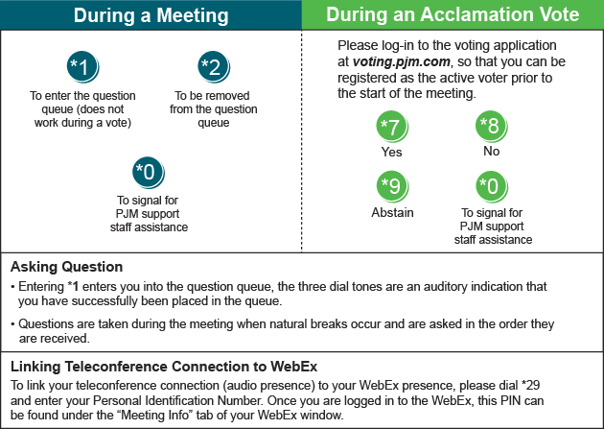

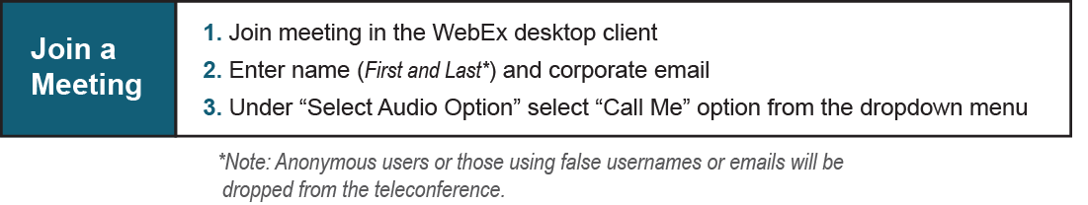

Provide feedback on the progress of this group: Facilitator Feedback Form
Visit learn.pjm.com, an easy-to-understand resource about the power industry and PJM’s role.

