Market Implementation Committee
PJM Conference & Training Center, Audubon, PA
July 12, 2017
9:00 a.m. – 4:00 p.m. EPT

Administration (9:00-9:10)
Welcome, announcements and review of the Antitrust, Code of Conduct, and Public Meetings/Media Participation Guidelines – Ms. Christina Stotesbury

The committee will be asked to approve draft minutes from the June 7, 2017 Market Implementation Committee meeting.

Review MIC Issue Tracking

Mr. Eric Hsia, PJM, will provide an update on a Black Start billing adjustment in the AEP zone.

Ms. Jen Tribulski, PJM, will provide an update on the Minimum Offer Price Rule (MOPR) appeal.

Endorsements/Approvals (9:10-10:10)
- Manual Revisions for Capacity Performance & Performance Assessment Hours (9:10-9:25)
Ms. Rebecca Stadelmeyer, PJM, will review revisions to Manual 11: Energy & Ancillary Services, and Manual 18: PJM Capacity Market, for revisions associated with Capacity Performance Shortfall and Bonus MW calculations. The committee will be asked to endorse the manual revisions.

- Manual Revisions for Intraday Offers (9:25-9:50)
- Ms. Lisa Morelli, PJM, will review revisions to Manual 11: Energy & Ancillary Services, associated with the implementation of Intraday Offers. The committee will be asked to endorse the manual revisions.
- Monitoring Analytics will present concerns related to the implementation of Intraday Offers in Manual 11.

- Governing Document Revisions to the Limitation on Claims (9:50-10:10)
Mr. Steven Shparber, PJM, will review Tariff and Operating Agreement revisions related to the Limitation on Claims. The committee will be asked to endorse the Tariff revisions.

Working Issues (10:10-11:05)
Annual Revenue Requirements for new Black Start Units – Phase 2 (10:10-10:25)
Mr. Tom Hauske, PJM, will present solution packages on the Minimum Tank Suction Levels (MTSL) as part of Phase 2 for the Annual Revenue Requirements for new Black Start units. Stakeholders will be given an opportunity to offer additional solutions.

- Energy Efficiency Participation in Capacity Markets (10:25-11:05)
Mr. Pete Langbein, PJM, will review the problem statement and issue charge that was approved at the June 7 MIC, and Ms. Terri Esterly, PJM, and Ms. Andrea Yeaton, PJM, will present education on the registration process and EE participation.
Break (11:05-11:15)

First Readings (11:15-12:15)
- Governing Document Revisions for PJM-MISO CTS (11:15-11:40)
- Mr. Michael Olaleye, PJM, will present a first read of conforming revisions to Manual 11: Energy & Ancillary Services, associated with Coordinated Transaction Scheduling. The committee will be asked to endorse the manual revisions at the August MIC meeting.
- Mr. Bhushan Dhuri, PJM, will present a first read of revisions to the Regional Transmission and Energy Scheduling Practices document. The committee will be asked to endorse the revisions at the August MIC meeting.

- Transmission Penalty Factors – Problem Statement and Issue Charge (11:40-12:00)
Dr. Joe Bowring, Monitoring Analytics, will present a first read of a problem statement and issue charge associated with Transmission Penalty Factors. The committee will be asked to approve the issue at the August MIC meeting.

- Market Path/Interface Pricing Point Alignment – Problem Statement and Issue Charge (12:00-12:15)
- Dr. Joe Bowring, Monitoring Analytics, will present a first read of a problem statement and issue charge associated with Market Path/Interface Pricing Point Alignment. The committee will be asked to approve the issue at the August MIC meeting.
- Dr. Joe Bowring, Monitoring Analytics, will provide education on the Pricing Point Alignment issue and review a proposed solution.

Lunch (12:15-1:00)

Additional Updates (1:00-2:30)
- Markets Gateway Enhancements (1:00-1:10)
Ms. Cheryl Mae Velasco, PJM, will provide an update on Markets Gateway enhancements that have been reviewed at the Tech Change Forum.

- Fuel Cost Policy Annual Review Process Update (1:10-1:45)
- Mr. Jeff Schmitt, PJM, will provide an update on the Annual Review of Fuel Cost Policies.
- Ms. Melissa Pilong, PJM, will review the VOM template and Mr. Scott Benner, PJM, will review the Emissions template as part of the Fuel Cost Policy Annual Review requirement. The deadline to submit VOM and Emissions data is August 1, 2017.

- Order 825: Shortage Pricing (1:45-2:10)
Ms. Lisa Morelli, PJM, will provide an update on Order 825: Shortage Pricing.

- Order 831: Offer Caps (2:10-2:30)
Ms. Alpa Jani, PJM, will provide an update on implementation details for Order 831: Offer Caps.

Informational Section
Credit Subcommittee (CS)
Meeting materials will be posted to the CS website.

Demand Response Subcommittee (DRS)
Meeting materials will be posted to the DRS web site.

Intermittent Resources Subcommittee (IRS)
Meeting materials will be posted to the IRS web site.

Interregional Coordination Activity
Mr. Tim Horger, PJM, will be available to answer questions on Interregional Coordination efforts.
Materials are posted as informational only.

Market Settlements Subcommittee (MSS)
Meeting materials are posted to the MSS web site.

Report on Market Operations
The Report on Market Operations will be reviewed during the MC Webinar.

Future Meeting Dates
August 9, 2017 | 9:00 a.m. | PJM Interconnection – Conference & Training Center
September 13, 2017 | 9:00 a.m. | PJM Interconnection – Conference & Training Center
October 11, 2017 | 9:00 a.m. | PJM Interconnection – Conference & Training Center
November 8, 2017 | 9:00 a.m. | PJM Interconnection – Conference & Training Center
December 13, 2017 | 9:00 a.m. | PJM Interconnection – Conference & Training Center

Author: Christina Stotesbury

Antitrust:
You may not discuss any topics that violate, or that might appear to violate, the antitrust laws including but not limited to agreements between or among competitors regarding prices, bid and offer practices, availability of service, product design, terms of sale, division of markets, allocation of customers or any other activity that might unreasonably restrain competition. If any of these items are discussed the chair will re-direct the conversation. If the conversation still persists, parties will be asked to leave the meeting or the meeting will be adjourned.

Code of Conduct:
As a mandatory condition of attendance at today's meeting, attendees agree to adhere to the PJM Code of Conduct as detailed in PJM Manual 34 Section 4.5, including, but not limited to, participants' responsibilities and rules regarding the dissemination of meeting discussion and materials.

Public Meetings/Media Participation:
Unless otherwise noted, PJM stakeholder meetings are open to the public and to members of the media. Members of the media are asked to announce their attendance at all PJM stakeholder meetings at the beginning of the meeting or at the point they join a meeting already in progress. Members of the Media are reminded that speakers at PJM meetings cannot be quoted without explicit permission from the speaker. PJM Members are reminded that "detailed transcriptional meeting notes" and white board notes from "brainstorming sessions" shall not be disseminated. Stakeholders are also not allowed to create audio, video or online recordings of PJM meetings.

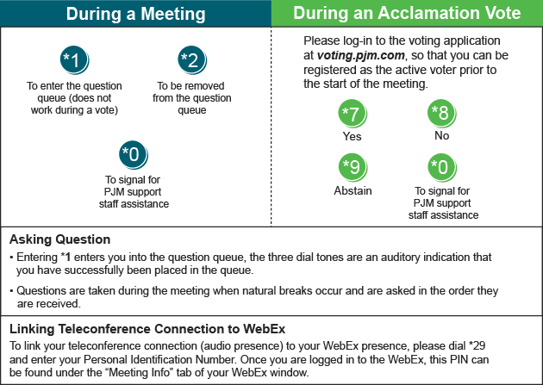
Facilitator Feedback Form: http://www.pjm.com/committees-and-groups/committees/form-facilitator-feedback.aspx

