Market Implementation Committee
PJM Conference & Training Center, Audubon, PA
August 10, 2016
9:30 a.m. – 4:00 p.m. EPT

Administration (9:30-9:40)
Welcome, announcements and review of the Antitrust, Code of Conduct, and Public Meetings/Media Participation Guidelines – Ms. Christina Stotesbury

Approve draft minutes from the July 13, 2016 Market Implementation Committee meeting, the July 27, 2016, and the August 4, 2016 Special Sessions of the Market Implementation Committee.

Review MIC Issue Tracking

Endorsements/Approvals (9:40-9:55)
Periodic Review for Manual 11 – Energy & Ancillary Services Market Operations (9:40-9:55)
Mr. Tong Zhao, PJM, and Ms. Cheryl Mae Velasco, PJM, will review changes to Manual 11 – Energy & Ancillary Services Market Operations for Day Ahead and Real Time as part of the periodic review process.
The Committee will be asked to endorse these changes.

Working Issues (9:55-3:20)
Residual ARR Enhancements (9:55-10:25)
Mr. Brian Chmielewski, PJM, will briefly review the Residual Auction Revenue Rights issue, and initiate discussion around potential enhancements to the Residual Auction Revenue Rights (ARR) process.
Issue Tracking: Residual ARR Enhancements

Operating Parameter Discussion (10:25-10:55)
- Mr. Tom Hauske, PJM, will provide a brief update on the proposals to un-nest Operating Parameter definitions in Manuals 11, 15 and 28.
- The MIC Chair will conduct a survey poll on the un-nested operating parameters and present the results immediately following.
The committee will be asked to endorse a package at the September MIC meeting.
Issue Tracking: Operating Parameter Definitions

Break (10:55-11:05)

Release of Capacity in 17/18 Delivery Year 3rd Incremental Auction (11:05-11:35)
Mr. Jeff Bastian, PJM, will review the PJM proposal and continue discussion in response to the reporting directive in FERC Docket ER16-532 concerning the release of annual capacity in the 2017/2018 Delivery Year 3rd Incremental Auction related to excess capacity procured in the Capacity Performance Transition Incremental Auction.

Spot-in Transmission Service for Energy Imports from NYISO (11:35-12:05)
Mr. Chris Pacella, PJM, and Mr. Joe Wadsworth, Vitol, will continue the discussion on spot-in transmission service for energy imports from NYISO.
Issue Tracking: Spot-in Transmission Service for Energy Imports from NYISO

Lunch (12:05-1:00)

Cost Development Guideline Changes and Fuel Cost Policy (1:00-1:30)
- Mr. Tom Hauske, PJM, will provide an update on governing document changes and the Fuel Cost Policy process as related to PJM’s Hourly Offer compliance filing.
- Dr. Joe Bowring, Monitoring Analytics, will present additional information and respond to PJM on behalf of the MMU.
The committee will be asked to endorse the Manual 15 changes at the September MIC meeting.

FERC Order 825 - Settlements (1:30-2:00)
Mr. Ray Fernandez, PJM, will provide a summary on FERC Order 825 related to energy, reserve and intertie settlements.

FERC Order 825 - Shortage (2:00-2:50)
Ms. Rebecca Stadelmeyer, PJM, will provide education on PJM’s current shortage practices and initiate discussion on FERC Order 825 shortage requirements.

Break (2:50-3:00)

Annual Revenue Requirements for new Black Start Units (3:00-3:20)
Mr. Tom Hauske, PJM, will provide education on Annual Revenue Requirements for new Black Start Units.

Additional Updates (3:20-4:00)
- FTR Credit Analysis Update (3:20-3:30)
Mr. Hal Loomis, PJM, will provide an update on the FTR Credit Analysis on behalf of the Credit Subcommittee.

- Net Energy Injections Quarterly Review (3:30-3:40)
Ms. Jennifer Warner-Freeman, PJM, will review the 2nd quarter Net Energy Injections Quarterly Report.

- Unit Specific Adjustment Process Review (3:40-3:50)
Ms. Alpa Jani, PJM, will review Unit Specific Adjustment Process updates.

- Inter-Regional Coordination Activity (3:50-4:00)
- Mr. Tim Horger, PJM, will provide an update on Inter-Regional Coordination activity.
- Mr. Tim Horger, PJM, will also provide an update on the PSE&G/ConEd Wheel Modeling.

Informational Section
Credit Subcommittee (CS)
Meeting materials will be posted to the CS website.

Demand Response Subcommittee (DRS)
Meeting materials will be posted to the DRS web site.

DR Hub
As discussed over the last 6 months at the Demand Response Subcommittee (“DRS”), PJM is developing a replacement tool for eLRS called “DR Hub”. Questions and feedback regarding DR Hub should be sent to DRHubSupport@pjm.com. PJM will continue to update members on the status and timeline for the DR Hub implementation at the DRS and through the DRS email notification distribution. Stakeholders interested in receiving updates on DR Hub should self-subscribe to “eLRS/DR Hub” via My Email Lists by selecting “PJM Tools”.

Intermittent Resources Subcommittee (IRS)
Meeting materials will be posted to the IRS web site.

Market Settlements Subcommittee (MSS)
Meeting materials are posted to the MSS web site.

Report on Market Operations
The Report on Market Operations will be reviewed during the MC Webinar.

Future Meeting Dates
September, 14, 2016 | 9:30 a.m. | PJM Interconnection – Conference & Training Center
October 5, 2016 | 9:30 a.m. | PJM Interconnection – Conference & Training Center
November 2, 2016 | 9:30 a.m. | PJM Interconnection – Conference & Training Center
December 14, 2016 | 9:30 a.m. | PJM Interconnection – Conference & Training Center

Author: Christina Stotesbury

Antitrust:
You may not discuss any topics that violate, or that might appear to violate, the antitrust laws including but not limited to agreements between or among competitors regarding prices, bid and offer practices, availability of service, product design, terms of sale, division of markets, allocation of customers or any other activity that might unreasonably restrain competition. If any of these items are discussed the chair will re-direct the conversation. If the conversation still persists, parties will be asked to leave the meeting or the meeting will be adjourned.

Code of Conduct:
As a mandatory condition of attendance at today's meeting, attendees agree to adhere to the PJM Code of Conduct as detailed in PJM Manual M-34 section 4.5, including, but not limited to, participants' responsibilities and rules regarding the dissemination of meeting discussion and materials.

Public Meetings/Media Participation:
Unless otherwise noted, PJM stakeholder meetings are open to the public and to members of the media. Members of the media are asked to announce their attendance at all PJM stakeholder meetings at the beginning of the meeting or at the point they join a meeting already in progress. Members of the Media are reminded that speakers at PJM meetings cannot be quoted without explicit permission from the speaker. PJM Members are reminded that "detailed transcriptional meeting notes" and white board notes from "brainstorming sessions" shall not be disseminated. Stakeholders are also not allowed to create audio, video or online recordings of PJM meetings.

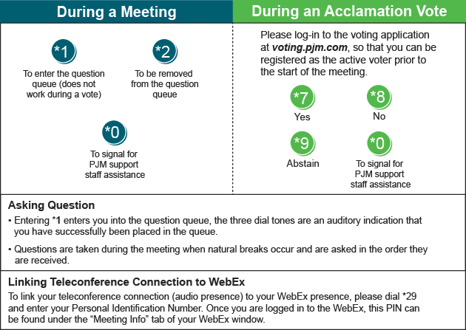
Facilitator Feedback Form: http://www.pjm.com/committees-and-groups/committees/form-facilitator-feedback.aspx

