Market Implementation Committee
PJM Conference & Training Center, Audubon, PA
April 6, 2016
9:30 a.m. – 2:30 p.m. EPT

Administration (9:30-9:40)
Welcome, announcements and review of the Antitrust, Code of Conduct, and Public Meetings/Media Participation Guidelines – Ms. Christina Stotesbury

Approve draft minutes from the March 9, 2016 Market Implementation Committee meeting.

Review MIC Issue Tracking

Endorsements/Approvals (9:40-10:00)
Demand Response Emergency Energy Settlement Measurement and Verification (9:40-9:50)
Mr. Pete Langbein, PJM, will present proposed changes for the Demand Response Emergency Energy Settlement Measurement and Verification process. The proposal will change the emergency energy default CBL from the “hour before” methodology to the current default economic CBL (3 daytype with symmetric additive adjustment). The committee will be asked to endorse this change.

Spot-in Transmission Service Imports from NYISO (9:50-10:00)
Mr. Joe Wadsworth, Vitol Inc., will present a Problem Statement and Issue Charge regarding Spot-in Transmission Service for imports from New York ISO. The committee will be asked to approve the Problem Statement and Issue Charge.

First Readings (10:00-10:15)
Manual 11 – Day-Ahead Scheduling Reserve (10:00-10:15)
Mr. Keyur Patel, PJM, will review a problem statement and issue charge for changes to Manual 11 – Energy & Ancillary Services Market Operations for the Day-Ahead Scheduling Reserve (DASR). The committee will be asked to endorse the problem statement and issue charge at the May Market Implementation Committee.

Informational Updates (10:15-11:45)
Emergency Procedures Update (10:15-10:35)
Mr. David Hislop, PJM, will provide an update to PJM Emergency Procedures that are changing due to the implementation of Capacity Performance.

Real-Time Values (10:35-11:20)
- Mr. Tong Zhao, PJM, will review changes to Manual 11 - Energy & Ancillary Services Market Operations to define Real-Time Values relating to the implementation of Capacity Performance. The committee will be asked to endorse these changes at the May Market Implementation Committee meeting.
- Mr. Ray Fernandez, PJM, will provide an update on the settlements impact for the implementation of Real-Time Values (RTV) parameters.
Break (11:20-11:30)

Unit Specific Parameters (11:30-11:35)
Ms. Alpa Jani, PJM, will provide an update on the Maximum Run Time parameter implementation discussed at the Operating Committee.

Inter-Regional Coordination Activity (11:35-11:45)
- Ms. Danielle Croop, PJM, will present Joint Operating Agreement changes for the Michigan Ontario Par.
- Ms. Danielle Croop, PJM, will review a PJM-MISO M2M Settlement Adjustment.

Working Issues (11:45-2:30)
Market Settlement Subcommittee – Settlement C (11:45-12:00)
Mr. Ray Fernandez, PJM, will review the Settlement C issue that has been discussed at the Market Settlement Subcommittee. The committee will be asked for support to terminate work on the problem statement and issue charge that was presented to the MIC on September 9, 2015.

Lunch (12:00-12:45)

PLS Exception Process (12:45-1:05)
Mr. Tong Zhao, PJM, and Ms. Jacqui Hugee, PJM, will present a PLS Exception process proposal for consideration. The committee will be asked for feedback on the proposal.

Auction Specific Bilateral Transactions (1:05-1:35)
Ms. Jen Tribulski, PJM, will present PJM’s proposed solution package on Auction Specific Bilateral Transactions and provide any additional education as needed.

Capacity Import Limit Exception Modification from the GDECS (1:35-1:50)
Ms. Jen Tribulski, PJM, will present the CIL Exception language from the Governing Documents Enhancements & Clarifications Subcommittee, along with the friendly amendment offered thereto, for further stakeholder discussion before seeking endorsement at the next Members Committee meeting.

Operating Parameter Discussion (1:50-2:30)
Mr. Tom Hauske, PJM, will continue the discussion around un-nesting Operating Parameter definitions in Manuals 11, 15 and 28. Min run, soak time, min down time, (new) ramp to release
Issue Tracking: Operating Parameter Definitions

Informational Section
Report on Market Operations
The Report on Market Operations will be reviewed during the MC Webinar.

Inter-regional Coordination Efforts
Mr. Stan Williams, PJM, will be available to answer questions on inter-regional coordination efforts.

Markets Gateway
Ms. Risa Holland, PJM, will be available during the meeting to answer questions on Markets Gateway.
PJM will retire eMKT at 7:00 a.m. EPT on April 19, 2016. Information entered in eMKT prior to its retirement will be accessible in Markets Gateway. Both Markets Gateway and eMKT will continue to be available for parallel operations through 04/19/2016. Please continue to transition to Markets Gateway and discontinue use of eMKT to ensure PJM’s ability to monitor Market Gateway’s performance. As of 7AM EPT on 04/19/2016, stakeholders can only use Markets Gateway to enter or view market data information. PJM asks that you continue to send questions to MarketsGatewaySupport@pjm.com.

Transmission Operations Manual 3 Review
Ms. Nicole Scott, PJM, will be available to answer questions on updates to Manual 3 - Transmission Operations. Materials are posted as Informational Only.

MIC Working Session Updates
Energy Scheduling
Energy Scheduling was put on hold to allow for further discussion at Joint and Common Market (JCM) meetings. Interface pricing became more narrowly focused and a document was issued to provide clarification around this issue. The other outstanding issue is related to the IMO Pricing Point, which PJM is working with Monitoring Analytics to define. Additional clarification will be provided when available.
Issue Tracking: Energy Scheduling

FTR Forfeiture
The last MIC working session was held on February 18, 2014. PJM submitted comments to the FERC related to Docket No. EL14-37-000 in June 2015, and is awaiting a FERC Order. Meeting materials are posted to the MIC web site.
Issue Tracking: FTR Forfeiture

Up-To Congestion Transactions
A MIC working session was held on June 10, 2014. This issue has been put on hold to allow greater concentration on the remaining issues in the stakeholder process which have more pressing completion date requirements. When available, materials will be posted to the MIC web site.
Issue Tracking: Up To Congestion Transactions – Financial and Node Limitation

Subcommittee and Task Force Updates
Credit Subcommittee (CS)
Meeting materials will be posted to the CS website.

Demand Response Subcommittee (DRS)
Meeting materials will be posted to the DRS web site.

Intermittent Resources Subcommittee (IRS)
Meeting materials will be posted to the IRS web site.

Market Settlements Subcommittee (MSS)
Meeting materials are posted to the MSS web site.

Future Meeting Dates
May 11, 2016 | 9:30 a.m. | PJM Interconnection – Conference & Training Center
June 8, 2016 | 9:30 a.m. | PJM Interconnection – Conference & Training Center
July 13, 2016 | 9:30 a.m. | PJM Interconnection – Conference & Training Center
August 10, 2016 | 9:30 a.m. | PJM Interconnection – Conference & Training Center
September, 14, 2016 | 9:30 a.m. | PJM Interconnection – Conference & Training Center
October 5, 2016 | 9:30 a.m. | PJM Interconnection – Conference & Training Center
November 2, 2016 | 9:30 a.m. | PJM Interconnection – Conference & Training Center
December 14, 2016 | 9:30 a.m. | PJM Interconnection – Conference & Training Center

Author: Christina Stotesbury

Antitrust:
You may not discuss any topics that violate, or that might appear to violate, the antitrust laws including but not limited to agreements between or among competitors regarding prices, bid and offer practices, availability of service, product design, terms of sale, division of markets, allocation of customers or any other activity that might unreasonably restrain competition. If any of these items are discussed the chair will re-direct the conversation. If the conversation still persists, parties will be asked to leave the meeting or the meeting will be adjourned.

Code of Conduct:
As a mandatory condition of attendance at today's meeting, attendees agree to adhere to the PJM Code of Conduct as detailed in PJM Manual M-34 section 4.5, including, but not limited to, participants' responsibilities and rules regarding the dissemination of meeting discussion and materials.

Public Meetings/Media Participation:
Unless otherwise noted, PJM stakeholder meetings are open to the public and to members of the media. Members of the media are asked to announce their attendance at all PJM stakeholder meetings at the beginning of the meeting or at the point they join a meeting already in progress. Members of the Media are reminded that speakers at PJM meetings cannot be quoted without explicit permission from the speaker. PJM Members are reminded that "detailed transcriptional meeting notes" and white board notes from "brainstorming sessions" shall not be disseminated. Stakeholders are also not allowed to create audio, video or online recordings of PJM meetings.

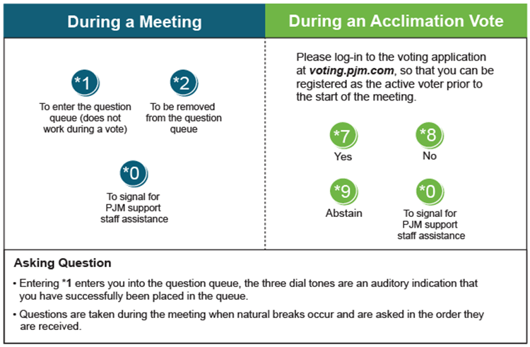

Facilitator Feedback Form: http://www.pjm.com/committees-and-groups/committees/form-facilitator-feedback.aspx

