Members Committee

Two Hundred Fourteenth Meeting

Webex Only

July 28, 2021

1:00 p.m. – 5:00 p.m. EPT

***\*Operator assisted phone lines will be opened 30 minutes prior to the start of the meeting. Due to the high volume of remote participation, stakeholders are asked to connect early to allow additional time for operator queue processing.***

Administration (1:00-1:10)

1. Announce sector selections of new members since the last meeting – David Anders
2. Confirm the presence of a quorum of representatives or designated alternates for this meeting – David Anders
3. Anti-trust, Code of Conduct, Meeting Participation, and Safety announcements – David Anders

Consent Agenda (1:10-1:15)

1. **Approve** draft minutes of the June 23, 2021 Members Committee meeting.
2. **Approve** draft minutes of the June 30, 2021 Special MC-CIFP.
3. **Approve** draft minutes of the July 14, 2021 MC Special Meeting.
4. **Approve** proposed revisions to Manual 34: PJM Stakeholder Process to address clarifications within the newly revised Section 9.5 Motion Amendments.
5. **Endorse** Tariff revisions to address concerns associated with the pro forma Interconnection Construction Service Agreement’s (a) lack of superseding language and (b) current automatic termination provision.

[Issue Tracking: ICSA Superseding Language and Automatic Termination Provision](https://www.pjm.com/committees-and-groups/issue-tracking/issue-tracking-details.aspx?Issue=0e5d5f5b-2ea8-483d-af01-a4bb9fc51cb5)

Endorsements (1:15-1:30)

1. Non-Firm Transmission Service Preemption (1:15-1:30)

Jeff McLaughlin will review proposed revisions to section 14.2 of the Tariff related to preemption of non-firm transmission service. **The committee will be asked to endorse the proposed solution. The Markets and Reliability Committee (MRC) endorsement will be sought on the same day.**

First Reads (1:30-2:15)

1. PJM Administrative Rates (1:30-1:55)
2. Jim Snow will review a proposal and Tariff revisions related to PJM administrative rates. The committee will be asked to endorse the proposed solution and Tariff revisions at its next meeting.
3. Jim Benchek, American Transmission Systems, Inc., will provide comments from the Member representatives on the Finance Committee.
4. Manual 34 Revisions (1:55-2:15)

John Horstmann, The Dayton Power & Light Company, will sponsor proposed revisions to Manual 34: PJM Stakeholder Process addressing photography in meetings and media guidelines. The committee will be asked to approve the proposed revisions at its next meeting.

Reports (2:15-2:30)

1. MC Vice Chair Report (2:15-2:25)
2. Provide an update on the Members Committee Annual Plan – Becky Robinson
3. Provide a preview on the July 26, 2021 Liaison Committee meeting with the PJM Board of Managers – Becky Robinson
4. Webinar Feedback (2:25-2:30)

Stakeholders may raise any items identified for further discussion from the June 21, 2021 Members Committee Webinar.

|  |
| --- |
| Future Agenda Items (2:30) |
|  |

|  |  |  |  |  |
| --- | --- | --- | --- | --- |
| **Future Meeting Dates and Materials** | | | **Materials Due  to Secretary** | **Materials Published** |
| Date | Time | Location |
| September 29, 2021 | 1:15 p.m. | WebEx | September 17, 2021 | September 22, 2021 |
| October 20, 2021 | 1:15 p.m. | WebEx | October 8, 2021 | October 13, 2021 |
| November 17, 2021 | 1:15 p.m. | WebEx | November 5, 2021 | November 10, 2021 |
| December 15, 2021 | 1:15 p.m. | WebEx | December 3, 2021 | December 8, 2021 |

Author: M. Greening

Antitrust:

You may not discuss any topics that violate, or that might appear to violate, the antitrust laws including but not limited to agreements between or among competitors regarding prices, bid and offer practices, availability of service, product design, terms of sale, division of markets, allocation of customers or any other activity that might unreasonably restrain competition. If any of these items are discussed the chair will re-direct the conversation. If the conversation still persists, parties will be asked to leave the meeting or the meeting will be adjourned.

Code of Conduct:

As a mandatory condition of attendance at today's meeting, attendees agree to adhere to the PJM Code of Conduct as detailed in PJM Manual M-34 section 4.5, including, but not limited to, participants' responsibilities and rules regarding the dissemination of meeting discussion and materials.

Public Meetings/Media Participation:

Unless otherwise noted, PJM stakeholder meetings are open to the public and to members of the media. Members of the media are asked to announce their attendance at all PJM stakeholder meetings at the beginning of the meeting or at the point they join a meeting already in progress. Members of the Media are reminded that speakers at PJM meetings cannot be quoted without explicit permission from the speaker. PJM Members are reminded that "detailed transcriptional meeting notes" and white board notes from "brainstorming sessions" shall not be disseminated. Stakeholders are also not allowed to create audio, video or online recordings of PJM meetings. PJM may create audio, video or online recordings of stakeholder meetings for internal and training purposes, and your participation at such meetings indicates your consent to the same.

Participant Identification in Webex:

When logging into the Webex desktop client, please enter your real first and last name as well as a valid email address. Be sure to select the “call me” option.

PJM support staff continuously monitors Webex connections during stakeholder meetings. Anonymous users or those using false usernames or emails will be dropped from the teleconference.

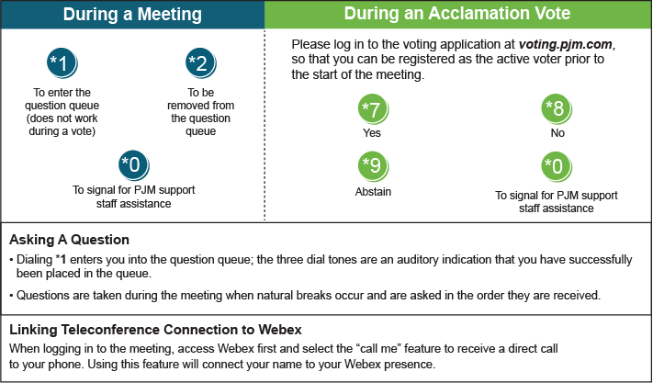

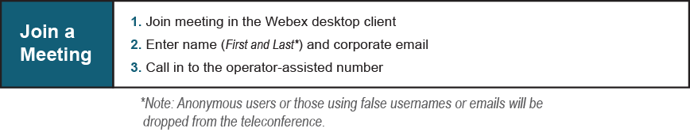

Provide feedback on the progress of this group: [*Facilitator Feedback Form*](https://www.pjm.com/committees-and-groups/committees/form-facilitator-feedback.aspx)   
Visit [*learn.pjm.com*](https://learn.pjm.com/), an easy-to-understand resource about the power industry and PJM’s role.