Members Committee Webinar
PJM Conference and Training Center
February 18, 2020
1:00 p.m. – 3:30 p.m. EPT

Administration (1:00-1:05)
Welcome, announcements and Anti-trust and Code of Conduct announcement – Ms. Janell Fabiano

Informational Updates (1:05-1:25)
- Interregional Coordination (1:05– 1:15)
Mr. Joseph Ciabattoni will provide an update on interregional coordination activities

- Operational Data & Dispatch Rates Page Retirements (1:15 – 1:20)
Ms. Tawnya Luna will provide information on the retirement of the PJM.com Operational Data and Dispatch Rates pages.
- Stakeholder Process Forum Feedback (1:20 – 1:25)
Ms. Michele Greening will summarize discussion from the December 2, 2019 Stakeholder Process Forum

Upcoming Stakeholder Process Items
None

Reports (1:25-3:25)
- State Activities (1:25-1:30)
Receive report on recent activities of the Organization of PJM States, Inc. – Mr. Gregory Carmean
- Market Monitoring Report (1:30-1:45)
Receive report of the Independent Market Monitor – Mr. Joe Bowring

- PJM Updates (1:45-2:15)
- Receive report on market operations – Ms. Jennifer Freeman
- Receive report on system operations – Ms. Hong Chen
- Receive report on recent regulatory activities – Ms. Jessica Troiano

- Standing Committee Reports (2:15-2:35)
A. Markets and Reliability Committee (MRC) – Mr. Dave Anders
- Market Implementation Committee (MIC) – Ms. Bhavana Keshavamurthy
- Operating Committee (OC) – Ms. Danielle Croop
- Planning Committee (PC) – Ms. Molly Mooney

- Informational Reports (2:35 – 3:25)
A. Capacity Market Capability of Energy Storage Resources (MIC) – Mr. Andrew Levitt
B. Opportunity Cost Calculator (MIC) – Mr. Glen Boyle
C. Five Minute Dispatch and Pricing (MIC) – Ms. Alex Scheirer
D. Fuel Requirements for Black Start Resources (OC/MIC) – Ms. Janell Fabiano
E. RTEP Market Efficiency Analysis (MEPETF) – Mr. Jack Thomas

- Informational Only Postings
Item | Issue | Committee | Stakeholder Process Status
a. | Transparency and End of Life Planning | MRC Special Sessions | Developing Options
b. | Real Time Market Values | MIC | Education
c. | Stability Limits in Markets and Operations | MIC | Education
d. | Fuel Cost Policy | MIC | Solution Alternatives Proposed
e. | Non-Retail Behind the Meter Generation Business Rules | OC | Education
f. | Critical Infrastructure Stakeholder Oversight | PC | Education
g. | ARR/FTR Market Review | AFMTF | Education
h. | Carbon Pricing | CPSTF | Education
i. | Distributed Energy Resources in PJM Markets | DERS | Packages
j. | Financial Risk Mitigation | FRMSTF | Solution Alternatives Proposed
k. | Harmonizing Provisions of Governing Documents | GDECS | Reviewing Language Edits
l. | Modeling Generation in Markets Gateway | MGSTF | Solution Alternatives Proposed
m. | Load Reconciliation Process | MSS | Polling

Future Agenda Items (3:25 - 3:30)

Future Meeting Dates
March 23, 2020  May 26, 2020  June 15, 2020  July 20, 2020  September 14, 2020  October 26, 2020  November 16, 2020/  December 14, 2020 | 1:00 p.m.  1:00 p.m.  1:00 p.m.  1:00 p.m.  1:00 p.m.  1:00 p.m.  1:00 p.m.  1:00 p.m. | PJM Conference and Training Center/ WebEx PJM Conference and Training Center/ WebEx PJM Conference and Training Center/ WebEx PJM Conference and Training Center/ WebEx PJM Conference and Training Center/ WebEx PJM Conference and Training Center/ WebEx PJM Conference and Training Center/ WebEx PJM Conference and Training Center/ WebEx
Author: Janell L Fabiano

Antitrust:
You may not discuss any topics that violate, or that might appear to violate, the antitrust laws including but not limited to agreements between or among competitors regarding prices, bid and offer practices, availability of service, product design, terms of sale, division of markets, allocation of customers or any other activity that might unreasonably restrain competition. If any of these items are discussed the chair will re-direct the conversation. If the conversation still persists, parties will be asked to leave the meeting or the meeting will be adjourned.

Code of Conduct:
As a mandatory condition of attendance at today's meeting, attendees agree to adhere to the PJM Code of Conduct as detailed in PJM Manual M-34 section 4.5, including, but not limited to, participants' responsibilities and rules regarding the dissemination of meeting discussion and materials.
Public Meetings/Media Participation:
Unless otherwise noted, PJM stakeholder meetings are open to the public and to members of the media. Members of the media are asked to announce their attendance at all PJM stakeholder meetings at the beginning of the meeting or at the point they join a meeting already in progress. Members of the Media are reminded that speakers at PJM meetings cannot be quoted without explicit permission from the speaker. PJM Members are reminded that "detailed transcriptional meeting notes" and white board notes from "brainstorming sessions" shall not be disseminated. Stakeholders are also not allowed to create audio, video or online recordings of PJM meetings. PJM may create audio, video or online recordings of stakeholder meetings for internal and training purposes, and your participation at such meetings indicates your consent to the same.
Participant Identification in WebEx:
When logging into the WebEx desktop client, please enter your real first and last name as well as a valid email address. Be sure to select the “call me” option.
PJM support staff continuously monitors WebEx connections during stakeholder meetings. Anonymous users or those using false usernames or emails will be dropped from the teleconference.



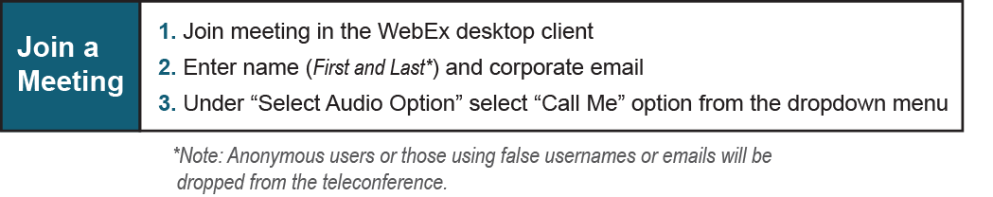

Provide feedback on the progress of this group: Facilitator Feedback Form
Visit learn.pjm.com, an easy-to-understand resource about the power industry and PJM’s role.

