Members Committee Webinar
PJM Conference and Training Center
January 21, 2020
1:00 p.m. – 3:30 p.m. EPT

Administration (1:00-1:05)
Welcome, announcements and Anti-trust and Code of Conduct announcement – Ms. Janell Fabiano

Informational Updates (1:05-1:55)
- Interregional Coordination (1:05– 1:15)
Mr. Joseph Ciabattoni will provide an update on interregional coordination activities

- Stakeholder Process Forum Feedback (1:15-1:20)
Ms. Michele Greening will summarize discussion from the December 2, 2019 Stakeholder Process Forum
- Officer of Member and Authorized Representative Designation (1:20 – 1:30)
Ms. Amanda Egan will review the requirements for the completion of the Officer of the Member and Authorized Representative designation through the Form of Secretary Certificate. All full Members are asked to provide this information to PJM by January 31, 2020.
- PJM Annual Meeting Changes (1:30 – 1:40)
Ms. Jennifer Tribulski will provide an update regarding the PJM Annual Meeting and describe registration updates and enhancements

Upcoming Stakeholder Process Items
None

Reports (1:40-3:35)
- State Activities (1:40-1:45)
Receive report on recent activities of the Organization of PJM States, Inc. – Mr. Gregory Carmean
- Market Monitoring Report (1:45-2:00)
Receive report of the Independent Market Monitor – Mr. Joe Bowring

- PJM Updates (2:00-2:30)
- Receive report on market operations – Ms. Laura Walter
- Receive report on system operations – Ms. Hong Chen
- Receive report on recent regulatory activities – Mr. Thomas DeVita

- Stakeholder Group Reports (2:30-3:25)
- Markets and Reliability Committee (MRC) – Mr. Dave Anders
- Market Implementation Committee (MIC) – Ms. Bhavana Keshavamurthy
- Operating Committee (OC) – Ms. Danielle Croop
- Planning Committee (PC) – Ms. Molly Mooney
- ARR FTR Market Task Force (ARMTF) – Ms. Emmy Messina
- Carbon Pricing Sr. Task Force (CPSTF) – Ms. Suzanne Coyne
- Financial Risk Mitigation Sr. Task Force (FRMSTF) – Ms. Anita Patel
- Governing Document Enhancement & Clarification Subcommittee (GDECS) – no update
- Market Efficiency Process Enhancement Task Force (MEPETF) – Mr. Jack Thomas
- Modeling Generation Sr. Task Force (MGSTF) – Ms. Megan McLaverty

Future Agenda Items (3:25 - 3:30)

Future Meeting Dates
February 18, 2020  March 23, 2020  April 27, 2020  June 15, 2020  July 20, 2020  September 14, 2020  October 26, 2020  November 16, 2020/  December 14, 2020 | 1:00 p.m.  1:00 p.m.  1:00 p.m.  1:00 p.m.  1:00 p.m.  1:00 p.m.  1:00 p.m.  1:00 p.m.  1:00 p.m. | PJM Conference and Training Center/ WebEx PJM Conference and Training Center/ WebEx PJM Conference and Training Center/ WebEx PJM Conference and Training Center/ WebEx PJM Conference and Training Center/ WebEx PJM Conference and Training Center/ WebEx PJM Conference and Training Center/ WebEx PJM Conference and Training Center/ WebEx PJM Conference and Training Center/ WebEx
Author: Janell L Fabiano

Antitrust:
You may not discuss any topics that violate, or that might appear to violate, the antitrust laws including but not limited to agreements between or among competitors regarding prices, bid and offer practices, availability of service, product design, terms of sale, division of markets, allocation of customers or any other activity that might unreasonably restrain competition. If any of these items are discussed the chair will re-direct the conversation. If the conversation still persists, parties will be asked to leave the meeting or the meeting will be adjourned.

Code of Conduct:
As a mandatory condition of attendance at today's meeting, attendees agree to adhere to the PJM Code of Conduct as detailed in PJM Manual M-34 section 4.5, including, but not limited to, participants' responsibilities and rules regarding the dissemination of meeting discussion and materials.
Public Meetings/Media Participation:
Unless otherwise noted, PJM stakeholder meetings are open to the public and to members of the media. Members of the media are asked to announce their attendance at all PJM stakeholder meetings at the beginning of the meeting or at the point they join a meeting already in progress. Members of the Media are reminded that speakers at PJM meetings cannot be quoted without explicit permission from the speaker. PJM Members are reminded that "detailed transcriptional meeting notes" and white board notes from "brainstorming sessions" shall not be disseminated. Stakeholders are also not allowed to create audio, video or online recordings of PJM meetings. PJM may create audio, video or online recordings of stakeholder meetings for internal and training purposes, and your participation at such meetings indicates your consent to the same.
Participant Identification in WebEx:
When logging into the WebEx desktop client, please enter your real first and last name as well as a valid email address. Be sure to select the “call me” option.
PJM support staff continuously monitors WebEx connections during stakeholder meetings. Anonymous users or those using false usernames or emails will be dropped from the teleconference.



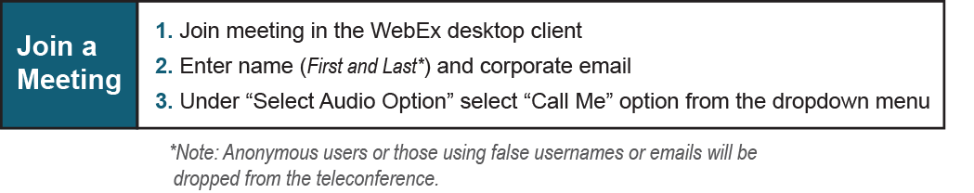

Provide feedback on the progress of this group: Facilitator Feedback Form
Visit learn.pjm.com, an easy-to-understand resource about the power industry and PJM’s role.

