Demand Response Subcommittee
PJM Conference and Training Center
June 22, 2018
9:30 a.m. – 12:00 p.m. EPT

Administration (9:30-9:40)
- Welcome, Announcements and Anti-trust and Code of Conduct announcement
- Roll call: in-person only
- Review prior minutes – 5/21/2018 meeting
- Request for any additional agenda items
- DRS Secretary role transition from Andrea Yeaton to Jack Thomas
- Brief update/discussion of DR related activity in other stakeholder groups – MIC, OC, PC, or other

Seasonal DR Aggregation Registration Rules (9:40-9:50)
- Ms. Andrea Yeaton, PJM, will review a clarification to the proposal around aggregation of Capacity Performance registrations.

Update to Load Management registration submission deadline language (9:50-10:05)
- Ms. Andrea Yeaton, PJM, will review a change to the OATT and OA through GDECS to clarify the Load Management submission deadline.

Duplicate Resolution Process (10:05-10:30)
- Ms. Andrea Yeaton will review the duplicate registrations from the last 2 years and lead a discussion of changes that might be needed for the process next year.

Demand Response Activity Report (10:30-11:00)
- Ms. Masha Nyemko, PJM, will review the DR Activity Report

Future Agenda Items
Participants will have the opportunity to request the addition of any new item(s) to the agenda of a future meeting.

Future Meeting Dates
Monday | 7/16/2018 | 9:30 am – 4:00 pm | PJM Conference & Training Center/ Webex
Thursday | 8/30/2018 | 9:30 am – 4:00 pm | PJM Conference & Training Center/ Webex
Tuesday | 9/25/2018 | 9:30 am – 4:00 pm | PJM Conference & Training Center/ Webex
Wednesday | 10/24/2018 | 9:30 am – 4:00 pm | PJM Conference & Training Center/ Webex
Friday | 11/16/2018 | 9:30 am – 4:00 pm | PJM Conference & Training Center/ Webex
Monday | 12/10/2018 | 9:30 am – 4:00 pm | PJM Conference & Training Center/ Webex

Author: Andrea Yeaton

Antitrust:
You may not discuss any topics that violate, or that might appear to violate, the antitrust laws including but not limited to agreements between or among competitors regarding prices, bid and offer practices, availability of service, product design, terms of sale, division of markets, allocation of customers or any other activity that might unreasonably restrain competition. If any of these items are discussed the chair will re-direct the conversation. If the conversation still persists, parties will be asked to leave the meeting or the meeting will be adjourned.

Code of Conduct:
As a mandatory condition of attendance at today's meeting, attendees agree to adhere to the PJM Code of Conduct as detailed in PJM Manual M-34 section 4.5, including, but not limited to, participants' responsibilities and rules regarding the dissemination of meeting discussion and materials.

Public Meetings/Media Participation:
Unless otherwise noted, PJM stakeholder meetings are open to the public and to members of the media. Members of the media are asked to announce their attendance at all PJM stakeholder meetings at the beginning of the meeting or at the point they join a meeting already in progress. Members of the Media are reminded that speakers at PJM meetings cannot be quoted without explicit permission from the speaker. PJM Members are reminded that "detailed transcriptional meeting notes" and white board notes from "brainstorming sessions" shall not be disseminated. Stakeholders are also not allowed to create audio, video or online recordings of PJM meetings.

Participant Identification in WebEx:
When logging into the WebEx desktop client, please enter your real first and last name as well as a valid email address. Be sure to select the “call me” option.
PJM support staff continuously monitors WebEx connections during stakeholder meetings. Anonymous users or those using false usernames or emails will be dropped from the teleconference.



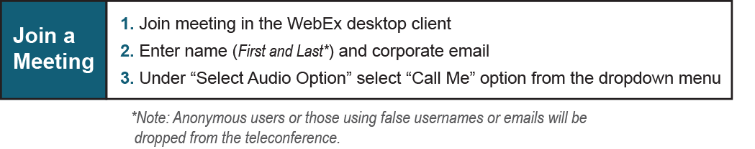

Provide feedback on the progress of this group: Facilitator Feedback Form
Visit learn.pjm.com an easy-to-understand resource about the power industry and PJM’s role.

