November Planning Committee
Teleconference / WebEx
November 4, 2020
9:00 a.m. – 12:00 p.m. EPT

Administration (9:00 – 9:15)
- Welcome, announcements and review of the Anti-trust, Code of Conduct, and Media Participation Guidelines.
- Approve Planning Committee (PC) Agenda for this meeting
- Approve draft minutes from the October 6, 2020 PC meeting
- Review of PC Charter. The committee will be requested to endorse the Charter at next month’s meeting.

Endorsements (9:15 – 9:45)
- Manual 14C Update
Mark Sims, PJM, will provide a second read of changes to Manual 14C: Generation and Transmission Interconnection Facility Construction, as part of the biennial cover-to-cover review. The committee will be requested to endorse the changes at today’s meeting.

First Reads (9:45– 11:15)
- Storage As Transmission Asset Update
Michele Greening, PJM, will discuss work being done at the most recent Storage As Transmission Asset Special Planning Committee sessions and review recent poll results. Jeffrey Goldberg, PJM, will present a first read of PJM’s package. The committee will be asked to endorse the package at its next meeting.
Issue Tracking: Storage As a Transmission Asset
- Critical Infrastructure Stakeholder Update
Christina Stotesbury, PJM, will review results from the second survey monkey poll on the Critical Infrastructure Stakeholder Oversight issue. Mike Herman, PJM, will present a first read of proposals to address both the Mitigation and Avoidance of future CIP-014 facilities. The committee will be asked to endorse the packages at its next meeting.
Issue Tracking: Critical Infrastructure Stakeholder Oversight

Informational Updates (11:15 – 12:00)
- Recent Load Impacts and Load Forecast Model Development
A. Andrew Gledhill, PJM, will present the estimated Covid-19 impacts on recent loads.
B. Andrew Gledhill, will discuss details of proposed load forecast model changes.
- Update on Executive Order on Bulk Electric Power System
Craig Glazer, PJM, will provide an update on Department of Energy Efforts to Implement the
President’s Executive Order to Remove Grid Equipment Connected to ‘Foreign Adversaries’.

- Capacity Capability Senior Task Force Update
Andrew Levitt, PJM, will provide an update on the Effective Load Carrying Capability (ELCC) data submission requirements for intermittent and limited duration resources. The November data submission deadline will be pushed back to November 23rd , and is only required for members who wish to receive preliminary, non-binding ELCC results. The deadline for submitting data to supporting binding ELCC results to be used in the 2023/24 BRA will be early next year.

Informational Posting
Model Build Activity Update
2020 Series MMWG
- Powerflow – PJM to review and approve final cases as soon as they are posted by Powertech; Powertech to post final cases once all Planning Coordinators have reviewed and approved the final cases
2021 Series RTEP
- Powerflow – Transmission Owners to submit Trial 1 case updates by Friday November 20, 2020
- Short Circuit – PJM is currently building the Trial 1 2023 case, it will be sent to the Transmission Owners for review in early January 2021
Update on 2021 Generator Model Window
Posted with materials for the November PC is a document describing 2021 Gen Model updates. New data requested is described in the document.

PJM Interconnection Queue Status Update
PJM has posted slides showing an update on the status of the PJM Interconnection Queues.

Future Meeting Dates
Tuesday, December 01, 2020 | 9:00 a.m. – 12:00 p.m. | Planning Committee | WebEx
Friday, December 11, 2020 | 9:00 a.m. – 4:00 p.m. | Interconneciton Process Workshop 2 | WebEx
Author: Molly Mooney

Antitrust:
You may not discuss any topics that violate, or that might appear to violate, the antitrust laws including but not limited to agreements between or among competitors regarding prices, bid and offer practices, availability of service, product design, terms of sale, division of markets, allocation of customers or any other activity that might unreasonably restrain competition. If any of these items are discussed the chair will re-direct the conversation. If the conversation still persists, parties will be asked to leave the meeting or the meeting will be adjourned.

Code of Conduct:
As a mandatory condition of attendance at today's meeting, attendees agree to adhere to the PJM Code of Conduct as detailed in PJM Manual M-34 section 4.5, including, but not limited to, participants' responsibilities and rules regarding the dissemination of meeting discussion and materials.

Public Meetings/Media Participation:
Unless otherwise noted, PJM stakeholder meetings are open to the public and to members of the media. Members of the media are asked to announce their attendance at all PJM stakeholder meetings at the beginning of the meeting or at the point they join a meeting already in progress. Members of the Media are reminded that speakers at PJM meetings cannot be quoted without explicit permission from the speaker. PJM Members are reminded that "detailed transcriptional meeting notes" and white board notes from "brainstorming sessions" shall not be disseminated. Stakeholders are also not allowed to create audio, video or online recordings of PJM meetings. PJM may create audio, video or online recordings of stakeholder meetings for internal and training purposes, and your participation at such meetings indicates your consent to the same.
Participant Identification in WebEx:
When logging into the WebEx desktop client, please enter your real first and last name as well as a valid email address. Be sure to select the “call me” option.
PJM support staff continuously monitors WebEx connections during stakeholder meetings. Anonymous users or those using false usernames or emails will be dropped from the teleconference.

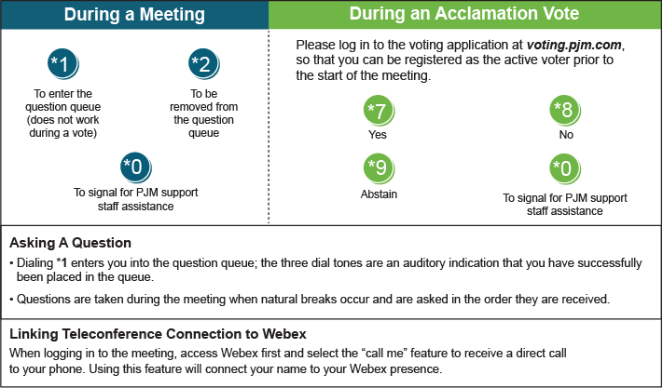

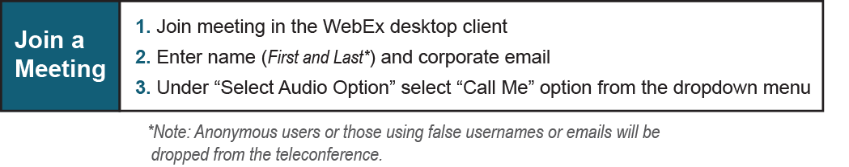

Provide feedback on the progress of this group: Facilitator Feedback Form
Visit learn.pjm.com, an easy-to-understand resource about the power industry and PJM’s role.

