Planning Committee
PJM Conference and Training Center
February 4, 2020
9:00 a.m. – 12:00 p.m. EPT

Administration (9:00-9:15)
- Welcome, announcements and review of the Anti-trust, Code of Conduct, and Media Participation Guidelines.
- Approve Planning Committee (PC) Agenda for this meeting
- Approve draft minutes from the January 7th, 2020 PC meeting
- PJM Annual Meeting Changes
Ms. Jennifer Tribulski, PJM, will provide an update regarding the PJM Annual Meeting and describe registration updates and enhancements

Endorsements (9:15-9:30)
- TO/TOP Matrix V14
Mr. Srinivas Kappagantula, PJM, will present the proposed changes to the TO/TOP Matrix. The Committee will be requested to provide a recommendation to the TOA-AC to approve the Draft TO/TOP Matrix V14 at today’s meeting.

First Reads (9:30-11:00)
- Market Efficiency Process Enhancement Task Force Update
Mr. Jack Thomas, PJM, will review the work completed at the Market Efficiency Process Enhancement Task Force. Package sponsors will provide an overview of the packages. The Committee will be asked to vote on the packages at its next meeting.

- Manual 22 Updates
Mr. Jerry Bell, PJM, will present updates to Manual 22 Generator Resource Performance Indices. The Committee will be requested to endorse these updates at the next meeting.

- Manual 14A/14E/14G Updates
Ms. Onyinye Caven, PJM, will present updates to Manual 14A, Manual 14E, and Manual 14G in relation to the recent FERC 845 ruling. The Committee will be requested to endorse these updates at the next meeting.

Informational Updates (11:00-12:00)
- Manual 12 Attachment F Updates
Mr. Ed Franks, PJM, will present updates to Manual 12 Balancing Operations regarding the planning eligibility criteria as part of the pseudo-tie approval process.

- Designated Entity Design Standards
Mr. Jay Liu, PJM, will review the status of bi-annual (every two years) review of the Designated Entity Minimum Required Standards as required by the DEDSS Charter.
- TPL 007-3 Geomagnetic Disturbance Update
Ms. Ilyana Dropkin, PJM, will provide an update on the NERC Reliability Standard TPL-007-3: Transmission System Planned Performance for Geomagnetic Disturbance Events work.
- Critical Infrastructure Stakeholder Oversight Update
Ms. Christina Stotesbury, PJM, will discuss the workplan for the Critical Infrastructure Stakeholder Oversight Special Planning Committee sessions.
- Reliability Compliance Update
Mr. Preston Walker, PJM, will provide an update on the activities, issues and items of interest at NERC, SERC, and RF.

- Data Request Update
Mr. Ken Seiler and Mr. Chris O’Hara, PJM, will update the Planning Committee on data request sharing with the Independent Market Monitor.

Informational Posting

Model Build Activity Update
The 2020 series RTEP powerflow cases and associated files were provided to PJM’s Transmission Planning Department on Friday January 31, 2020. The 2020 series RTEP Trial 2 short circuit case was provided to the Transmission Owners on Friday January 31, 2020; the Transmission Owners will have until Friday February 14, 2020 to provide any feedback or corrections to the case.
MOD-032 Update
The Gen Model window will open May 1 and remain open through June 15. Generator Owners have the option of using data submitted in previous years to prepopulate the 2020 forms. Gen Model link: https://pjm.com/planning/services-requests/planning-modeling-submission-mod-032.aspx; for any questions or comments email MOD-032@pjm.com

Future Meeting Dates
Wednesday, Feruary 12, 2020 | 1:00 p.m. – 4:00 p.m. | Special PC: Critical Infrastructure | PJM Conference & Training Center/ WebEx
Tuesday, March 10, 2020 | 9:00 a.m. – 12:00 p.m. | Planning Committee | PJM Conference & Training Center/ WebEx
Tuesday, March 3, 2020 | 9:00 a.m. – 12:00 p.m. | Special PC: Critical Infrastructure | PJM Conference & Training Center/ WebEx
Friday, April 3, 2020 | 1:00 p.m. – 4:00 p.m. | Special PC: Critical Infrastructure | PJM Conference & Training Center/ WebEx
Tuesday, April 14, 2020 | 9:00 a.m. – 12:00 p.m. | Planning Committee | PJM Conference & Training Center/ WebEx
Tuesday, April 28, 2020 | 1:00 p.m. – 4:00 p.m. | Special PC: Critical Infrastructure | PJM Conference & Training Center/ WebEx
Tuesday, May 12, 2020 | 9:00 a.m. – 12:00 p.m. | Planning Committee | PJM Conference & Training Center/ WebEx
Tuesday, June 02, 2020 | 9:00 a.m. – 12:00 p.m. | Planning Committee | PJM Conference & Training Center/ WebEx
Tuesday, July 07, 2020 | 9:00 a.m. – 12:00 p.m. | Planning Committee | PJM Conference & Training Center/ WebEx
Tuesday, August 04, 2020 | 9:00 a.m. – 12:00 p.m. | Planning Committee | PJM Conference & Training Center/ WebEx
Tuesday, September 01, 2020 | 9:00 a.m. – 12:00 p.m. | Planning Committee | PJM Conference & Training Center/ WebEx
Tuesday, October 06, 2020 | 9:00 a.m. – 12:00 p.m. | Planning Committee | PJM Conference & Training Center/ WebEx
Wednesday, November 04, 2020 | 9:00 a.m. – 12:00 p.m. | Planning Committee | PJM Conference & Training Center/ WebEx
Tuesday, December 01, 2020 | 9:00 a.m. – 12:00 p.m. | Planning Committee | PJM Conference & Training Center/ WebEx
Author: Molly Mooney

Antitrust:
You may not discuss any topics that violate, or that might appear to violate, the antitrust laws including but not limited to agreements between or among competitors regarding prices, bid and offer practices, availability of service, product design, terms of sale, division of markets, allocation of customers or any other activity that might unreasonably restrain competition. If any of these items are discussed the chair will re-direct the conversation. If the conversation still persists, parties will be asked to leave the meeting or the meeting will be adjourned.

Code of Conduct:
As a mandatory condition of attendance at today's meeting, attendees agree to adhere to the PJM Code of Conduct as detailed in PJM Manual M-34 section 4.5, including, but not limited to, participants' responsibilities and rules regarding the dissemination of meeting discussion and materials.

Public Meetings/Media Participation:
Unless otherwise noted, PJM stakeholder meetings are open to the public and to members of the media. Members of the media are asked to announce their attendance at all PJM stakeholder meetings at the beginning of the meeting or at the point they join a meeting already in progress. Members of the Media are reminded that speakers at PJM meetings cannot be quoted without explicit permission from the speaker. PJM Members are reminded that "detailed transcriptional meeting notes" and white board notes from "brainstorming sessions" shall not be disseminated. Stakeholders are also not allowed to create audio, video or online recordings of PJM meetings. PJM may create audio, video or online recordings of stakeholder meetings for internal and training purposes, and your participation at such meetings indicates your consent to the same.
Participant Identification in WebEx:
When logging into the WebEx desktop client, please enter your real first and last name as well as a valid email address. Be sure to select the “call me” option.
PJM support staff continuously monitors WebEx connections during stakeholder meetings. Anonymous users or those using false usernames or emails will be dropped from the teleconference.

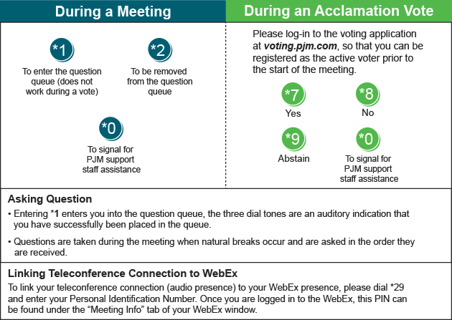

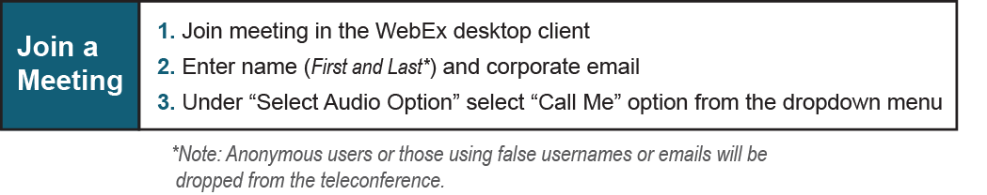

Provide feedback on the progress of this group: Facilitator Feedback Form
Visit learn.pjm.com, an easy-to-understand resource about the power industry and PJM’s role.

