Planning Committee
PJM Conference and Training Center
June 13, 2019
9:00 a.m. – 12:00 p.m. EPT

Administration (9:00-9:15)
- Welcome, announcements and review of the Anti-trust, Code of Conduct, and Media Participation Guidelines
- Approve Planning Committee (PC) Agenda for this meeting
- Approve draft minutes from the May 16th, 2019 PC meeting

Endorsements (9:15-9:30)
- Manual 14G Updates
Ms. Lisa Krizenoskas, PJM, will present updates to Manual 14G Generation Interconnection Requests. The Committee will be requested to endorse these updates today.
- 2019 RRS Assumptions
Mr. Jason Quevada, PJM, will present the 2019 RRS assumptions as developed in the Resource Adequacy Analysis Subcommittee. The Committee will be requested to endorse the study assumptions today.
- Market Efficiency Process Enhancement Task Force Charter
Mr. Fran Barrett, PJM, will present the updated Market Efficiency Process Enhancement Task Force (MEPETF) Charter that incorporates the IMM Problem Statement tasks as Phase 3 of the Key Work Activities. The Committee will be requested to endorse the updated Charter today.

First Reads (9:30-9:45)
- Manual 21 Revisions
Mr. Jerry Bell, PJM, will present revisions to PJM Manual 21 Rules & Procedures for Determination of Generating Capability. The Committee will be requested to endorse these updates at the next meeting.

Informational Updates (9:45-12:00)
Cost Commitment Status and Next Steps
Mr. Mark Sims, PJM, will provide an update on the status and next steps for the Consideration of Cost Commitment for Evaluation of Competitive Transmission Proposals.
Issue Tracking: Cost Containment
RTEP Process Enhancements Update
Mr. Aaron Berner, PJM, will provide an update concerning the activities of the PC Special Sessions around the subject of upgrade modeling in the RTEP. Stakeholders will be requested to participate in a non-binding poll to provide indication to the MRC as to the PC support of the language prepared at the Special PC in favor of the current language proposed under the motion at the MRC.
DER Ride Through Task Force Update
Ms. Susan McGill, PJM, will provide an update on the DERRTTF activities.
FERC Order No. 845 Update
Ms. Susan McGill, PJM, will provide an update on the FERC Order No. 845 compliance filing.
Transmission & Substation Subcommittee Update
Mr. Ray Rouault, PHI, will provide an update on the TSS work activities through 2018 and the first half of 2019, TSS Charter review and a work plan for the remainder of the year.
- Model Build Activity Update
Mr. Peter Lamaina, PJM, will provide an update regarding current model build activities, including the 2019 series MMWG/MOD-032 cases.
- Multi-user Submissions for Queue Point
Mr. Ian Mundell, PJM, will provide an update on an upcoming enhancement to Queue Point which will allow multiple Queue Point users to collaborate on the same submission.

Informational Posting
Economic Project Cost Allocation Stakeholder Notice
The posted “Economic Cost Allocation Stakeholder Notice” is being provided on behalf of the Transmission Owners’ Agreement - Administrative Committee. Please note that written comments on the proposed provisions may be submitted for consideration by email to: Comments_for_Transmission_Owners@pjm.com on or before July 1, 2019.

Future Meeting Dates
June 28, 2019 | 1:00 p.m. – 4:00 p.m. | Special PC: Merchant Transmission and Off-Shore Wind | PJM Conference & Training Center/ WebEx
July 11, 2019 | 9:00 a.m. – 12:00 p.m. | Planning Committee | PJM Conference & Training Center/ WebEx
July12, 2019 | 9:00 a.m. – 12:00 p.m. | Special PC: M-3 Process Lessons Learned | PJM Conference & Training Center/ WebEx
July 24, 2019 | 1:00 p.m. – 4:00 p.m. | Special PC: Merchant Transmission and Off-Shore Wind | PJM Conference & Training Center/ WebEx
August 8, 2019 | 9:00 a.m. – 12:00 p.m. | Planning Committee | PJM Conference & Training Center/ WebEx
September 12, 2019 | 9:00 a.m. – 12:00 p.m. | Planning Committee | PJM Conference & Training Center/ WebEx
October 11, 2019 | 9:00 a.m. – 12:00 p.m. | Special PC: M-3 Process Lessons Learned | PJM Conference & Training Center/ WebEx
October 17, 2019 | 9:00 a.m. – 12:00 p.m. | Planning Committee | PJM Conference & Training Center/ WebEx
November 14, 2019 | 9:00 a.m. – 12:00 p.m. | Planning Committee | PJM Conference & Training Center/ WebEx
December 12, 2019 | 9:00 a.m. – 12:00 p.m. | Planning Committee | PJM Conference & Training Center/ WebEx

Author: Anisha Fernandes

Antitrust:
You may not discuss any topics that violate, or that might appear to violate, the antitrust laws including but not limited to agreements between or among competitors regarding prices, bid and offer practices, availability of service, product design, terms of sale, division of markets, allocation of customers or any other activity that might unreasonably restrain competition. If any of these items are discussed the chair will re-direct the conversation. If the conversation still persists, parties will be asked to leave the meeting or the meeting will be adjourned.

Code of Conduct:
As a mandatory condition of attendance at today's meeting, attendees agree to adhere to the PJM Code of Conduct as detailed in PJM Manual M-34 section 4.5, including, but not limited to, participants' responsibilities and rules regarding the dissemination of meeting discussion and materials.

Public Meetings/Media Participation:
Unless otherwise noted, PJM stakeholder meetings are open to the public and to members of the media. Members of the media are asked to announce their attendance at all PJM stakeholder meetings at the beginning of the meeting or at the point they join a meeting already in progress. Members of the Media are reminded that speakers at PJM meetings cannot be quoted without explicit permission from the speaker. PJM Members are reminded that "detailed transcriptional meeting notes" and white board notes from "brainstorming sessions" shall not be disseminated. Stakeholders are also not allowed to create audio, video or online recordings of PJM meetings. PJM may create audio, video or online recordings of stakeholder meetings for internal and training purposes, and your participation at such meetings indicates your consent to the same.
Participant Identification in WebEx:
When logging into the WebEx desktop client, please enter your real first and last name as well as a valid email address. Be sure to select the “call me” option.
PJM support staff continuously monitors WebEx connections during stakeholder meetings. Anonymous users or those using false usernames or emails will be dropped from the teleconference.

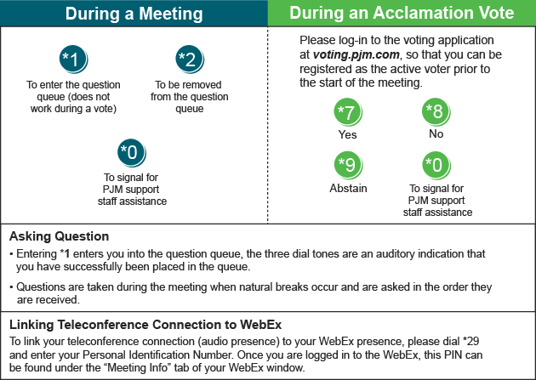

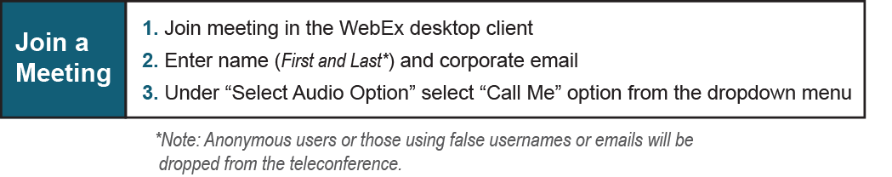
Provide feedback on the progress of this group: Facilitator Feedback Form
Visit learn.pjm.com, an easy-to-understand resource about the power industry and PJM’s role.

