PC Special Session: Merchant Transmission and Offshore Wind
PJM Conference and Training Center
May 3, 2019
1:00 p.m. – 4:00 p.m. EPT

Administration (1:00-1:10)
Welcome, review agenda, PJM meeting guidelines, roll call, Anti-trust and Code of Conduct, announcements and minutes from the April 16th meeting – Mr. John Reynolds and Ms. Natalie Tacka

Work Plan Discussion (1:10-1:15)
Work Plan (1:15-1:20) - Mr. Reynolds will review the work plan and meeting schedule.

Education (1:15-2:15)
- Review of Education on New Service Requests in PJM (1:15 – 1:25)
Ms. Anupama Janapareddy and Ms. Lisa Krizenoskas, PJM, will review key points from the April 16 education session and clarify what is unique about proposed merchant transmission developer requests related to offshore wind development.
Impact of Withdrawn Queue Position on Network Upgrades & Lower Queue Positions (1:25 – 1:35)
Ms. Anupama Janapareddy, PJM, will provide clarification on the process for network upgrades associated with withdrawn queue positions, and the impacts of a higher ordered queue withdraw on lower queue positions.
Rights Retention and Transferability (1:35 – 1:45)
Ms. Anupama Janapareddy, PJM, will provide clarification on retention and transferability of rights.
Economic Value of Rights (1:45 – 2:00)
Mr. Nicolae Dumitriu and Ms. Anupama Janapareddy, PJM, will provide education on the economic value (compensation structures) of existing rights.
State Agreement Approach (2:00 – 2:10)
Ms. Suzanne Glatz, PJM, will provide education on the state agreement approach as part of the interconnection process.

Consensus Based Issue Resolution (CBIR) (2:10-3:45)
Interest Identification and Design Components & Options Matrix
Mr. Reynolds will lead a discussion around interest identification and design components for Phase 1 of the Merchant Transmission and Offshore Wind special session.

Wrap-up: Action Items, Future Agenda Items, Reminders (3:45-4:00)
Mr. Reynolds and Ms. Tacka will close the meeting by reviewing action items and previewing topics for the next meeting.

Future Meeting Dates
May 31, 2019 | 1:00 p.m. | PJM Conference & Training Center/ WebEx
June 28, 2019 | 1:00 p.m. | PJM Conference & Training Center/ WebEx
July 24, 2019 | 1:00 p.m. | PJM Conference & Training Center/ WebEx
Author: Natalie Tacka

Antitrust:
You may not discuss any topics that violate, or that might appear to violate, the antitrust laws including but not limited to agreements between or among competitors regarding prices, bid and offer practices, availability of service, product design, terms of sale, division of markets, allocation of customers or any other activity that might unreasonably restrain competition. If any of these items are discussed the chair will re-direct the conversation. If the conversation still persists, parties will be asked to leave the meeting or the meeting will be adjourned.

Code of Conduct:
As a mandatory condition of attendance at today's meeting, attendees agree to adhere to the PJM Code of Conduct as detailed in PJM Manual M-34 section 4.5, including, but not limited to, participants' responsibilities and rules regarding the dissemination of meeting discussion and materials.

Public Meetings/Media Participation:
Unless otherwise noted, PJM stakeholder meetings are open to the public and to members of the media. Members of the media are asked to announce their attendance at all PJM stakeholder meetings at the beginning of the meeting or at the point they join a meeting already in progress. Members of the Media are reminded that speakers at PJM meetings cannot be quoted without explicit permission from the speaker. PJM Members are reminded that "detailed transcriptional meeting notes" and white board notes from "brainstorming sessions" shall not be disseminated. Stakeholders are also not allowed to create audio, video or online recordings of PJM meetings. PJM may create audio, video or online recordings of stakeholder meetings for internal and training purposes, and your participation at such meetings indicates your consent to the same.
Participant Identification in WebEx:
When logging into the WebEx desktop client, please enter your real first and last name as well as a valid email address. Be sure to select the “call me” option.
PJM support staff continuously monitors WebEx connections during stakeholder meetings. Anonymous users or those using false usernames or emails will be dropped from the teleconference.

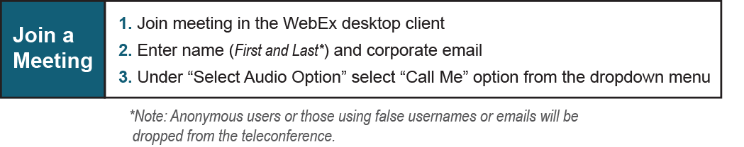

Provide feedback on the progress of this group: Facilitator Feedback Form
Visit learn.pjm.com, an easy-to-understand resource about the power industry and PJM’s role.

