Planning Committee
PJM Conference and Training Center
June 7, 2018
9:00 a.m. – 12:00 p.m. EPT

Administration (9:00-9:15)
- Welcome, announcements and review of the Anti-trust, Code of Conduct, and Media Participation Guidelines
- Approve Planning Committee (PC) Agenda for this meeting
- Approve draft minutes from the May 3rd, 2018 PC meeting

Endorsements (9:15-9:45)
- Manual 20 Revisions
Mr. Patricio Rocha-Garrido, PJM, will present revisions to Manual 20 PJM Resource Adequacy Analysis. The committee will be requested to endorse these revisions.
- 2018 IRM Study Assumptions
Mr. Jason Quevada, PJM, will present the 2018 IRM study assumptions as developed in the Resource Adequacy Analysis Subcommittee. The committee will be requested to endorse these assumptions.

First Reads (9:45-10:15)
- Manual 14A-14G Split
Ms. Lisa Krizenoskas, PJM, will present the split of Manual 14A into revised Manual 14A New Services Requests Study Process and new Manual 14G Generation Interconnection Requests. The committee will be requested to endorse these revisions at the next meeting.
- Load Model Selection
Mr. Patricio Rocha-Garrido, PJM, will present the results of the Load Model selection process for the 2018 Reserve Requirement Study. The committee will be requested to endorse this Load Model selection at the next meeting.

Informational Updates (10:15-12:00)
Transmission Owner Ratings Development and Reporting in PJM
Mr. Mark Kuras, PJM, will discuss ratings development as well as requirements under NERC FAC-008
- Transmission Replacement Processes Senior Task Force Update
Mr. Fran Barrett, PJM, will provide an update on the Transmission Replacement Processes Senior Task Force activities.
Cost Containment Status Update
Ms. Sue Glatz, PJM, will provide a status update on Cost Containment from the May 24th MRC meeting and the next steps of the process.
Competitive Transmission Process
Mr. Jason Shoemaker, PJM, will present revised project proposal templates.
- Manual 14B Updates
Mr. Jonathan Kern, PJM, will present updates to Manual 14B Regional Transmission Planning Process.
Transmission Expansion Advisory Committee (TEAC) and Sub-regional RTEP (SRRTEP) Meeting Information
Mr. Aaron Berner, PJM, will discuss stakeholder feedback to the review process of the Regional and Local Plans, including those conducted at the TEAC and Sub-regional RTEP Committees.
Market Efficiency Process Enhancement Task Force Update
Mr. Brian Chmielewski, PJM, will provide an update on the Market Efficiency Process Enhancement Task Force activities.
PSEG Planning Criteria Updates
Mr. Glenn Catenacci, PSEG, will present updates to their planning criteria.
AEP Planning Criteria Updates
Mr. Nicholas Koehler, AEP, will present updates to their planning criteria.
FERC Order 845 Update
Ms. Pauline Foley, PJM, will provide an update on FERC Order 845.
Model Build Activity Update
Mr. Jonathan Thompson, PJM, will provide a status update regarding current model build activities, including the 2018 series MMWG/MOD-032 cases.
MOD-026 and MOD-027 Compliance Process Demo
Mr. Kyle Clifford, PJM, will provide a demonstration of the MOD-026 and MOD-027 compliance process in the Planning Community.

Recorded Updates
- Reliability Compliance Update
Link to recording:
https://videos.pjm.com/media/June+2018+-+Reliability+Compliance+Update/1_iajhb87o/57735481
Mr. Preston Walker, PJM, provides an update on the activities, issues and items of interest at NERC, SERC, and RFC.

Future Meeting Dates
July 12, 2018 | 9:00 a.m. | PJM Conference & Training Center/ WebEx
August 9, 2018 | 9:00 a.m. | PJM Conference & Training Center/ WebEx
September 13, 2018 | 9:00 a.m. | PJM Conference & Training Center/ WebEx
October 11, 2018 | 9:00 a.m. | PJM Conference & Training Center/ WebEx
November 8, 2018 | 9:00 a.m. | PJM Conference & Training Center/ WebEx
December 13, 2018 | 9:00 a.m. | PJM Conference & Training Center/ WebEx
Author: Anisha Fernandes

Antitrust:
You may not discuss any topics that violate, or that might appear to violate, the antitrust laws including but not limited to agreements between or among competitors regarding prices, bid and offer practices, availability of service, product design, terms of sale, division of markets, allocation of customers or any other activity that might unreasonably restrain competition. If any of these items are discussed the chair will re-direct the conversation. If the conversation still persists, parties will be asked to leave the meeting or the meeting will be adjourned.

Code of Conduct:
As a mandatory condition of attendance at today's meeting, attendees agree to adhere to the PJM Code of Conduct as detailed in PJM Manual M-34 section 4.5, including, but not limited to, participants' responsibilities and rules regarding the dissemination of meeting discussion and materials.

Public Meetings/Media Participation:
Unless otherwise noted, PJM stakeholder meetings are open to the public and to members of the media. Members of the media are asked to announce their attendance at all PJM stakeholder meetings at the beginning of the meeting or at the point they join a meeting already in progress. Members of the Media are reminded that speakers at PJM meetings cannot be quoted without explicit permission from the speaker. PJM Members are reminded that "detailed transcriptional meeting notes" and white board notes from "brainstorming sessions" shall not be disseminated. Stakeholders are also not allowed to create audio, video or online recordings of PJM meetings. PJM may create audio, video or online recordings of stakeholder meetings for internal and training purposes, and your participation at such meetings indicates your consent to the same.
Participant Identification in WebEx:
When logging into the WebEx desktop client, please enter your real first and last name as well as a valid email address. Be sure to select the “call me” option.
PJM support staff continuously monitors WebEx connections during stakeholder meetings. Anonymous users or those using false usernames or emails will be dropped from the teleconference.



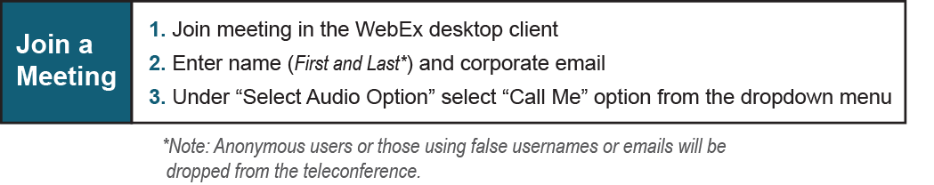

Provide feedback on the progress of this group: Facilitator Feedback Form
Visit learn.pjm.com, an easy-to-understand resource about the power industry and PJM’s role.

