Agenda

**Members Committee**

Two Hundred-twenty-sixth Meeting  
PJM Conference and Training Center, Audubon, PA

**May 17, 2022**

9:30 a.m. – 1:00 p.m. EDT

1. Administration (9:30-9:35)
2. Announce sector selections of new members since the last meeting and any members   
   changing sector *– David Anders*
3. Confirm the presence of a quorum of representatives or designated alternates for this  
   meeting *– David Anders*
4. Antitrust and Code of Conduct announcement *– David Anders*
5. Comments by the President and CEO (9:35-9:55)

Manu Asthana will provide remarks to reflect on his second year with PJM.

1. Comments by Members Committee Chair (9:55-10:00)

Erik Heinle, D.C. Office of the People’s Council, will provide remarks.

1. PJM Board of Managers Nominating Committee (NC) (10:00-10:15)
2. Sarah Rogers will review the activities of the NC. The Members Committee will be asked to **elect** members of the Board of Managers.
3. Dave Anders will review the sector nominees for the 2022-2023 Nominating Committee. The Members Committee will be asked to **elect** the sector representatives upon first read.
4. Year in Review (10:15-11:15)

Susan Buehler, PJM, will facilitate a panel discussion reviewing operations, markets, planning, and market monitoring & surveillance perspectives of the past year. Panelists will include Michael Bryson, Stu Bresler, Kenneth Seiler, Asim Haque, and Joseph Bowring.

1. Presentation on Renewable Integration Study, Phase 2 (11:15-11:45)

Emanuel Bernabeu, PJM, will provide an overview of PJM’s Renewable Integration Study, Phase 2.

1. Consent Agenda (11:45-11:55)
2. **Approve** draft minutes of the April 27, 2021 meeting.
3. **Approve** proposed revisions to Manual 34: PJM Stakeholder Process to incorporate a definition for workshops.
4. **Approve** proposedOperating Agreement (OA) revisions to appropriately document the underfrequency relay requirements applicable to EKPC.
5. Motions to Amend the Members Committee-Endorsed Interconnection Process Reform Package (11:55-12:45)
6. Motion of Exelon Business Services Company, LLC

Amber Thomas, Exelon Business Services Company, LLC, will move, and Laura Yovanovich, PPL Electric Utilities Corporation d/b/a PPL Utilities will second, a Motion to Amend the Members Committee-Endorsed Interconnection Process Reform Package

1. Motion of Enel X North America, Inc.

Brian Kauffman, Enel X North America, Inc. will move, and Cyrus Tashakkori, Open Road Renewables, LLC, will second, a Motion to Amend the Members Committee-Endorsed Interconnection Process Reform Package

1. Motion of Virginia Electric & Power Company

Jim Davis, Virginia Electric & Power Company, will move, and Alex Stern, Public Service Electric and Gas Company, will second, a Motion to Amend the Members Committee-Endorsed Interconnection Process Reform Package

1. MC Vice Chair Report (12:45-1:00)
2. Provide an update on Members Committee Annual Plan *– Becky Robinson*
3. Discuss the plans for the upcoming July 11, 2022 Liaison Committee meeting with the PJM Board of Managers *– Becky Robinson*
4. Future Agenda Items (1:00)
5. Future Meetings

|  |  |  |  |  |  |  |  |  |
| --- | --- | --- | --- | --- | --- | --- | --- | --- |
| Future Meeting Dates and Materials | | | | | | Materials Due  to Secretary | | Materials Published |
| **Date** | **Time** | | **Location** | |  | |  | |
| **June 29, 2022** | | 1:15 p.m. | | PJM Conference & Training Center and WebEx | June 17, 2022 | | June 22, 2022 | |
| **July 27, 2022** | | 1:15 p.m. | | PJM Conference & Training Center and WebEx | July 15, 2022 | | July 20, 2022 | |
| **September 21, 2022** | | 1:15 p.m. | | PJM Conference & Training Center and WebEx | September 9, 2022 | | September 14, 2022 | |
| **October 26, 2022 *tentative dates & time** | | *\* 9:00 a.m.* | | *Off-site TBD* | *\* October 14, 2022* | | *\* October 19, 2022* | |
| **November 16, 2022** | | 1:15 p.m. | | PJM Conference & Training Center and WebEx | November 4, 2022 | | November 9, 2022 | |
| **December 21, 2022** | | 1:15 p.m. | | PJM Conference & Training Center and WebEx | December 9, 2022 | | December 14, 2022 | |

Author: D. Anders

**Antitrust:**

You may not discuss any topics that violate, or that might appear to violate, the antitrust laws including but not limited to agreements between or among competitors regarding prices, bid and offer practices, availability of service, product design, terms of sale, division of markets, allocation of customers or any other activity that might unreasonably restrain competition. If any of these items are discussed the chair will re-direct the conversation. If the conversation still persists, parties will be asked to leave the meeting or the meeting will be adjourned.

**Code of Conduct:**

As a mandatory condition of attendance at today's meeting, attendees agree to adhere to the PJM Code of Conduct as detailed in PJM Manual M-34 section 4.5, including, but not limited to, participants' responsibilities and rules regarding the dissemination of meeting discussion and materials.

**Public Meetings/Media Participation:**

Unless otherwise noted, PJM stakeholder meetings are open to the public and to members of the media. Members of the media are asked to announce their attendance at all PJM stakeholder meetings at the beginning of the meeting or at the point they join a meeting already in progress. Members of the Media are reminded that speakers at PJM meetings cannot be quoted without explicit permission from the speaker. PJM Members are reminded that "detailed transcriptional meeting notes" and white board notes from "brainstorming sessions" shall not be disseminated. Stakeholders are also not allowed to create audio, video or online recordings of PJM meetings. PJM may create audio, video or online recordings of stakeholder meetings for internal and training purposes, and your participation at such meetings indicates your consent to the same.

**Participant Identification in WebEx:**

When logging into the WebEx desktop client, please enter your real first and last name as well as a valid email address. Be sure to select the “call me” option. PJM support staff continuously monitors WebEx connections during stakeholder meetings. Anonymous users or those using false usernames or emails will be dropped from the teleconference.

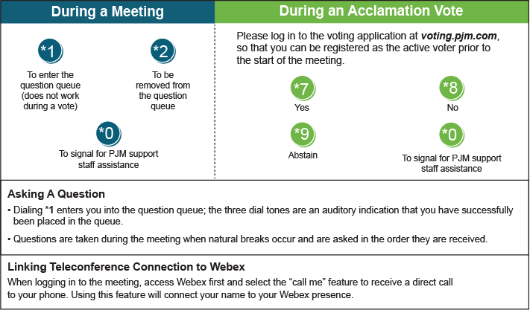

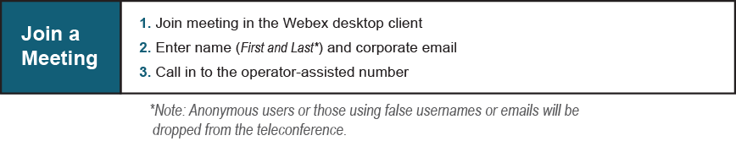

Provide feedback on the progress of this group: *Facilitator Feedback Form*   
Visit [*learn.pjm.com*](http://learn.pjm.com/), an easy-to-understand resource about the power industry and PJM’s role.