Members Committee
Two Hundred Third Meeting
Webex Only
November 19, 2020
10:30 a.m. – 5:00 p.m. EPT
*Operator assisted phone lines will be opened 30 minutes prior to the start of the meeting. Due to the high volume of remote participation, stakeholders are asked to connect early to allow additional time for operator queue processing.

Administration (10:30-10:35)
- Announce sector selections of new members since the last meeting – David Anders
- Confirm the presence of a quorum of representatives or designated alternates for this meeting – David Anders
- Anti-trust, Code of Conduct, Meeting Participation, and Safety announcements – David Anders

Consent Agenda (10:35-10:40)
- Approve draft minutes of the October 29, 2020 meeting.
- Endorse revisions to Manual 15: Cost Development Guidelines resulting from its biennial periodic review process.
- Endorse the Installed Reserve Margin (IRM) and Forecast Pool Requirement (FPR) values included in the 2020 Reserve Requirement Study results.

Initial First Reading (10:40-11:10)
- Manual 34 Revisions (10:40-11:10)
Michele Greening will review proposed revisions addressing stakeholder process updates as discussed at the Stakeholder Process Forum. The committee will be asked to approve the proposed revisions at a future meeting.

Reports (11:10-11:25)
- MC Vice Chair Report (11:10-11:20)
- Provide an update on the Members Committee Annual Plan – Katie Guerry
- Provide a report on the September 22, 2020 Liaison Committee meeting with the PJM Board of Managers – Katie Guerry

- Webinar Feedback (11:20-11:25)
Stakeholders may raise any items identified for further discussion from the October 26, 2020 Members Committee Webinar.

Future Agenda Items (11:25)

Future Meeting Dates
December 17, 2020 | 1:15 p.m. | WebEx

Author: M. Greening

Antitrust:
You may not discuss any topics that violate, or that might appear to violate, the antitrust laws including but not limited to agreements between or among competitors regarding prices, bid and offer practices, availability of service, product design, terms of sale, division of markets, allocation of customers or any other activity that might unreasonably restrain competition. If any of these items are discussed the chair will re-direct the conversation. If the conversation still persists, parties will be asked to leave the meeting or the meeting will be adjourned.

Code of Conduct:
As a mandatory condition of attendance at today's meeting, attendees agree to adhere to the PJM Code of Conduct as detailed in PJM Manual M-34 section 4.5, including, but not limited to, participants' responsibilities and rules regarding the dissemination of meeting discussion and materials.

Public Meetings/Media Participation:
Unless otherwise noted, PJM stakeholder meetings are open to the public and to members of the media. Members of the media are asked to announce their attendance at all PJM stakeholder meetings at the beginning of the meeting or at the point they join a meeting already in progress. Members of the Media are reminded that speakers at PJM meetings cannot be quoted without explicit permission from the speaker. PJM Members are reminded that "detailed transcriptional meeting notes" and white board notes from "brainstorming sessions" shall not be disseminated. Stakeholders are also not allowed to create audio, video or online recordings of PJM meetings. PJM may create audio, video or online recordings of stakeholder meetings for internal and training purposes, and your participation at such meetings indicates your consent to the same.
Participant Identification in WebEx:
When logging into the WebEx desktop client, please enter your real first and last name as well as a valid email address. Be sure to select the “call me” option.
PJM support staff continuously monitors WebEx connections during stakeholder meetings. Anonymous users or those using false usernames or emails will be dropped from the teleconference.

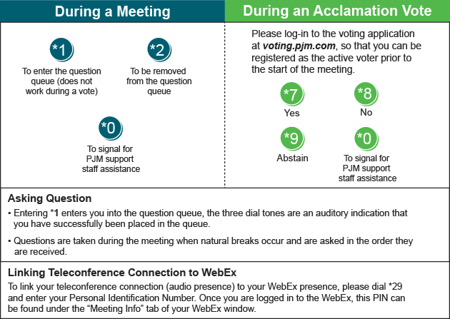

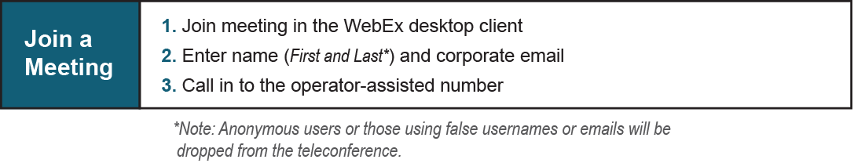
Provide feedback on the progress of this group: Facilitator Feedback Form
Visit learn.pjm.com, an easy-to-understand resource about the power industry and PJM’s role.

