Members Committee
One Hundred Ninety-Fifth Meeting
PJM Conference and Training Center, Valley Forge, PA
January 23, 2020
11:00 a.m. – 5:00 p.m. EPT

Administration (11:00-11:05)
- Announce sector selections of new members since the last meeting – Mr. Anders
- Confirm the presence of a quorum of representatives or designated alternates for this meeting – Mr. Anders
- Anti-trust and Code of Conduct announcement – Mr. Anders

Consent Agenda (11:05-11:10)
- Approve draft minutes of the December 5, 2019 meeting.
- Approve proposed revisions to the Operating Agreement (OA) related to the Financial Risk Mitigation Senior Task Force (FRMSTF) and Markets & Reliability Committee (MRC) endorsed solution package for FTR Product Range and Auction Process.
Issue Tracking: Financial Risk Mitigation
- Approve revisions to the OA to implement changes to the competitive transmission proposal fee structure.
- Endorse proposed revisions to the Open Access Transmission Tariff (OATT) and OA related to the Hourly Differentiated Ramp Rate changes originating from the Modeling Generator Senior Task Force (MGSTF).
Issue Tracking: Modeling Generation in Markets Gateway
- Endorse/Approve Tariff and Operating Agreement revisions regarding the use of market-based Parameter Limited Schedules.
- Approve proposed revisions to the OA clarifying the requirements for sharing forecasted unit commitment data to Transmission Owners for reliability studies.
- Endorse conforming revisions to Manual 15: Cost Development Guidelines consistent with the May 10, 2019 VOM Compliance Filing that was recently accepted by FERC (EL19-8).

Endorsements/Approvals (11:10-11:35)
- Members Committee Resolution (11:10-11:35)
Ms. Sharon Segner, LS Power, will present a resolution related to PJM Transmission Owners’ Section 205 consultation with the PJM Members Committee under Section 9.1 of PJM OATT. The committee may be asked to approve the proposed resolution.

Reports (11:35-11:50)
- MC Vice Chair Report (11:35-11:45)
- Provide an update on the Members Committee Annual Plan – Ms. Katie Guerry
- Provide a report on plans for the February 10, 2020 Liaison Committee meeting with the PJM Board of Managers – Ms. Katie Guerry
- Webinar Feedback (11:45-11:50)
Stakeholders may raise any items identified for further discussion from the January 21, 2020 Members Committee Webinar.

Informational Only
- PJM Annual Meeting Changes (11:50-12:00)
Ms. Jennifer Tribulski will provide an update regarding the PJM Annual Meeting and describe registration updates and enhancements

Future Agenda Items (12:00)

Future Meeting Dates
February 20, 2020 | 1:15 p.m. | PJM Conference & Training Center/ WebEx
March 26, 2020 | 1:15 p.m. | PJM Conference & Training Center/ WebEx
May 4, 2020 (PJM Annual Meeting) | 2:00 p.m. | PJM Conference & Training Center/ WebEx
May 28, 2020 | 1:15 p.m. | PJM Conference & Training Center/ WebEx
June 18, 2020 | 1:15 p.m. | PJM Conference & Training Center/ WebEx
July 23, 2020 | 1:15 p.m. | PJM Conference & Training Center/ WebEx
September 17, 2020 | 1:15 p.m. | PJM Conference & Training Center/ WebEx
October 29, 2020 | 1:15 p.m. | PJM Conference & Training Center/ WebEx
November 19, 2020 | 1:15 p.m. | PJM Conference & Training Center/ WebEx
December 17, 2020 | 1:15 p.m. | PJM Conference & Training Center/ WebEx
Author: M. Greening

Antitrust:
You may not discuss any topics that violate, or that might appear to violate, the antitrust laws including but not limited to agreements between or among competitors regarding prices, bid and offer practices, availability of service, product design, terms of sale, division of markets, allocation of customers or any other activity that might unreasonably restrain competition. If any of these items are discussed the chair will re-direct the conversation. If the conversation still persists, parties will be asked to leave the meeting or the meeting will be adjourned.

Code of Conduct:
As a mandatory condition of attendance at today's meeting, attendees agree to adhere to the PJM Code of Conduct as detailed in PJM Manual M-34 section 4.5, including, but not limited to, participants' responsibilities and rules regarding the dissemination of meeting discussion and materials.

Public Meetings/Media Participation:
Unless otherwise noted, PJM stakeholder meetings are open to the public and to members of the media. Members of the media are asked to announce their attendance at all PJM stakeholder meetings at the beginning of the meeting or at the point they join a meeting already in progress. Members of the Media are reminded that speakers at PJM meetings cannot be quoted without explicit permission from the speaker. PJM Members are reminded that "detailed transcriptional meeting notes" and white board notes from "brainstorming sessions" shall not be disseminated. Stakeholders are also not allowed to create audio, video or online recordings of PJM meetings. PJM may create audio, video or online recordings of stakeholder meetings for internal and training purposes, and your participation at such meetings indicates your consent to the same.
Participant Identification in WebEx:
When logging into the WebEx desktop client, please enter your real first and last name as well as a valid email address. Be sure to select the “call me” option.
PJM support staff continuously monitors WebEx connections during stakeholder meetings. Anonymous users or those using false usernames or emails will be dropped from the teleconference.

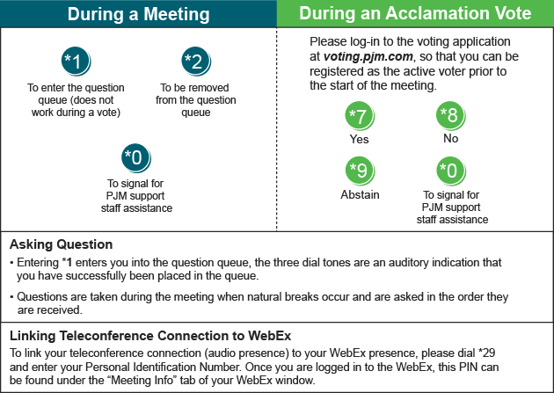

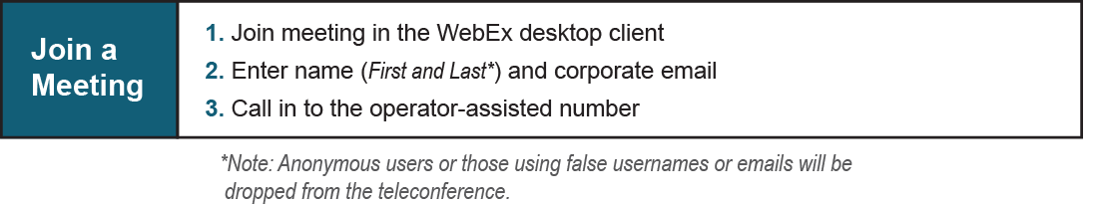
Provide feedback on the progress of this group: Facilitator Feedback Form
Visit learn.pjm.com, an easy-to-understand resource about the power industry and PJM’s role.

